

|  |  |
| --- | --- |
| **JWSS-22B-M** | **Scroll Saw** |
| **JWSS-22BM...727200BM...**  **1~ 230V, 50Hz** |

**PARTS LIST**



**JPW (Tool) AG**

Tämplerlistrasse 5

CH-8117 Fällanden

Switzerland

Phone +41 44 806 47 48

Fax +41 44 806 47 58

www.jettools.com

P-727200M 2016-11

JWSS-22B-M Upper & Lower Arm Assembly – Exploded View

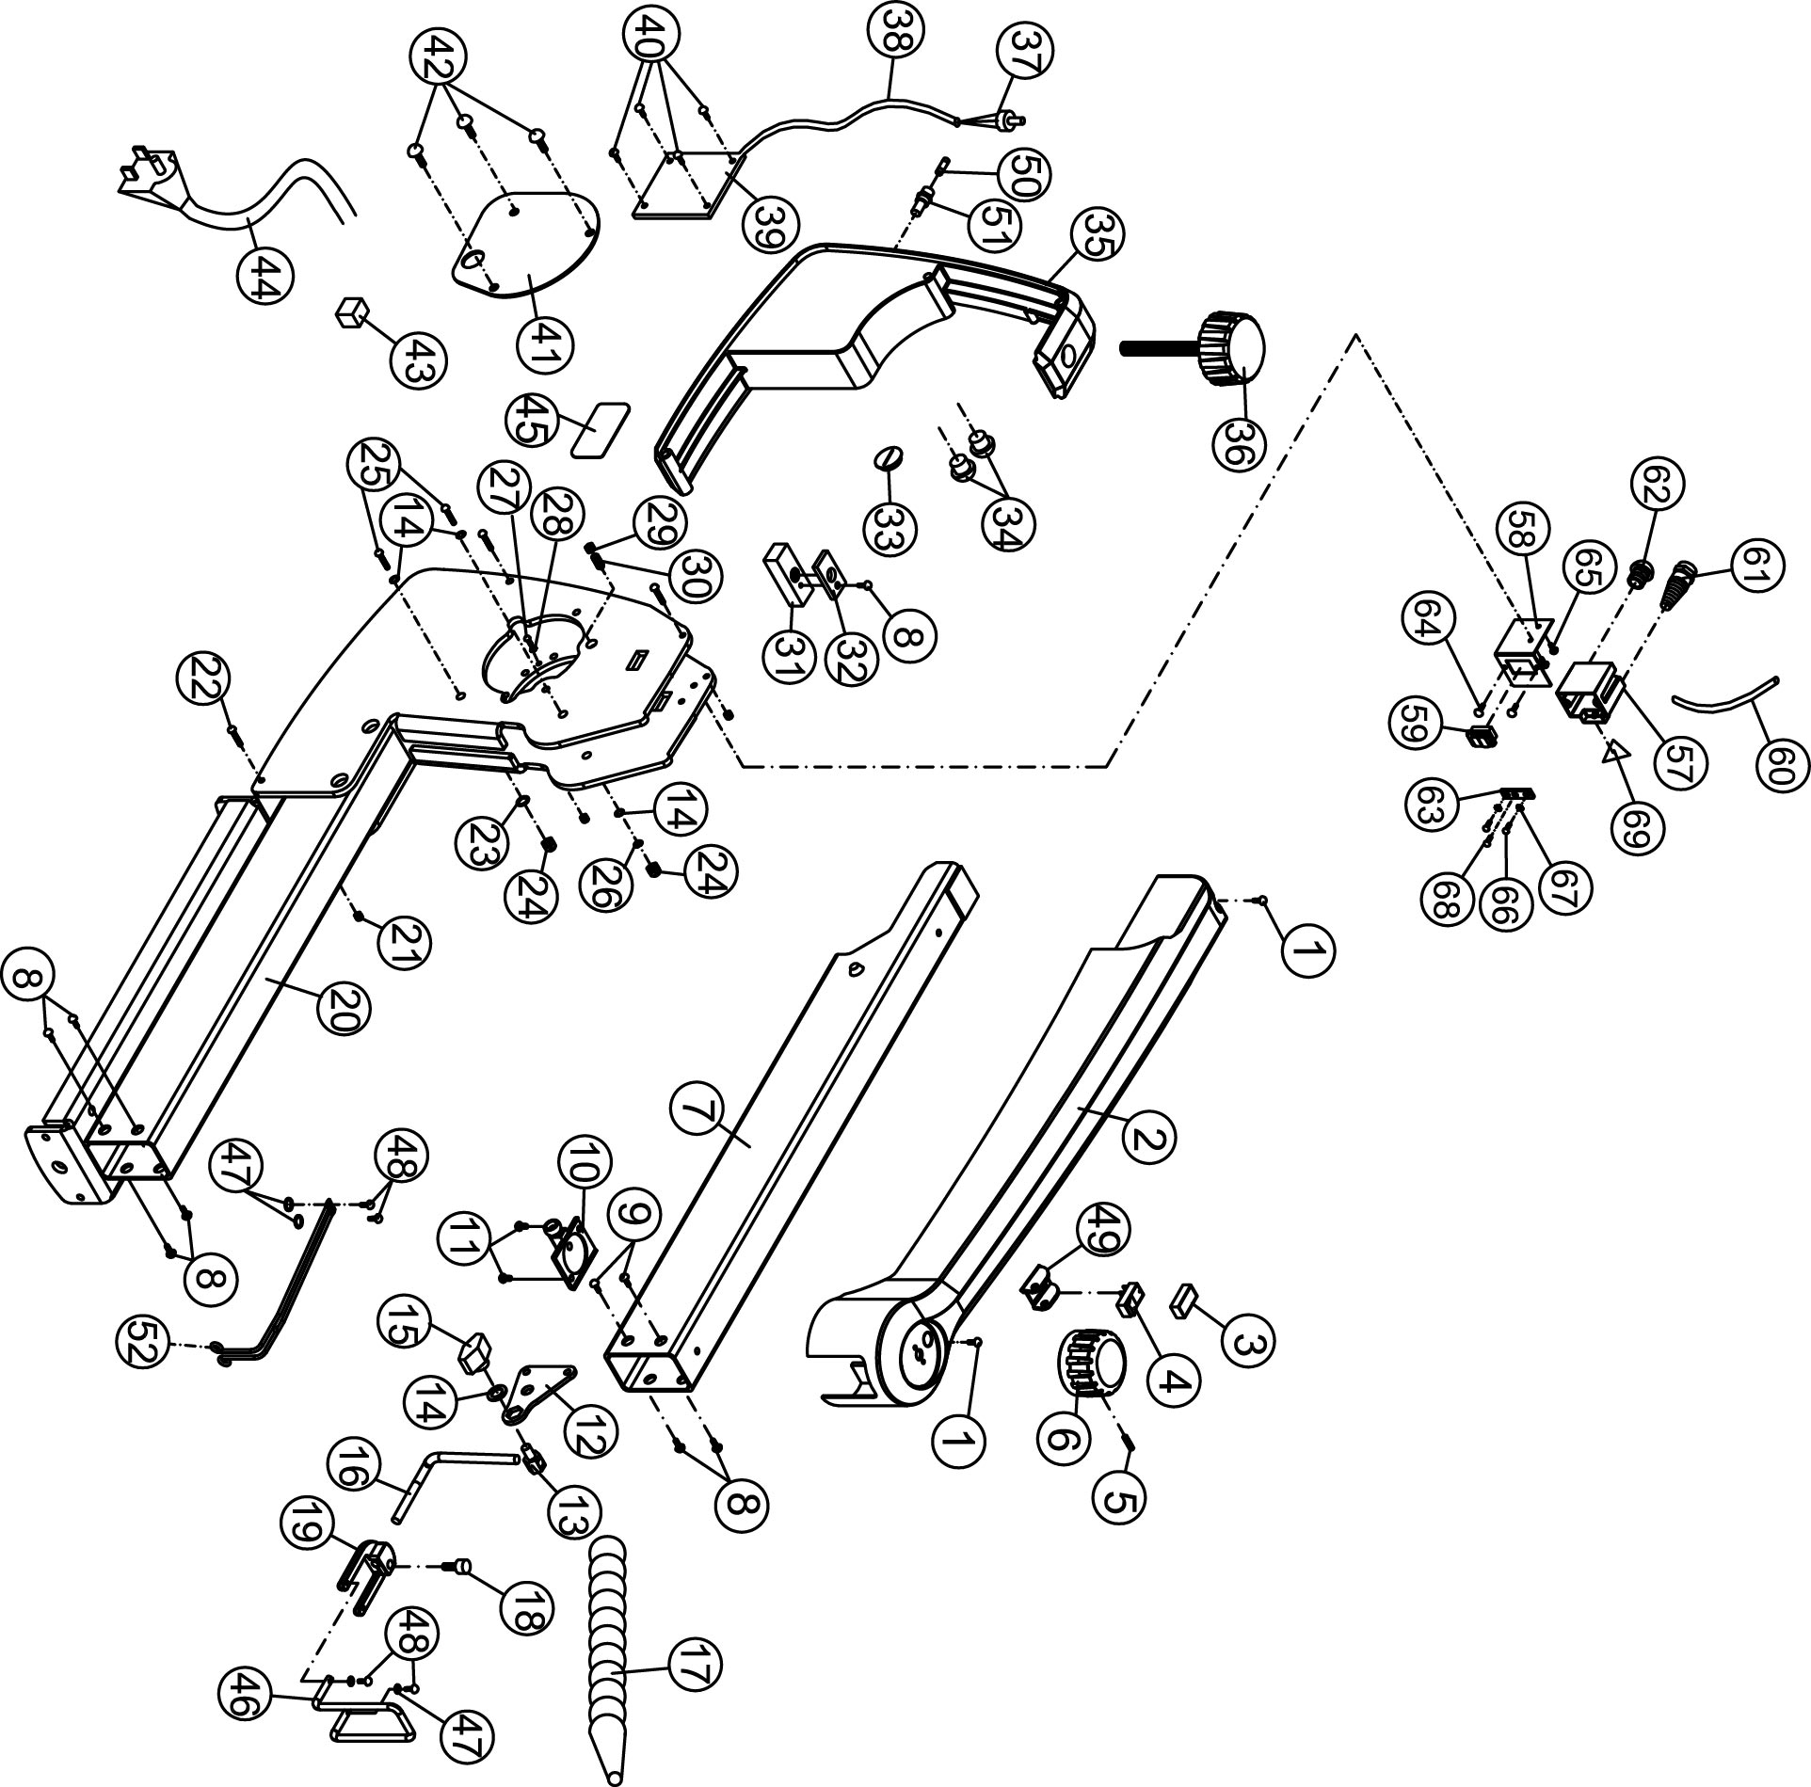

15.1.2 JWSS-22B-M Upper & Lower Arm Assembly – Parts List

Index No Part No Description Size Qty

1 F009668 Button Head Socket Screw #10-32x1/4 2

2 JWSS22B-202 Top Cover 1

3 JWSS22B-203 Switch Rubber Cover 1

4 JWSS22B-204 Switch 1

5 TS-1521031 Socket Set Screw M4x8 1

6 JWSS22B-206 VR Knob with Speed Label 1

7 JWSS22B-207 Upper Arm 1

8 F009916 Button Head Socket Screw #10-32x5/16 7

9 F009670 Button Head Socket Screw #10-32x3/8 2

10 JWSS22B-210 Dust Blower 1

11 TS-081B022 Pan Head Screw #8-32x3/8 2

12 JWSS22B-212 Hold Down Mount Plate 1

13 JWSS22B-213 Hold Down Clamp Screw 1

14 TS-0680021 Flat Washer 1/4” 4

15 JWSS22B-215 Hold Down Clamp Knob 1

16 JWSS22B-216 Hold Down Bar 1

17 JWSS22B-217 Air Nozzle 1

18 TS-0206022 Socket Head Cap Screw #10-32x1/2 1

19 JWSS22B-219 Hold Down Fork 1

20 JWSS22B-220E Main Body 1

21 5508073 Hex Nylon Lock Nut #10-32 3

22 F009917 Button Head Socket Screw #10-32x2-1/4 3

23 TS-0680021 Flat Washer 1/4 1

24 TS-0640071 Hex Nylon Lock Nut 1/4-20 2

25 F009918 Button Head Socket Screw 1/4-20x2-1/2 2

26 TS-130205 Lock Washer 1/4 1

27 TS-081B012 Phillips Pan Head Machine Screw #8-32x1/4 1

28 TS-0720041 External Tooth Lock Washer #8 1

29 TS-0561031 Hex Nut 3/8-16 1

30 JWSS22B-230 Ball Set Screw 3/8-16x5/8 1

31 JWSS22B-231 Housing Cross Block 1

32 JWSS22B-232 Cross Block Retainer 1

33 JWSS22B-233 Cap 1

34 JWSS22B-234 Strain Relief 2

35 JWSS22B-235 Control Box 1

36 JWSS22B-236 Arm Adjustment Knob 1

JWSS22B-237AE PC Board with VR (#37,38,39) 1

37 Variable Resistor 1

38 Control Cable 1

39 JWSS22B-239E PC Board 1

40 JWSS22B-240 Machine Screw M4x8 4

41 JWSS22B-241 Cover Plate 1

42 TS-0254021 Button Head Socket Screw 1/4-20x1/2 3

43 JWSS22B-243 Sponge Block 1

44 JWSS22B-244E Power Cord 3x18AWG 1

45 JET-92 JET Logo 92x38mm 1

46 JWSS22B-246 Upper Blade Guard 1

47 TS-2361041 Lock Washer M4 4

48 TS-081B022 Phillips Pan Head Machine Screw #8-32x3/8 4

49 JWSS22B-249 Switch Protector 1

50 JWSS22B-250E Fuse 5 A 1

51 JWSS22B-251 Fuse Holder 1

52 JWSS22B-252 Lower Blade Guard 1

55 LM000188E Warning Label (not shown) 49x100mm 1

56 LM000189E ID Label, JWSS-22B (not shown) 1

57 JWL1015-168 Switch Box 1

Index No Part No Description Size Qty

58 JWSS22B-258E Bracket 1

59 JWSS22B-259E Magnetic Switch 1

60 JWSS22B-260E Connection Cable 1

61 JWSS22B-261E Cable Protector 1

62 JML-70E Strain Relief PG 9 1

63 JWL1015-171 Ground Plate 1

64 TS-081C022 Pan Head Screw #10-24x3/8” 2

65 TS-1533032 Pan Head Screw M5x10 2

66 JWSS22B-266E Pan Head Screw M5x6 2

67 TS-0733041 External Tooth Lock Washer ¼” 2

68 JWL1015-163 Tapping Screw M3.5x6mm 1

69 3520A-289E Warning Label 1

15.2.1 JWSS-22B-M Table & Cabinet Assembly – Exploded View



15.2.2 JWSS-22B-M Table & Cabinet Assembly – Parts List

Index No Part No Description Size Qty

1 JWSS22B-301 Blade Tilt Locking Lever 1

2 TS-0680021 Flat Washer 1/4 1

3 JWSS22B-303 Tilt Adjust Knob 1

4 JWSS22B-304 Blade Tilt Washer 2

5 JWSS22B-305 Tilt Lock Draw Rod 1

6 JWSS22B-306 Detent Plunger 1

7 JWSS22B-307 Spring 1

8 JWSS22B-308 Tilt Detent Barrel 1

9 JWSS22B-309 E-Ring ETW-3 1

10 JWSS22B-310 Pointer 1

11 TS-1550021 Flat Washer M4 1

12 TS-2284061 Phillips Pan Head Machine Screw M4x6 1

13 TS-0254061 Button Head Socket Screw 1/4-20x1 2

14 JWSS22B-314 Angle Indicator Bracket 1

15 JWSS22B-315 Blade Tilt Drive Gear 2

16 JWSS22B-316 Angle Follower 2

17 F009916 Button Head Socket Screw #10-32x5/16 8

18 TS-069204 Flat Washer #10x12x1 8

19 JWSS22B-319 Front Trunnion Plate 1

20 JWSS22B-320 Hex Flange Nut 1/4-20UNC 12

21 JWSS22B-321 Trunnion 2

22 JWSS22B-322 Side Panel 2

23 TS-0050031 Hex Cap Screw 1/4-20x3/4 10

24 TS-0680021 Flat Washer 1/4 9

25 JWSS22B-325 Rear Trunnion Plate 1

26 TS-0720071 Lock Washer 1/4 3

27 TS-0050011 Hex Cap Screw 1/4-20x1/2 1

28 JWSS22B-328 Table 1

29 TS-0273062 Socket Set Screw 1/4-20x1 4

30 JWSS22B-330 Dust Collect Plate 1

31 JWL1015-124 Button Head Socket Screw #10-24x1/4 4

32 JWSS22B-332 Dust Port 1-1/2 OD 1

33 TS-0561082 Hex Nut 3/8-16 8

34 JWSS22B-334 Leveling Foot 3/8-16x1-1/4 4

35 JWSS22B-335 Blade Rack 1

36 TS-2286121 Pan Head Screw M6x12 2

37 JWSS22B-337 Sponge 1

15.3.1 JWSS-22B-M Drive Link Assembly – Exploded View

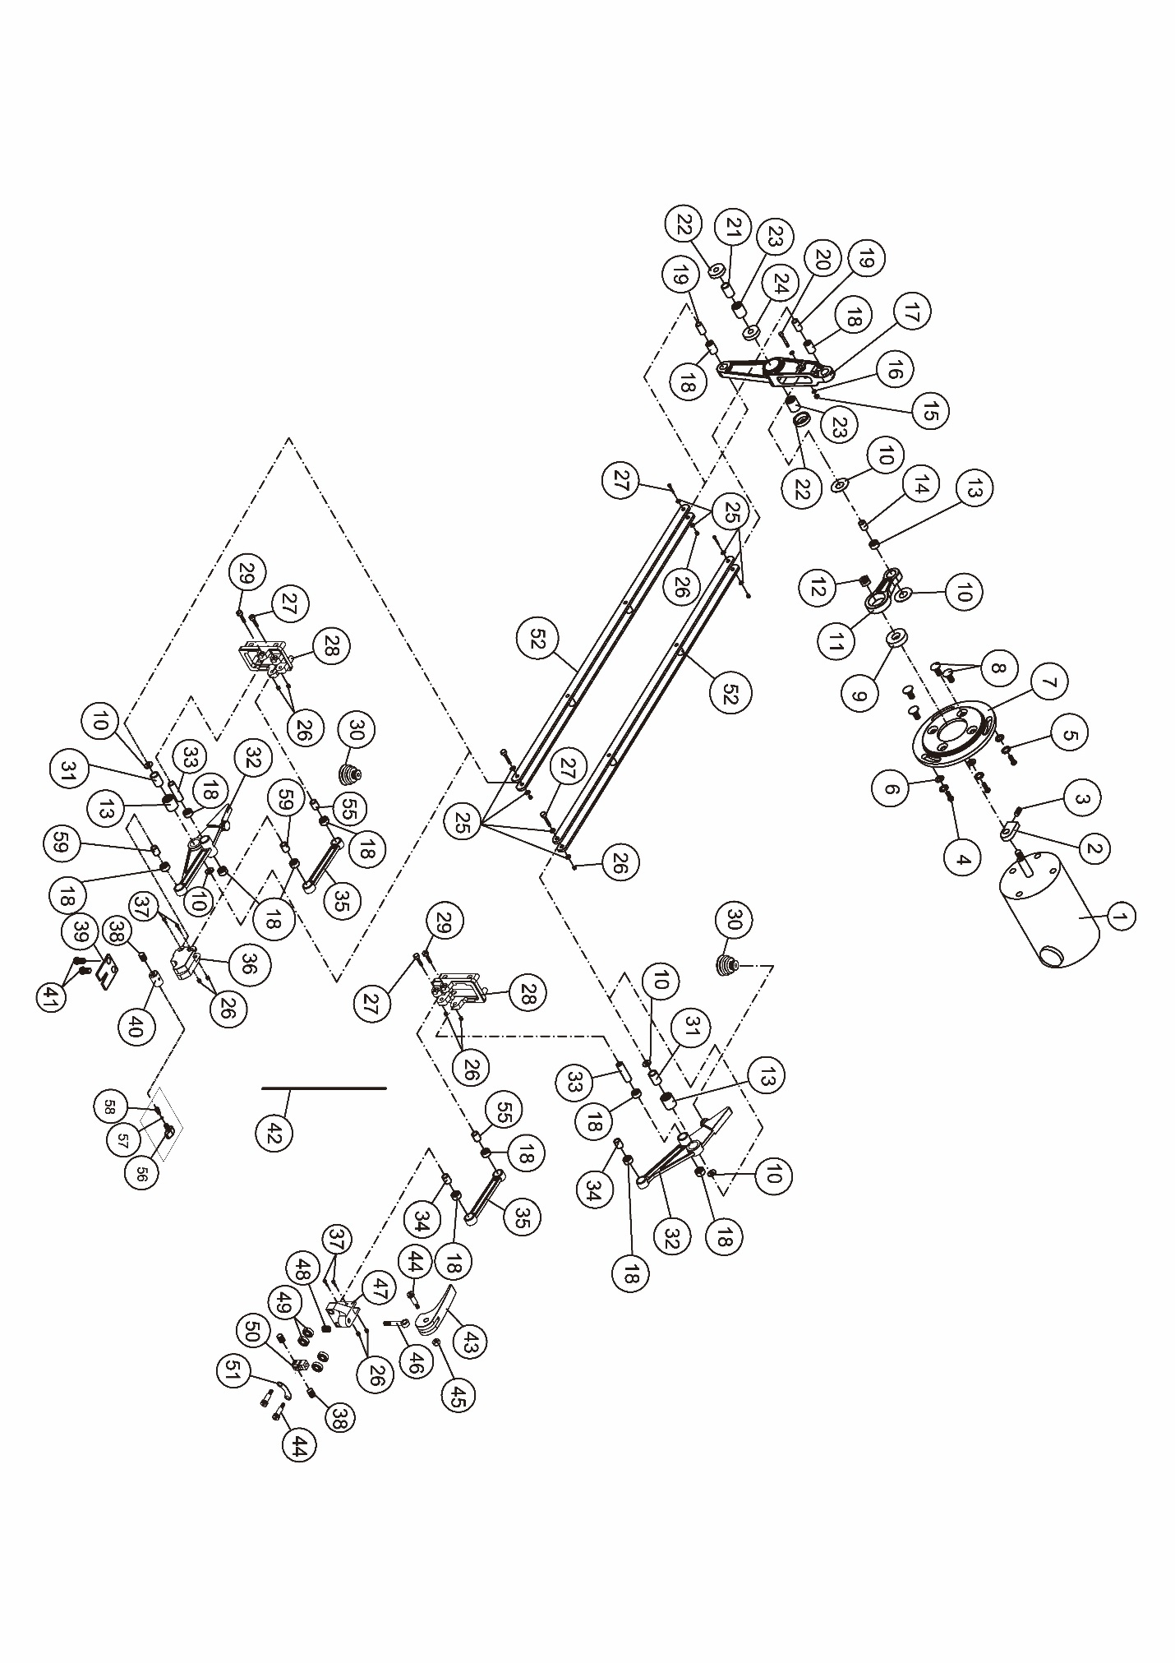

15.3.2 JWSS-22B-M Drive Link Assembly – Parts List

Index No Part No Description Size Qty

1 JWSS22B-401E Motor 1

JWSS22B-MCB Motor Carbon Brush (not shown) 2

JWSS22B-MCBC Motor Carbon Brush Cap (not shown) 2

LM000190E Motor Label, JWSS-22B (not shown) 1

2 JWSS22B-402 Balance Block 1

3 TS-1523011 Socket Set Screw M6x6 1

4 TS-0254021 Button Head Socket Screw 1/4-20x1/2 3

Index No Part No Description Size Qty

5 TS-0720071 Lock Washer 1/4 3

6 TS-0680021 Flat Washer 1/4 3

7 JWSS22B-407 Motor Cover Plate 1

8 TS-1514021 Socket Head Flat Screw M6x16 4

JWSS22B-CDLA Complete Drive Link Assembly (#9 thru 27, #52) 1

9 BB-608ZZ Ball Bearing 608ZZ 1

10 TS-1550061 Flat Washer M8 6

11 JWSS22B-411 Motor Cam 1

12 JWSS22B-412 Nut M8xP1.25LH 1

13 JWSS22B-413 Bearing 810 3

14 JWSS22B-414 Inner Bearing Sleeve Ø8.046x21.5mm 1

15 TS-1541011 Hex Nylon Lock Nut M5 1

16 TS-1550031 Flat Washer M5 2

17 JWSS22B-417 Rocker Cam 1

18 JWSS22B-418 Bearing 0609 12

19 JWSS22B-419 Inner Bearing Sleeve (Long) Ø6.03x16.5mm 2

20 F005667 Socket Head Cap Screw M5x28 1

21 JWSS22B-421 Main Rocker Pivot Ø14.04x35.50mm 1

22 JWSS22B-422 Bearing Cover 2

23 JWSS22B-423 Bearing 1412 2

24 JWSS22B-424 Bushing 1

25 TS-1550021 Flat Washer M4 8

26 TS-1541001 Hex Nylon Lock Nut M4 12

27 TS-1501071 Socket Head Cap Screw M4x25 6

28 JWSS22B-428 Rocker Mount 2

29 F005358 Socket Head Cap Screw M4x40 2

30 JWSS22B-430 Air Pump Bellows 2

31 JWSS22B-431 Inner Bearing Sleeve – Front Rocker Ø8.03x18.40mm 2

32 JWSS22B-432 Front Rocker 2

33 JWSS22B-433 Inner Bearing Sleeve (Long) Ø6.03x37mm 2

34 JWSS22B-434 Inner Bearing Sleeve Ø6.03x16mm 2

35 JWSS22B-435 Strut 2

36 JWSS22B-436 Lower Blade Chuck 1

37 F005668 Socket Head Cap Screw M4x22 4

38 JWSS22B-438 Set Screw M6x5 5

39 JWSS22B-439 Spring Plate 1

727201 Lower Blade Holder Assembly (#38, 40, 56 thru 58), set of 3 1

40 JWSS22B-440 Lower Blade Holder 3

41 6286494 Pan Head Screw M5x6 2

42 JWSS22B-442 Blade……………………..0.36mm (t) x 1.1mm (W) x 130mm (L) x 11 TPI 5

43 JWSS22B-443 Tension Lever 1

44 JWSS22B-444 Screw 3

45 TS-1541011 Hex Nylon Lock Nut M5 1

46 JWSS22B-446 Bolt 1

47 JWSS22B-447 Upper Blade Chuck 1

48 JWSS22B-448 Spring 1

49 JWSS22B-449 Bearing R4ZZ 4

50 JWSS22B-450 Blade Clamp Assembly (includes #38) 1

51 JWSS22B-451 Plate 1

52 JWSS22B-452 Drive Link Assembly 2

55 JWSS22B-455 Inner Bearing Sleeve (Short) Ø6.03x21mm 2

JWSS22B-TSA Thumb Screw Assembly (#56 thru 58) 1

56 JWSS22B-456 Thumb Screw 1

57 JWSS22B-457 O-Ring 1

58 JWSS22B-458 Press Bar 1

59 JWSS22B-459 Inner Bearing Sleeve Ø6.03x14mm 2

15.4.1 Stand (OPTIONAL) for JWSS-22B-M Scroll Saw – Exploded View



15.4.2 Stand (OPTIONAL) for JWSS-22B-M Scroll Saw – Parts List

Index No Part No Description Size Qty

727200S Stand for Scroll Saw (#1 thru 10)

1 TS-0051051 Hex Cap Screw 5/16"-18 x 1" 4

2 TS-0680031 Flat Washer 5/16" 32

3 JWSS22B-103 Top Short Brace 2

4 JWSS22B-104 Top Long Brace 2

5 JWSS22B-105 Leg 4

6 TS-0570021 Hex Nut 5/16"-18 28

7 JWSS22B-107 Bottom Short Brace 2

8 JWSS22B-108 Bottom Long Brace 2

9 JWSS22B-109 Round Hd. Carriage Bolt, b.oxide 5/16"-18 x 1/2” 24

10 JWSS22B-110 Leg Extension 4

11 JWSS22B-111 Rubber washer (included with saw hardware) 4

JWSS22B-SHK Stand Hardware Kit (#1,2,6,9)

**JWSS-22B-M..727200BM….1~230V,50Hz**

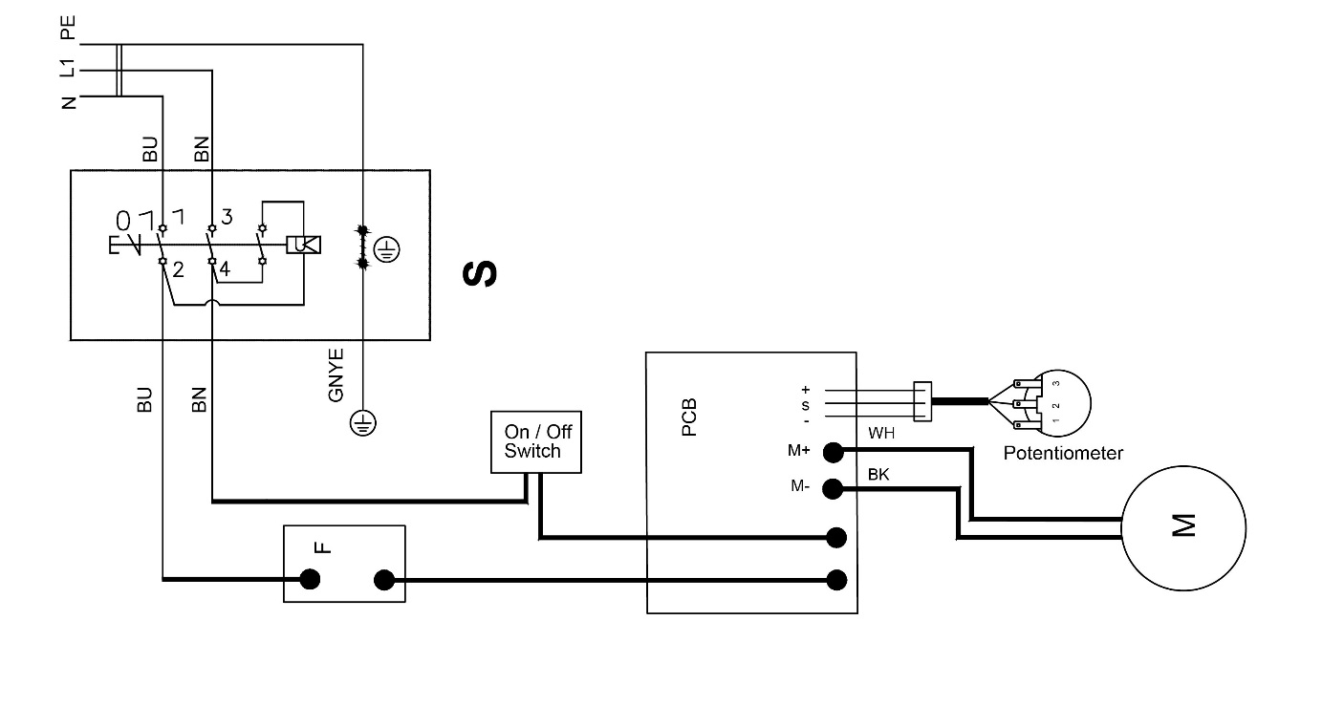

|  |  |  |  |
| --- | --- | --- | --- |
|  | **colour of strands** | **Litzenfarben** | **couleur des cordons** |
| **BK** | **black** | **schwarz** | **noir** |
| **WH** | **white** | **weiß** | **blanc** |
| **BU** | **blue** | **blau** | **bleu** |
| **YE** | **yellow** | **gelb** | **jaune** |
| **RD** | **red** | **rot** | **rouge** |
| **BN** | **brown** | **braun** | **brun** |
| **GY** | **grey** | **grau** | **gris** |
| **GNYE** | **green-yellow** | **grün-gelb** | **vert-jaune** |
| **OG** | **orange** | **orange** | **orange** |
| **VT** | **violet** | **violett** | **violet** |

|  |  |  |  |
| --- | --- | --- | --- |
|  | **meaning of symbol** | **Bedeutung der Zeichen** | **interprétation** |
| **M** | **motor** | **Motor** | **moteur** |
| **S** | **switch** | **Schalter** | **interrupteur** |
| **C** | **condenser** | **Kondensator** | **condensateur** |
| **E** | **electronic unit** | **Elektronik Einheit** | **unité électronique** |
| **F** | **fuse** | **Sicherung** | **fusible** |
| **RS** | **reversing switch** | **Drehrichtungsschalter** | **commu. droite/gauche** |
| **CS** | **centrifugal switch** | **Fliehkraftschalter** | **déclencheur centrifuge** |
| **OL** | **overload cut-off** | **Überlastschutzschalter** | **déclencheur surcharge** |
| **LS** | **limit switch** | **Positionsendschalter** | **micro** |