BD-12G | OPERATING MANUAL LATHE
Original:  GB  Operating Instructions  Parts List | 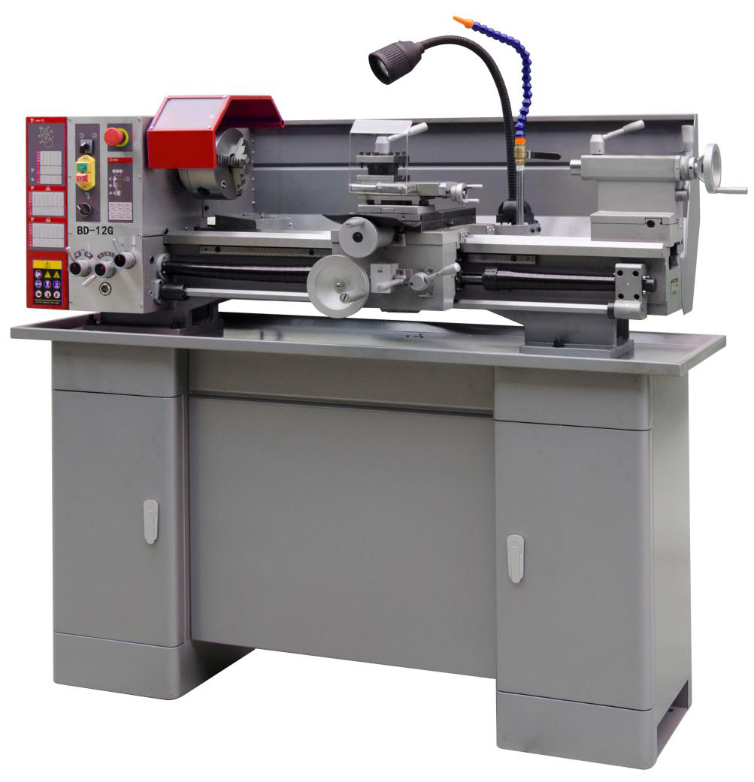

JPW (Tool) AG
Tämperlistrasse 5
CH-8117 Fällanden
Switzerland
Phone +41 44 806 47 48
Fax +41 44 806 47 58
www.jettools.com

50000913M 2017-11

CE-Conformity Declaration
CE-Konformitätserklärung
Déclaration de Conformité CE

Product / Produkt / Produit:

Metal Lathe
Die Metall - Dreher
Tour de métal

BD-12G

Brand / Marke / Marque:
JET
Manufacturer / Hersteller / Fabricant:
JPW (Tool) AG, Tämperlistrasse 5, CH-8117 Fällanden
Schweiz / Suisse / Switzerland

We hereby declare that this product complies with the regulations
Wir erklären hiermit, dass dieses Produkt der folgenden Richtlinie entspricht
Par la présente, nous déclarons que ce produit correspond aux directives suivantes

2006/42/EC
Machinery Directive
Maschinenrichtlnie
Directive Machines

2006/95/EC
electromagnetic compatibility
elektromagnetische Verträglichkeit
compatibilité électromagnétique

Directive Basse Tension
designed in consideration of the standards
und entsprechend folgender zusätzlicher Normen entwickelt wurde
et été développé dans le respect des normes complémentaires suivantes

EN ISO 12100:201 0; EN 60204-1 :2006+A 1 :2009+AC:2010
EN 61000-6-2:2005; EN 61000-6-4:2007+A1:2011

Responsible for the Documentation / Dokumentations-Verantwortung / Résponsabilité de Documentation:
Hansjörg Meier
Head Product-Mgmt. / Leiter Produkt-Mgmt. / Resp. Gestion des Produits
JPW (Tool) AG
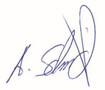

2016-10-10 Alain Schmid, General Manager
JPW (Tool) AG, Tämperlistrasse 5, CH-8117 Fällanden
Schweiz / Suisse / Switzerland

EN Operating Instructions (Original)

1.0 About this Manual
This manual is provided by JET, covering the safe operation and maintenance procedures for a JET Model BD-12G Metal Lathe. This manual contains instructions on installation, safety precautions, general operating procedures, maintenance instructions and parts breakdown. The machine has been designed and constructed to provide consistent, long-term operation if used in accordance with the instructions as set forth in this document.
Retain this manual for future reference. If the machine transfers ownership, the manual should accompany it.

2.0 Table of Contents
Section Page
1.0 About this manual 3
2.0 Table of contents 3
3.0 Important safety instructions 4~5
3.1 Designated use and limitations to use 6
3.2 Remaining hazards 6
4.0 Specifications 7~8
5.0 Machine description 9
6.0 Setup and assembly 10
6.1 Unpacking and clean up 10
6.2 Shipping contents 10
6.3 Assembly 10
6.4 Initial lubrication 10
6.5 Installation 10
7.0 Electrical connections 10~11
7.1 Grounding instructions 10
7.2 Extension cords 11
8.0 Adjustments 11~13
8.1 Spindle speed range selection 11
8.2 Change gear setup 11
8.3 Taper turning with tailstock 12 8.4 Taper turning with top slide 12
8.5 Three jaw universal chuck 13
8.6 Four jaw independent chuck 13
8.7 Live centre 13
8.8 Steady rest and follow rest 13
9.0 Operating controls 14
10.0 Machine operation 14~17
10.1 Cutting execution 14
10.2 Chucking 14
10.3 Cutting tool setup 15
10.4 Recommended spindle speeds 15
10.5 Manual turning 15
10.6 Turning with auto feed 15
10.7 Thread cutting 16
10.8 Drilling operation 17
11.0 User maintenance 17~18
11.1 Lubrication 17
11.2 Readjustments 18
12.0 Troubleshooting 19
13.0 Environmental protection 19
14.0 Available accessories 19
15.0 Replacement parts 20~37
16.0 Wiring diagrams 38-39

3.0 IMPORTANT SAFETY INSTRUCTIONS
READ ALL INSTRUCTIONS BEFORE USING THIS LATHE.
– To reduce risk of injury:
- Read and understand entire owner’s manual before attempting assembly or operation of this machine.
- Read and understand the warnings posted on the machine and in this manual.
- Replace warning labels if they become obscured or removed.
- This machine is designed and intended for use by properly trained and experienced personnel only. If you are not familiar with the proper and safe operation of a metal lathe, do not use until proper training and knowledge have been obtained.
- Do not use this machine for other than its intended use. If used for other purposes, JET disclaims any real or implied warranty and holds itself harmless from any injury that may result from that use.
- Always wear approved safety glasses or face shield while using this machine. (Everyday eyeglasses only have impact resistant lenses; they are not safety glasses.)
- Before operating this machine, remove tie, rings, watches and other jewellery, and roll sleeves up past the elbows. Remove loose clothing and confine long hair. Non-slip footwear or anti-skid floor strips are recommended. Do not wear gloves.
- Wear hearing protection (plugs or muffs) during extended periods of operation.
- Some dust created by sawing may contain chemicals known to cause cancer, birth defects or other reproductive harm. Some examples of these chemicals are:
- Lead from lead based paint.
- Crystalline silica from bricks, cement and other masonry products.
- Arsenic and chromium from chemically treated lumber.
Your risk of exposure varies, depending on how often you do this type of work. To reduce your exposure to these chemicals, work in a well-ventilated area and work with approved safety equipment, such as face or dust masks that are specifically designed to filter out microscopic particles.
- Do not operate this machine while tired or under the influence of drugs, alcohol or any medication.
- Make certain the switch is in the OFF position before connecting the machine to the power supply. Turn off all controls before unplugging.
- Make certain the machine is properly grounded. Connect to a properly grounded outlet only. See Grounding instructions.
- Make all machine adjustments or maintenance with the machine unplugged from the power source.
- Remove adjusting keys and wrenches. Form a habit of checking to see that keys and adjusting wrenches are removed from the machine before turning it on.
- Keep safety guards in place at all times when the machine is in use. If removed for maintenance purposes, use extreme caution and replace the guards immediately after maintenance is complete.
- Check damaged parts. Before further use of the machine, a guard or other part that is damaged should be carefully checked to determine that it will operate properly and perform its intended function. Check for alignment of moving parts, binding of moving parts, breakage of parts, mounting and any other conditions that may affect its operation. A guard or other part that is damaged should be properly repaired or replaced.
- Provide for adequate space surrounding work area and non-glare, overhead lighting.
- Keep the floor around the machine clean and free of scrap material, oil and grease.
- Keep visitors a safe distance from the work area. Keep children away.
- Make your workshop child proof with padlocks, master switches or by removing starter keys.
- Give your work undivided attention. Looking around, carrying on a conversation and “horse-play” are careless acts that can result in serious injury.
- Keep an ergonomic body position. Maintain a balanced stance at all times so that you do not fall or lean against the chuck or other moving parts. Do not overreach or use excessive force to perform any machine operation.
- Use the right tool at the correct speed and feed rate. Do not force a tool or attachment to do a job for which it was not designed. The right tool will do the job better and safer.
- The machine is intended for indoor use. To reduce the risk of electric shock, do not use outdoors or on wet surfaces.
- Do not handle plug or machine with wet hands.
- Use recommended accessories; improper accessories may be hazardous.
- Maintain tools with care. Keep tools sharp and clean for the best and safest performance. Follow instructions for lubricating and changing accessories.
- Turn off machine and disconnect from power before cleaning. Use a brush or compressed air to remove chips or debris; do not use bare hands.
- Do not stand on the machine. Serious injury could occur if the machine tips over.
- Never leave the machine running unattended. Turn the power off and do not leave the machine until it comes to a complete stop.
- Remove loose items and unnecessary work pieces from the area before starting the machine.
- Pull the mains plug if the machine is not in use.
- Make sure the workpiece is securely clamped.

Familiarize yourself with the following safety notices used in this manual:
WARNING: This means that if precautions are not heeded, it may result in serious, or possibly even fatal, injury.
CAUTION: This means that if precautions are not heeded, it may result in minor injury and/or possible machine
damage.

SAVE THESE INSTRUCTIONS
WARNING:
These symbols below advise that you follow the correct safety procedures when using this machine.

Read and understand the entire user manual before attempting assembly or machine operation.

Always wear approved working outfit
Wear safety goggles.
Wear ear protection.

Always wear the approved working outfit Wear safety shoes.
Remove tie, rings, watches, jewellery. Roll up sleeves above elbows.
Remove all loose clothing and confine long hair

Make all machine adjustments or maintenance with the machine unplugged from the power source.

Any work piece stock extending the rear end of the headstock must be covered on its entire length. High danger of injury

Do not operate this machine under the influence of drugs, alcohol or medication

Do not wear gloves while operating this machine

Connection and repair work on the electrical installation may be carried out by a qualified electrician only.

Never reach into the machine while it is operating or running down.

3.1 Designated use and limitations to use
The machine is designed for turning and drilling machinable metal and plastic materials only.
The workpiece must allow to safely be loaded, supported and clamped.
The machine is intended for indoor use. The protection rating of the electrical installation is IP 54.
To avoid tipping, the machine must be bolted down with four anchor bolts.
If used for other purposes, JET disclaims any real or implied warranty and holds itself harmless from any injury that may result from that use.
WARNING:
The machine is not suitable for machining magnesium…high danger to fire !
Never place your fingers in a position where they could contact any rotating parts or chips.
Check the save clamping of the work piece before starting the machine.
Don’t exceed the clamping range of the chuck.
Work pieces longer than 3 times the chucking diameter need to be supported by the tailstock or a steady rest.
Avoid small chucking diameters at big turning diameters. Avoid short chucking lengths and small chucking contact.
Do not exceed the max speed of the work holding device.
Use the right tool at the correct speed and feed rate. Do not force a tool or attachment to do a job for which it was not designed. The right tool will do the job better and more safely.
Use recommended accessories; improper accessories may be hazardous.
Maintain tools with care. Keep cutting tools sharp and clean for the best and safest performance.
Follow instructions for lubricating and changing accessories.
Do not attempt to adjust or remove tools during operation.
Never stop a rotating chuck or workpiece with your hands.
Choose a small spindle speed when working unbalanced work pieces and for threading and tapping operations.
Any work piece stock extending the rear end of the headstock must be covered on its entire length. High danger of injury!
Long work pieces may need a steady rest support. A long and thin work piece can suddenly bend at high speed rotation.
Never move the tailstock or tailstock quill while the machine is running.
Remove cutting chips with the aid of an appropriate chip hook when the machine is at a standstill only.
Measurements and adjustments may be carried out when the machine is at a standstill only.
Maintenance and repair work may only be carried out after the machine is protected against accidental starting, pull the mains plug.
Remove loose items and unnecessary work pieces from the area before starting the machine.
Rotate workpiece by hand before applying power. Use lowest speed when starting new workpiece.
Tighten all locks before operating.

3.2 Remaining hazards
When using the machine according to regulations some remaining hazards may still exist.
The rotating work piece and chuck can cause injury.
Thrown and hot work pieces and cutting chips can lead to injury.
Chips and noise can be health hazards. Be sure to wear personal protection gear such as safety goggles and ear protection.
The use of incorrect mains supply or a damaged power cord can lead to injuries caused by electricity.
When opening the electrical cabinet, the grid-feeding voltage persists. Therefore pay attention every time you enter it.

4.0 Specifications
Model number BD-12G
Stock number……………………………………………………………………. 50000913M

Motor and electricals:
Motor type……………………………………………………. Induction motor
Motor power 1.1 kW
Power supply 1~230V, PE, 50 Hz
Protection class IP 54
Listed load amps 6.4 A
Machine lamp Halogen lamp 24V, 35 W
Coolant pump 40 W

Capacities:
Centre height 150 mm
Swing over bed 300 mm
Swing over cross slide 170 mm
Distance between Centres 750 mm

Spindle:
Spindle nose mounting short taper mount (1:4 Ø63.51mm, Ø98x3xØ11)
Spindle bore 38 mm
Spindle taper MT5
Number of spindle speeds 6
Range of spindle speeds 150 ~ 2000 /min

Tailstock:
Tailstock ram travel 80 mm
Tailstock taper MT3

Bed and Slides:
Bed width 180 mm
Cross slide travel 170 mm
Top slide travel 90 mm
Tool size max 16x16 mm
Lead screw pitch 3 mm
Longitudinal feeds (9x) 0.085 /0.13 /0.17 /0.21 /0.25 /0.35 /0.40 /0.50 /0.83 mm/rev
Metric threads (21x) 0.2 ~ 4.0 mm/rev
Inch threads (21x) 8 ~ 56 TPI

Materials:
Machine Bed Cast iron, induction hardened and precision ground Headstock, tailstock, slides Cast iron
Spindle bearings Taper roller bearings, quality level P5

Sound emission in idle ¹ 73.4 dB (LpA)
Sound emission during cutting ¹ 78.3 dB (LpA)
¹ Sound emission measured according to EN ISO 11202, in 1m distance, 1.6m above ground. The specified values are emission levels and are not necessarily to be seen as safe operating levels. As workplace conditions vary, this information is intended to allow the user to make a better estimation of the hazards and risks involved only.

Dimensions and Weights:
Overall dimensions, assembled (W x D x H) 1400 x 700 x 700 (1400) mm
Shipping dimensions (W x D x H) (Separate packing) 1550x750x750 & 820x680x430 mm
Net weight (approximate) 357 kg
Shipping weight (approximate) 402 kg

L = length; W = width; H= height; D= depth
The specifications in this manual were current at time of publication, but because of our policy of continuous improvement, JET reserves the right to change specifications at any time and without prior notice, without incurring obligations.

4.1 Spindle nose mounting:

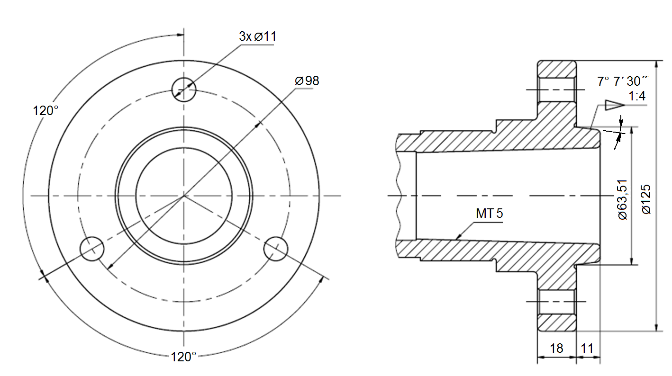
Figure 4-1: Spindle nose mounting

4.2 Anchor bolt hole pattern:
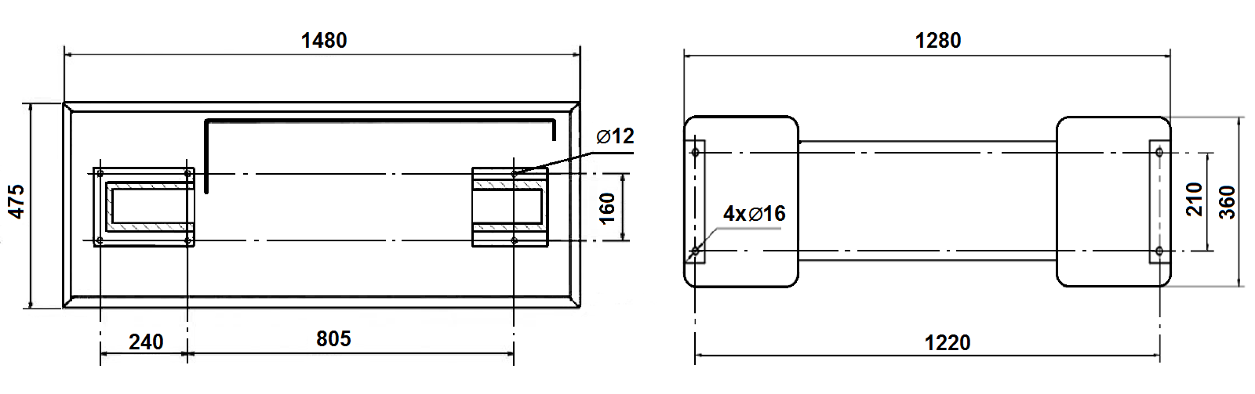
Figure 4-2: Lathe Bed (left) & Stand (right) anchor bolt pattern

WARNING:
To avoid tipping, the machine must be bolted down with four anchor bolts (not provided).

5.0 Machine Description
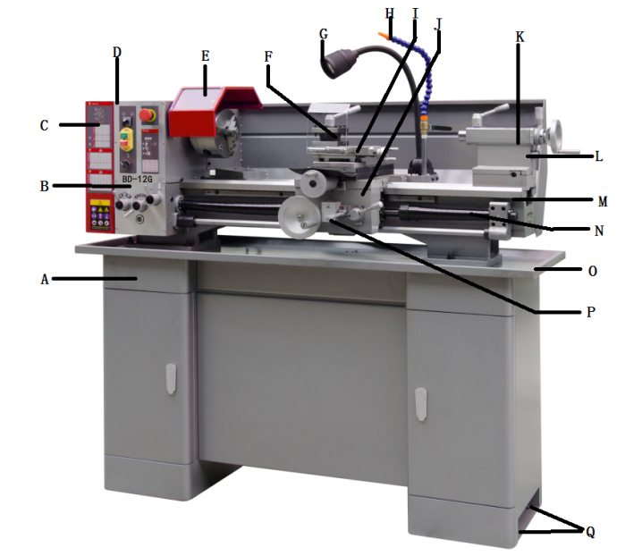
Figure 5-1: Machine description

A Machine cabinet stand
B Gear box
C Pulley cover
D Headstock
E Chuck and chuck guard
F Tool post and tool post guard
G Machine lamp
H Coolant nozzle
I Top slide
J Carriage
K Tailstock
L Splash guard
M Lathe bed
N Lead screw
O Chip tray
P Longitudinal feed / Cross feed select lever
Q Anchor bolt holes

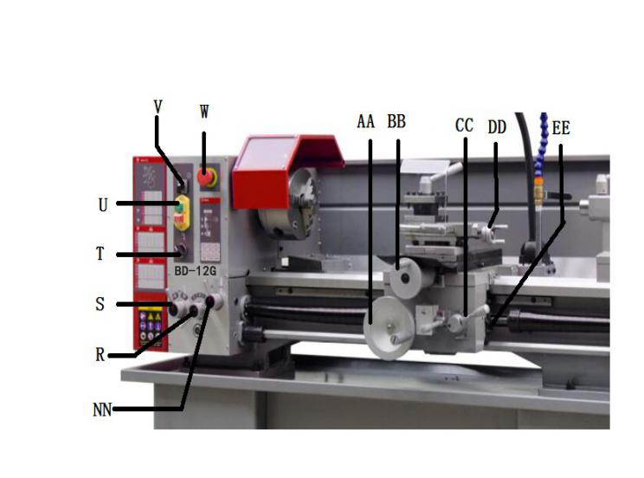

Figure 5-2: Machine description

R Feed speed select knob
S Feed forward/ off/ reverse
T Coolant ON/OFF
U Spindle power ON/OFF
V Spindle forward/reverse
W Emergency Stop
AA Apron hand wheel
BB Cross slide hand wheel
CC Half nut lever
DD Top slide hand wheel
EE Threading dial
NN Feeding / Threading select knob
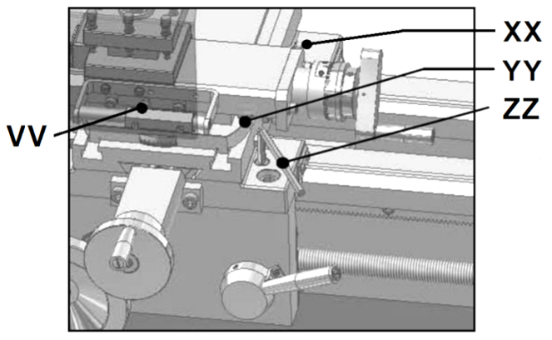
Figure 5-3 Machine description

VV Top slide lock
XX Cross slide lock
YY Top slide taper adjustment
ZZ Carriage lock

6.0 Setup and Assembly
WARNING:
Read and understand the entire contents of this manual before attempting assembly or operation. Failure to comply may cause serious injury.

6.1 Unpacking and clean up
Remove all contents from shipping crate and compare parts to the contents list in this manual. If shipping damage or any part shortages are identified, contact your distributor. Do not discard crate or packing material until machine is assembled and running satisfactorily.
Clean all rust protected surfaces with kerosene or a light solvent. Do not use lacquer thinner, paint thinner or gasoline, as these can damage plastic components and painted surfaces.

6.2 Shipping contents
1 Machine
1 Cabinet stand
1 Coolant facility (optional)
1 Machine lamp(optional)
1 160mm 3-jaw universal chuck
1 160mm 4-jaw independent chuck
1 265mm face plate(optional)
1 Chuck guard
1 4-way tool post
1 Tool post guard
1 Set of change gears
1 Threading dial
1 MT5 fixed centre
1 MT3 fixed centre
1 Steady rest
1 Follow rest(optional)
1 Operating tools in tool box
1 Oil can
1 Operating instructions and parts manual

6.3 Assembly
The machine comes completely assembled.
Install the drive belt (V-belt).
Inspect that all fasteners are tight.

6.4 Initial lubrication
The machine must be serviced at all lubrication points before it is placed into service (see chapter 11.1 for lubrication).

6.5 Installation
Unbolt the lathe from the shipping crate bottom.
Use heavy duty fibre belt for lifting the machine off the pallet.

Warning:
The machine is heavy (402kg)!
Assure the sufficient load capacity and proper condition of your lifting devices.
Never step underneath suspended loads.
To avoid tipping, the machine must be bolted down with four anchor bolts (not provided).
To avoid twisting the bed, make sure the setup surface is absolutely flat and level.
Loosen anchor bolts, shim and tighten bolts if needed.
The machine must be level to be accurate !

7.0 Electrical Connections
WARNING:
All electrical connections must be done by a qualified electrician in compliance with all local codes and ordinances. Failure to comply may result in serious injury.
The BD-12G Metal Lathes are rated at 1~230V, PE, 50Hz power supply. The machines come with a plug designed for use on a circuit with a grounded outlet.
Mains connection and any extension cords and plugs used must comply with the information on the machine license plate.
The mains connection must have a 16A surge-proof fuse.
Only use extension cords marked H07RN-F, with wires 1,5mm² or more.
The total length of cord may not exceed 18 Meter
Power cords and plugs must be free from defects.
Connections and repairs to the electrical equipment may only be carried out by qualified electricians.
The machine is equipped with 2.3m power cord and plug.
Before connecting to power source, be sure main switch is in off position.

7.1 Grounding instructions
This tool must be grounded. In the event of a malfunction or breakdown, grounding provides a path of least resistance for electric current to reduce the risk of electric shock. This tool is equipped with an electric cord having an equipment-grounding conductor and a grounding plug. The plug must be inserted into an appropriate outlet that is properly installed and grounded in accordance with all local codes and ordinances.
WARNING:
Improper connection of the equipment-grounding conductor can result in a risk of electric shock. Check with a qualified electrician or service person if you are in doubt as to whether the outlet is properly grounded. Do not modify the plug provided with the tool.
The green/yellow conductor is the equipment-grounding conductor. If repair or replacement of the electric cord or plug is necessary, do not connect the equipment-grounding conductor to a live terminal.
Use only 3-wire extension cords with grounding plugs.
Repair or replace damaged or worn cord immediately.

7.2 Extension cords
The use of extension cords is discouraged; try to position machines near the power source. If an extension cord is necessary, make sure it is in good condition.
An undersized cord will cause a drop in line voltage resulting in loss of power and overheating.
Only use extension cords marked H07RN-F, with wires 1,5mm2 or more.
The total length of cord may not exceed 18 Meter
Extension cords and plugs must be free from defects.

8.0 Adjustments

8.1 Changing spindle speed
The speeds of the lathe are controlled by the position of the belt on the pulleys (Fig 8-1).
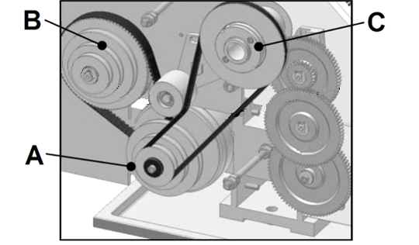
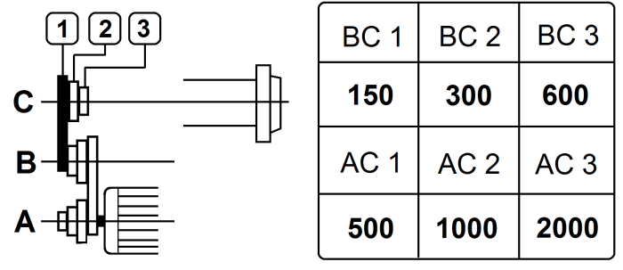
Figure 8-1: Spindle speed setup

Remove the pulley cover (C, Fig 5-1) to change the belt position.
Reinstall the pulley cover.

8.2 Change gear setup
Remove the pulley cover.
The rotational speed of the lead screw, and hence the rate of feed of the cutting tool, is determined by the gear configuration and by the feed speed select lever (R, Fig 5-2).
Assemble the gears with desired setup (Fig 8-2)
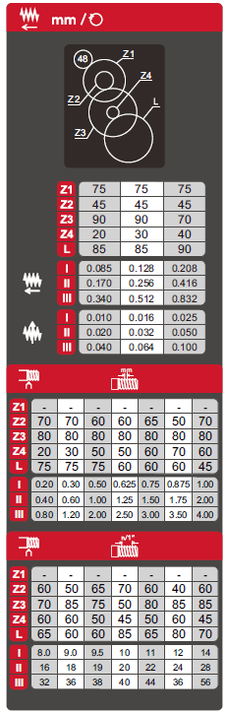
Figure 8-2: Change gear setup
Adjust gears to mesh with upper and lower gear.
Placing ordinary paper in between gears helps to adjust for correct gear spacing (… remove the paper afterwards!).
Reinstall the pulley cover.

8.3 Taper turning with tailstock
Mount the work piece fitted with the drive dog between centres. The drive dog is driven by the face plate.
Lubricate the tailstock centre with grease to prevent tip from overheating.
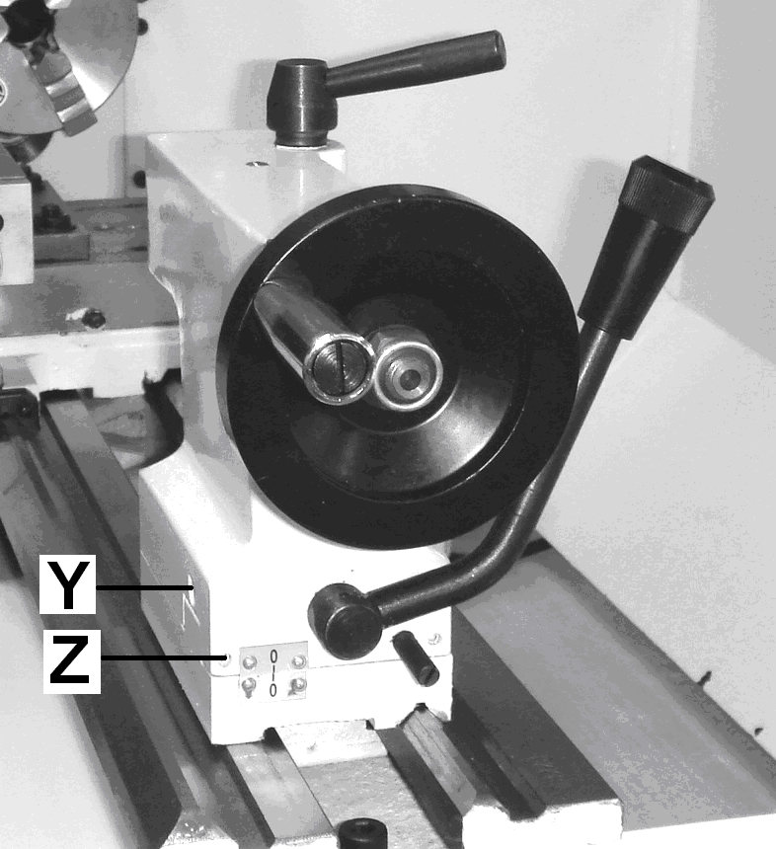
Figure 8-3: Taper turning between centres
To turn a taper, offset the tailstock, loosen the locking screws (Z, Fig 8-3) and use screws (Y) to adjust.
After taper turning, the tailstock must be returned to its original position. Turn a test piece and adjust until the machine turns a perfect cylinder.

8.4 Taper turning with top slide
By angling the top slide, tapers may be turned.
Loosen two hex nuts (A, Fig 8-4) and rotate the top slide according to the graduated scale (B).
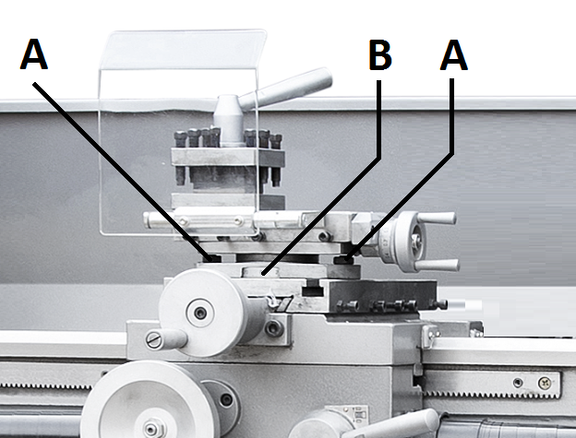
Figure 8-4: Taper turning with top slide

8.5 Three jaw universal chuck
With this universal chuck, cylindrical, triangular and hexagonal stock may be clamped (Fig 8-5).
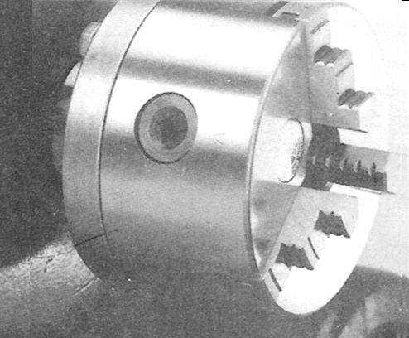
Figure 8-5: Three jaw universal chuck
To hold big diameter stock, a set of OD chuck jaws is supplied.
The jaws need to be inserted to the chuck in the correct order.
Use Molykote Paste G (or adequate grease) to lubricate the jaws.

8.6 Four jaw independent chuck (Optional)
This chuck has four independently adjustable chuck jaws (Fig 8-6).
These permit the holding of square and asymmetrical pieces and enables accurate concentric set-up of cylindrical pieces.
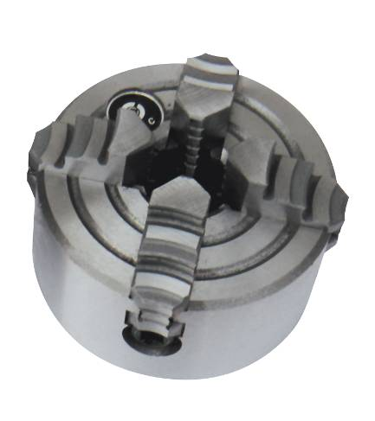
Figure 8-6: Four jaw independent chuck

8.7 Live centre (Optional)
The live centre (Fig 8-7) is mounted in ball bearings.
Its use is highly recommended for speeds above 500 RPM.
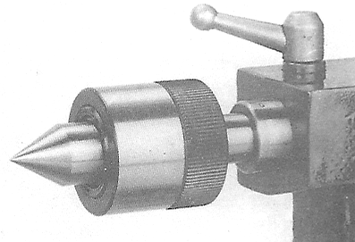
Figure 8-7: Live centre
To eject the live centre, fully retract the tailstock quill.

8.8 Steady rest and follow rest (Optional)
The rests prevent flexing of long and thin work pieces under pressure from the tool.
The steady rest (Fig 8-8) serves as a support for longer shafts and ensures a safe and chatter free operation.
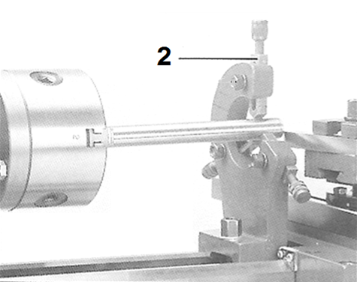
Figure 8-8: Steady rest

The follow rest (Fig 8-9) is mounted on the carriage and follows the movement of the tool.
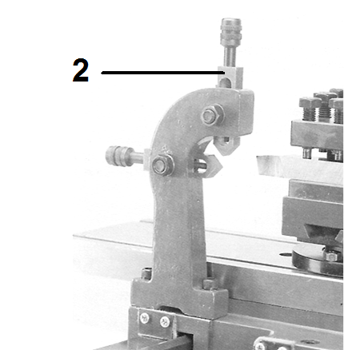
Figure 8-9: Follow rest

Note:
Set the fingers (2) snug but not overly tight.
Lubricate the fingers to prevent premature wear.

9.0 Operating Controls
Refer to Figure 9-1:
R Feed speed select lever (I, II, III)
S Feed forward/off/reverse
T Coolant ON/OFF
U Spindle power ON/OFF
V Spindle forward/reverse
W Emergency Stop
NN Feed shaft / Lead screw select lever
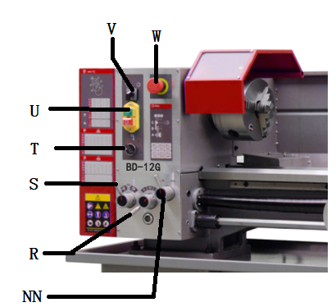
Figure 9-1: Operating Controls

10.0 Machine Operation
10.1 Cutting execution
Before starting the machine check the proper chucking.
Close the chuck guard and pulley cover before you start the machine.
Select running direction, forward or reverse (V, Fig 9-1).
You can start the machine with the green ON-button (U).
The red OFF-button stops the machine.
The emergency stop button (W) stops all machine functions.
Turn emergency stop button clockwise to reset.
The work lamp (G, Fig 5-1) operates independently; ON/OFF switch is on top of lamp housing.
Unplug the machine if not in use.

10.2 Chucking
Do not exceed the max speed of the work holding device.
Jaw teeth and scroll must always be fully engaged. Otherwise chuck jaws may break and fly off in rotation (Fig 10-1).
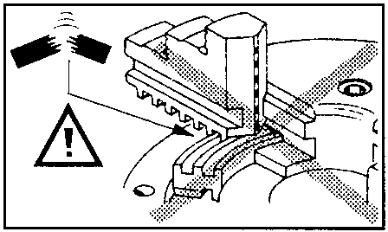
Figure 10-1: Poor jaw engagements
Avoid long workpiece extensions. Parts may bend (Fig 10-2) or fly off (Fig 10-3). Use tailstock or rest to support.
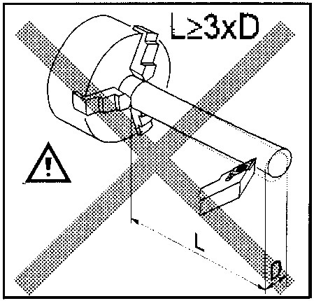
Figure 10-2: Workpiece too long
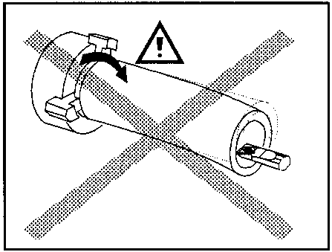
Figure 10-3: Workpiece too long
Avoid short clamping contact (A, Fig 10-4) or clamping on a minor diameter (B). Face locate workpiece for added support.
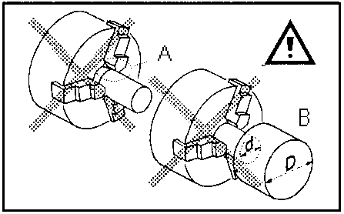
Figure 10-4: Poor clamping

10.3 Cutting Tool Setup
The cutting angle is correct when the cutting edge is in line with the centre axis of the work piece. Use the point of the tailstock centre as a gauge and shims under the tool to obtain the correct centre height (Fig 10-5).
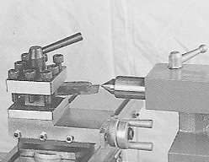
Figure 10-5: Cutting tool setup
Use a minimum of two screws to clamp the cutting tool.
Avoid large tool extensions.

10.4 Recommended spindle speeds
ATTENTION:
Generally speaking, the smaller the cut diameter, the greater the RPM required. Soft materials require higher speeds; hard metals slower speeds.
Metal is usually machined with coolant or cutting oil applied.
Recommended spindle speeds for cutting 10mm diameter, with HSS tools (High speed steel tools):
Plastic: 2000 /min
Aluminium: 2000 /min
Brass: 1000 /min
Cast iron: 1000 /min
Mild steel: 800 /min
High carbon steel: 600 /min
Stainless steel: 300 /min
For carbide tools (HM), 5 times higher speeds can be chosen.

For example:
Turning mild steel at a diameter of 20mm allows
With HSS tool 400 /min
With carbide tool. 2000 /min
10.5 Manual turning
Apron travel (AA, Fig 10-6), cross travel (BB) and top slide travel (DD) can be operated for longitudinal and cross feeding.
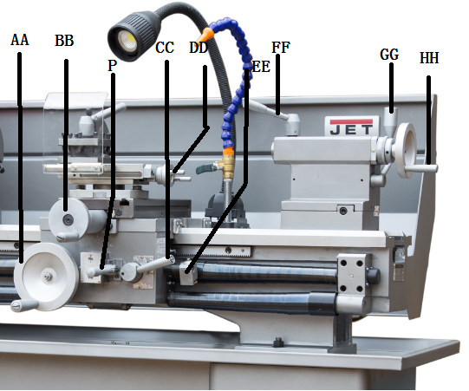
Figure 10-6: Machine controls
The correct feed depends on the material to be cut, the cutting operation, the type of tool, the rigidity of the work piece chucking, the depth of cut and the desired surface quality.

10.6 Turning with auto feed
Select “Feeding” mode on gear box (NN, Fig 9-1).
Select feed forward or reverse direction (S).
Start the auto feed with lever (P, Fig 10-7):
- For longitudinal feed, move lever right and up
- For cross feed, move lever left and down
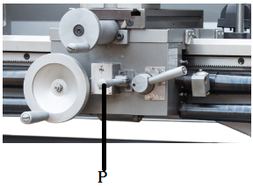
Figure 10-7: Auto feed
Three longitudinal and three cross feed rates are readily available by rotating the feed select knob (R, Fig 9-1).

Example for longitudinal turning:
Operation feed/rev feed select knob
Stock removal 0,34mm III
Finishing cut 0.17mm II
Micro finishing cut 0.085mm I
NOTE: Additional feed rates are available with different change gear setup (Fig 10-8).
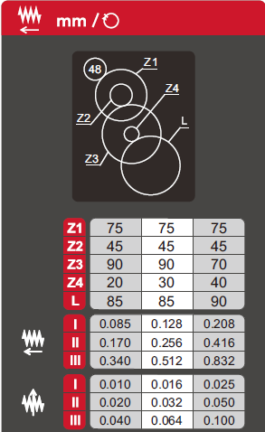
Figure 10-8: Available feed rates
The correct feed depends on the material to be cut, the cutting operation, the type of tool, the rigidity of the work piece chucking, the depth of cut and the desired surface quality.
When roughing big diameters reduce the depth of cut !

10.7 Thread cutting
Threading is performed in multiple passes with a threading tool.
Each depth of cut should be about 0,2mm and become less for the finishing passes.

A) Cut inch and metric threads:
Set the machine up for the desired threading pitch (see chapter 8.2).
Select the lowest possible spindle speed.
Engage the halve nut (CC, Fig 10-9).
NOTE: The halve nut must stay engaged during the entire threading process.
- Set the tool up for the threading pass.
- Start the motor.
- When the tool approaches the end of cut, stop the motor and at the same time back the tool out, so that it clears the thread diameter.
- Start the motor in reverse direction, let the cutting tool travel back to the starting point.
Repeat these steps until you have obtained the desired results.

B) Cut metric threads with threading dial
On most metric threads the threading dial (EE, Fig 10-9) can be used.
The halve nut can be opened at the end of cut, rather than the motor being stopped and reversed.
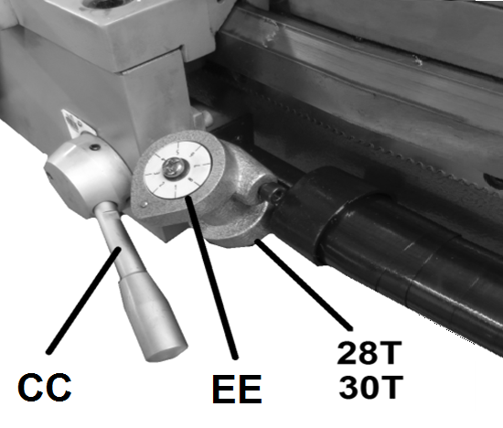
Figure 10-9: Threading Dial
Select threading dial gear 28T or 30T
The halve nut may only be engaged at the corresponding graduation match on the threading dial (Fig 10-10).

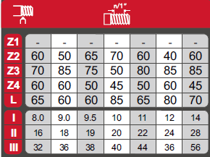
Figure 10-10: Threading dial setup
Note:
For thread pitches of 0,2/0,3/0,5/0,6/0,75/ 1,0/ 1,5/3 mm the half nut can be engaged at any point.
(lead screw pitch = 3 mm = can be divided by thread pitch).

10.8 Drilling operation
Use a drill chuck with MT3 arbor (option) to clamp centre drills and twisted drills in the tailstock (Fig 10-11)
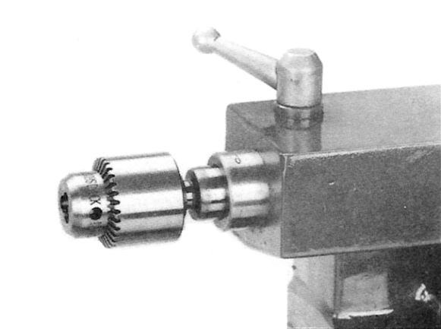
Figure 10-11: Drilling operation
For recommended speeds refer to section 10.4
To eject the drill chuck, fully retract the tailstock quill.

11.0 User-Maintenance
WARNING:
Before any intervention on the machine, disconnect it from electrical supply, pull the mains plug. Failure to comply may cause serious injury.
An important security factor is the cleaning of the machine, of bed, carriage and slides, of the floor and the surrounding places.
Loose objects could come into contact with the moving chuck or workpiece, creating hazards.
Empty the chip tray regularly.
Replace the coolant regularly, follow manufacturer’s advice.
Check that bolts are tight and electrical cords are in good condition. If an electrical cord is worn, cut, or damaged in any way, have it replaced immediately.

11.1 Lubrication
Spindle bearings are pre-lubricated and sealed, and require no further lubrication.
A) Weekly apply oil:
DIN 51502 CG ISO VG 68
(e.g. BP Maccurat 68, Castrol Magna BD 68, Mobil Vectra 2)
1…oil balls on change gear hubs
2…oil bed ways lightly
3…oil tailstock quill over entire length
4…oil lead screw on entire length
5…oil ball on lead screw bracket
6…oil balls on top slide
7…oil balls on tailstock
8...oil balls on carriage
9...oil balls on apron

B) Monthly apply grease:
DIN 51807-1 non slinging grease
(e.g. BP L2, Mobilgrease Special).
10…grease teeth of change gears
11…grease rack over entire length

Gear box oil:
DIN 51517-2 CL ISO VG 68
(e.g. BP Energol HLP 68, Mobil DTE Oil Heavy Medium)
Oil must be up to indicator mark in oil sight glass (L, Fig 11-1).
In case of need, fill up with oil by removing plug (M).

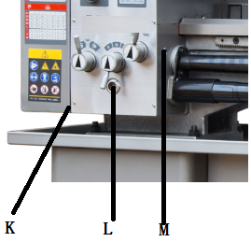
Figure 11-1: Gearbox oil fill-up
Change the oil in the gearbox every 1000 operating hours.
Drain oil by removing drain plug (K).

11.2 Readjustments
A) Bearing adjustment:
The main spindle taper roller bearings are adjusted at the factory.
If end play becomes evident after considerable use the bearings may be adjusted.
Loosen two hex socket cap screws (A, Fig 11-2). Tighten nut (B) until end play is taken up.
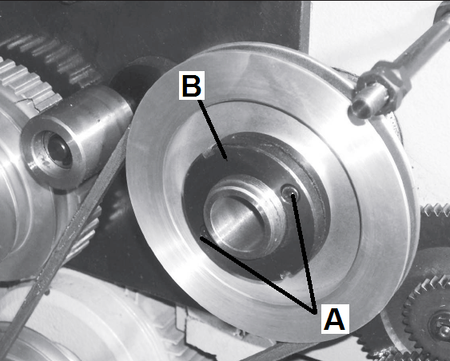
Figure 11-2: Bearing adjustment
Tighten nut carefully, the spindle should still revolve freely. Excessive preloading will damage the bearings.
Tighten the screws.

B) Cross slide and Top slide adjustment:
Each slide is fitted with a gib (C, Fig 11-3) and can be adjusted with screws (E) fitted with lock nuts (D).

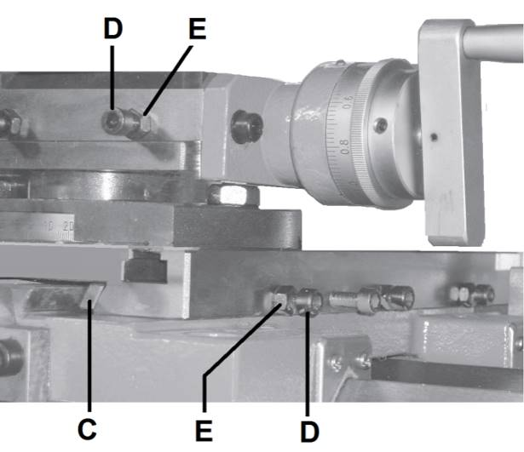
Figure 11-3: Slide adjustment
Adjust until slides move freely without play.

C) Cross slide spindle adjustment
Remove the top slide and adjust the grub screw (F, Fig 11-4) until the backlash between the spindle and the nut is eliminated.
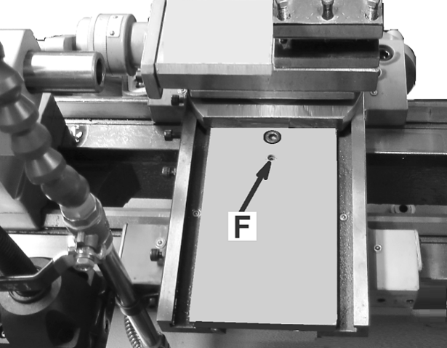
Figure 11-4: Cross slide spindle adjustment

12.0 Troubleshooting
Symptom | Possible Cause | Correction *
Lathe will not start. | Lathe unplugged from wall, or motor. | Check all plug connections.
 | Fuse blown, or circuit breaker tripped. | Replace fuse, or reset circuit breaker.
 | Cord damaged. | Replace cord.
 | Chuck guard not closed. | Close chuck guard.
 | Pulley cover removed | Install pulley cover
Lathe does not come up to speed. | Extension cord too light or too long. | Replace with adequate size and length cord.
 | Low current. | Contact a qualified electrician.
Lathe vibrates excessively. | Base on uneven surface. | Locate lathe on even floor.
 | Lathe not bolted to the floor | Bolt machine to the floor
 | Unbalanced workpiece | Reduce speed
 | Workpiece deflection | Improve chucking length or diameter, support on tailstock end
 | Tool deflection | Reduce tool length
 | Slide backlash | Adjust slides
 | Slides running dry | Lubricate with oil
 | Dull tool tip | Re-sharpen or change tool
 | Chip load too high | Reduce depth of cut or feed
Noisy operation | Dry change gear hubs. | Lubricate with oil.
 | Dry change gears | Lubricate with grease.
Tool tip burns | Cutting speed too high | Reduce spindle speed
 | Dull tool tip. | Re-sharpen or change tool
 | Dry cutting. | Use coolant.
 | Feeding too slowly. | Increase feed rate.
Machine turns a taper. | Tailstock alignment is offset. | Align tailstock position.
 | Machine bed is twisted. | Stand supporting surface must be flat. Shim if needed
 | Workpiece deflection. | Reduce depth of cut or feed
Drill chuck or arbor does not stay in place. | Dirt, grease, etc. on arbor, chuck, or tailstock quill | Clean all mating surfaces thoroughly with a cleaner-degreaser.
* WARNING: Some corrections may require a qualified electrician.
Table 1

13.0 Environmental Protection
Protect the environment.
Dispose all packaging material in an environmental friendly manner.
Dispose coolant in an environmentally friendly manner.
Your appliance contains valuable materials which can be recovered or recycled. Please leave it at a specialized institution.

14.0 Available Accessories
Refer to the JET price list.

15.0 Replacement Parts

BD-12G Assembly Breakdown -1

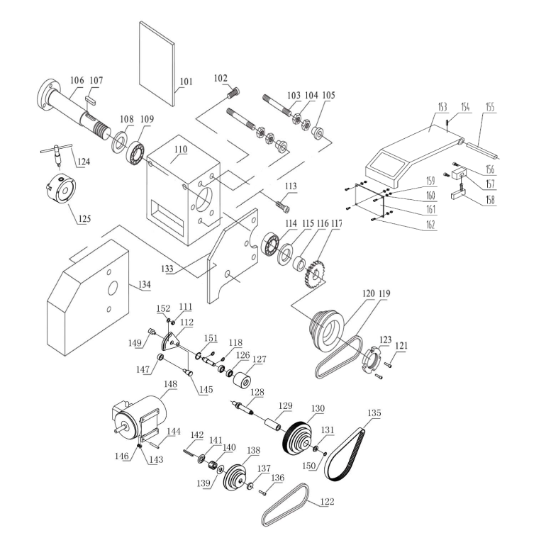
BD-12G Parts List for Breakdown -1

Index Part
No. No. Description Size Qty.

101 BD-12G-1-01 LABEL 1
102 BD-12G-1 SOCKET HD SCREW DIN912 Φ 4×10 6
103 BD-12G-1-03 BOLT 2
104 BD-12G-2 NUT DIN439-M10 4
105 BD-12G-3 KNURL NUT M10 2
106 BD-12G-1-06 SPINDLE 1
107 BD-12G-4 KEY DIN 6885-8×45 1
108 BD-12G-1-08 GASKET 1
109 TRB-30212 BEARING 30212 1
110 BD-12G-1-10 HEADSTOCK 1
111 BD-12G-5 HEXAGON NUT DIN439 - M8 1
112 BD-12G-1-12 ECCENTRIC DISK IDLER 1
113 BD-12G-6 SOCKET HD SCREW DIN912 M8×25 3
114 TRB-32211 BEARING 32211 1
115 BD-12G-1-15 GASKET 1
116 BD-12G-1-16 BUSH 1
117 BD-12G-1-17 GEAR 1
118 BD-12G-7 CIRCLIP DIN 471-12 x 1 2
119 BD-12G-1-19 GATES BELT O-889 1
120 BD-12G-1-20 SPINDLE PULLEY 1
121 BD-12G-8 SOCKET HD SCREW M5×12 2
122 BD-12G-1-22 GATES BELT O-710 1
123 BD-12G-1-23 NUT 1
124 BD-12G-1-24 CHUCK WRENCH 1
125 BD-12G-1-25 3-JAW CHUCK K11-160 1
126 BB-6001 BEARING 6001 2
127 BD-12G-1-27 IDLER 1
128 BD-12G-1-28 SHAFT 1
129 BD-12G-1-29 CASE 1
130 BD-12G-1-30 TOOTHED BELT DISK 1
131 BD-12G-9 DISK FOR TOOTHED BELT DISK 1
133 BD-12G-1-33 BRACKET PLATE 1
134 BD-12G-1-34 BELT COVER 1
135 BD-12G-1-35 TOOTHED BELT 255L075 1
136 BD-12G-10 SOCKET HEAD SCREW GB 70-85 - M6x25 1
137 BD-12G-11 FIXING DISC 1
138 BD-12G-1-38 MOTOR PULLEY 1
139 BD-12G-1-39 FLANGED WASHER IN FRONT 1
140 BD-12G-1-40 TOOTHED BELT DISK 1
141 BD-12G-1-41 FLANGED WASHER IN THE BACK 1
142 BD-12G-12 KEY DIN 6885-A6x6x50 1
143 BD-12G-13 WASHER DIN 125 - A8 1
144 BD-12G-1-144 SCREW 4
145 BD-12G-1-45 BOLT 1
146 BD-12G-15 HEX NUT ISO 4032 M8 4
147 BD-12G-1-47 SPACER 1
148 BD-12G-1-48 MOTOR 1.1KW 1
149 BD-12G-1-49 CLAMPING PIECE 1
150 BD-12G-16 CIRCLIP DIN 471 - 12x1 1
151 BD-12G-17 CIRCLIP DIN 471 - 28x1. 2 1
152 BD-12G-18 WASHER DIN 125 - A8 1
153 BD-12G-153 CHUCK GUARD 1
154 BD-12G-154 ROLL PIN 3 × 20 mm 1
155 BD-12G-155 SHAFT 1
156 BD-12G-156 SOCKET HD SCREW M5 × 12 mm 2
157 BD-12G-157 BRACKET 1
158 BD-12G-158 MICRO SWITCH 1
159 BD-12G-159 HEX NUT (THIN) M4 4
160 BD-12G-160 WASHER 4 4
161 BD-12G-161 ARCRYLIC GLASS 1
162 BD-12G-162 SOCKET HD SCREW M4 × 10 mm 4

BD-12G Assembly Breakdown -2

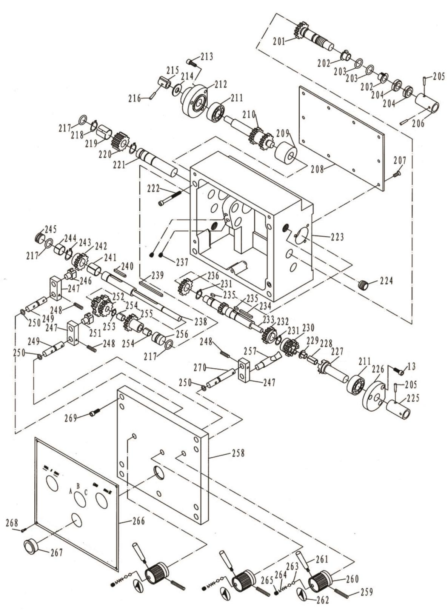

BD-12G Parts List for Breakdown -2

Index Part
No. No. Description Size Qty.

201 BD-12G-2-01 GEAR SHAFT 1
202 BD-12G-2-02 BEARING 16170 2
203 BD-12G-19 O-RING 18001400 2
204 BD-12G-2-04 NUT DIN 1804 M16×1.5 2
205 BD-12G-20 PIN DIN 1481 Φ3×22 2
206 BD-12G-2-06 COLLAR 1
207 BD-12G-21 SOCKET HD SCREW DIN912M5×8 10
208 BD-12G-2-08 COVER 1
209 BD-12G-2-09 COLLAR 1
210 BD-12G-2-10 GEAR SHAFT 1
211 BB-6202 BEARING 6202 2
212 BD-12G-2-12 LEFT PLUG 1
213 BD-12G-22 SOCKET HD SCREW DIN 912 M5X12 6
214 BD-12G-23 WASHER Φ10 1
215 BD-12G-2-15 KEY 1
216 BD-12G-24 PIN DIN 1481 Φ4×14 1
217 BD-12G-25 O-RING 18001500 3
218 BD-12G-26 SNAP RING Φ18 2
219 BD-12G-2-19 BEARING 1815 1
220 BD-12G-2-20 GEAR 1
221 BD-12G-2-21 SHAFT 1
222 BD-12G-27 SOCKET HD SCREW M6×50 4
223 BD-12G-2-23 GEARBOX 1
224 BD-12G-2-24 SET SCREW M16×1.5×12 2
225 BD-12G-2-25 COLLAR 1
226 BD-12G-2-26 RIGHT PLUG 1
227 BD-12G-2-27 SHAFT 1
228 BD-12G-2-28 BEARING 815 1
229 BD-12G-2-29 BEARING 8075 1
230 BD-12G-2-30 GEAR 1
231 BD-12G-28 SNAP RING Φ15 2
232 BD-12G-2-32 GEAR 1
233 BD-12G-2-33 SHAFT 1
234 BD-12G-29 KEY DIN 6885 4×25 1
235 BD-12G-30 KEY DIN 6885 4×8 2
236 BD-12G-2-36 GEAR 1
237 BD-12G-31 SET SCREW ISO4028-M6X10 2
238 BD-12G-2-38 SHAFT 1
239 BD-12G-32 KEY DIN 6885 4×50 1
240 BD-12G-33 KEY DIN 6885 4×20 1
241 BD-12G-2-41 BEARING 1615 1
242 BD-12G-2-42 GEAR 1
243 BD-12G-34 SNAP RING Φ16 1
244 BD-12G-2-44 BEARING 1610 1
245 BD-12G-35 LEFT PLUG 1
246 BD-12G-2-46 FORK 1
247 BD-12G-2-47 BRACKET 3
248 BD-12G-36 PIN DIN 1481 Φ3×20 3
249 BD-12G-2-49 SHAFT 2

BD-12G Parts List for Breakdown -2

Index Part
No. No. Description Size Qty.

250 BD-12G-37 O-RING 1800690 3
251 BD-12G-2-51 FORK 1
252 BD-12G-2-52 GEAR 1
253 BD-12G-38 SNAP RING Φ10 1
254 BD-12G-2-54 BEARING 1010 2
255 BD-12G-2-55 GEAR 1
256 BD-12G-2-56 RIGHT PLUG 1
257 BD-12G-2-57 DIALS BLOCK 1
258 BD-12G-2-58 GEARBOX COVER 1
259 BD-12G-39 PIN DIN 1481 Φ5×40 3
260 BD-12G-2-60 KNOB BASE 3
261 BD-12G-2-61 KONB 3
262 BD-12G-2-62 LABEL 3
263 BD-12G-40 BALL Φ5 6
264 BD-12G-2-64 SPRING 0.8×4×16 3
265 BD-12G-41 SOCKET HD SCREW DIN912 M6×12 3
266 BD-12G-2-66 LABEL 1
267 BD-12G-2-67 OIL SIGHT 1
268 BD-12G-42 SOCKET HD SCREW DIN912 M3×16 4
269 BD-12G-43 SOCKET HD SCREW DIN912 M5×16 5
270 BD-12G-2-70 SHAFT 1

BD-12G Assembly Breakdown -3

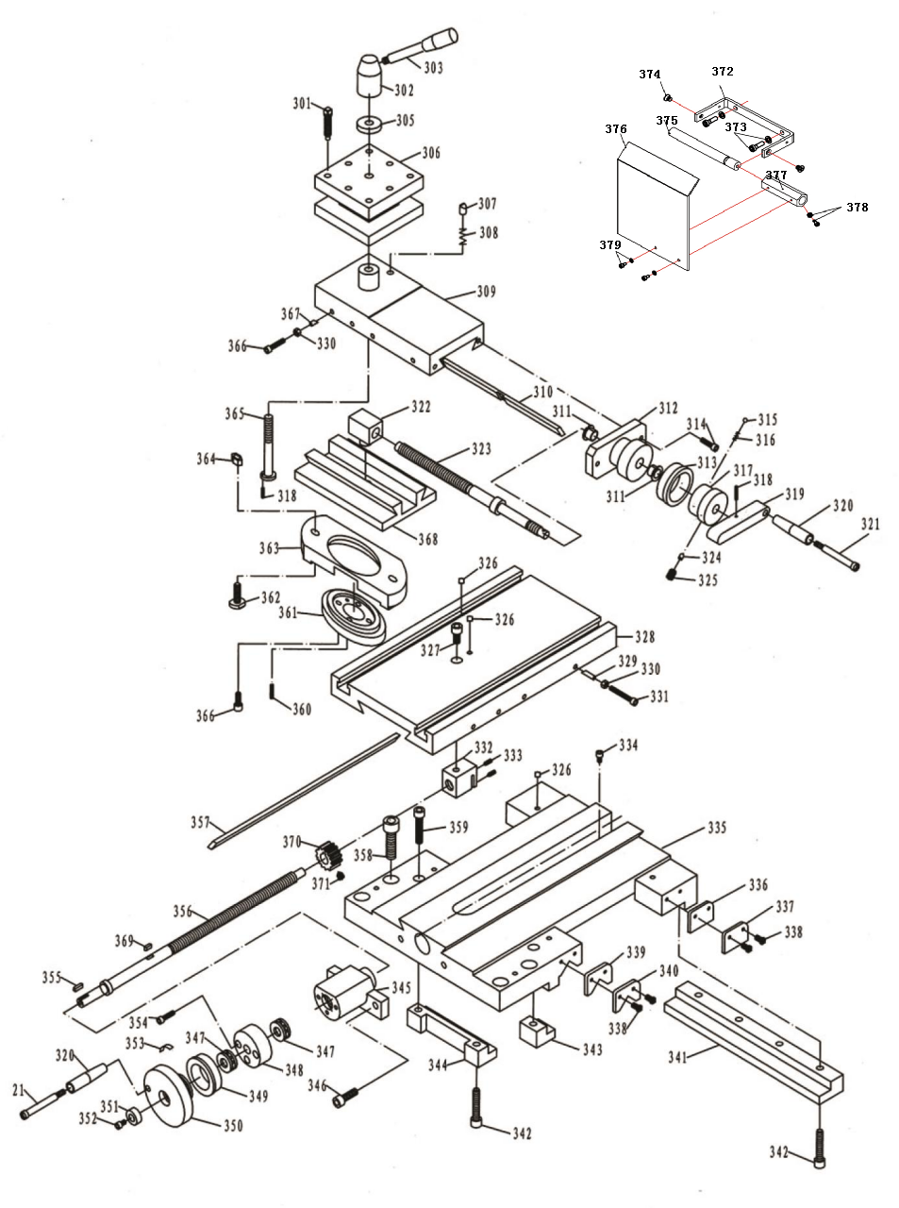

BD-12G Parts List for Breakdown -3

Index Part
No. No. Description Size Qty.

301 BD-12G-3-01 SCREW DIN912 M8×30 8
302 BD-12G-3-02 HANDLE BASE 1
303 BD-12G-3-03 HANDLE 1
305 BD-12G-3-05 WASHER 1
306 BD-12G-3-06 POST BASE 1
307 BD-12G-3-07 STOP 1
308 BD-12G-3-08 SPRING 7×0.8×11 1
309 BD-12G-3-09 TOP SLIDE 1
310 BD-12G-3-10 GIB 1
311 BD-12G-3-11 OILLESS BEARING 1210 2
312 BD-12G-3-12 HUB 1
313 BD-12G-3-13 INDEX RING 1
314 BD-12G-44 SOCKET HD SCREW DIN 912 M6×20 2
315 BD-12G-45 BALL Φ5 1
316 BD-12G-3-16 SPRING 1.5×0.5×6.5 1
317 BD-12G-3-17 INDEX BASE 1
318 BD-12G-46 PIN DIN 1481 Φ3×16 2
319 BD-12G-3-19 LEVER 1
320 BD-12G-3-20 LEVER 2
321 BD-12G-3-21 LEVER SHAFT 2
322 BD-12G-3-22 BLOCK 1
323 BD-12G-3-23 SCREW 1
324 BD-12G-47 PLUG 3
325 BD-12G-48 SET SCREW DIN912 M6×10 3
326 BD-12G-49 OIL BALL Φ6 7
327 BD-12G-50 SOCKET HD SCREW DIN 912 M8×10 1
328 BD-12G-3-28 CROSS SLIDE 1
329 BD-12G-51 PULG 4
330 BD-12G-52 HEX NUT DIN439 M6 8
331 BD-12G-53 SOCKET HD SCREW DIN 912 M6×30 4
332 BD-12G-3-32 BLOCK 1
333 BD-12G-54 SOCKET HD SCREW DIN912 M4×8 2
334 BD-12G-55 SOCKET HD SCREW DIN 912 M5×6 1
335 BD-12G-3-35 SADDLE 1
336 BD-12G-3-36 WIPER 2
337 BD-12G-3-37 PLATE 2
338 BD-12G-56 SOCKET HD SCREW DIN 912 M4×18 8
339 BD-12G-3-39 WIPER 2
340 BD-12G-3-40 PLATE 2
341 BD-12G-3-41 STRIP 1
342 BD-12G-57 SOCKET HD SCREW DIN 912 M8×30 4
343 BD-12G-3-43 STRIP 1
344 BD-12G-3-44 STRIP 1
345 BD-12G-3-45 BRACKET 1
346 BD-12G-58 SOCKET HD SCREW DIN 912 M5×20 3
347 TBB-51101 BEARING 51101 2
348 BD-12G-3-48 COLLAR 1
349 BD-12G-3-49 INDEX RING 1

BD-12G Parts List for Breakdown -3

Index Part
No. No. Description Size Qty.

350 BD-12G-3-50 HANDWHEEL 1
351 BD-12G-3-51 WASHER 1
352 BD-12G-59 SOCKET HD SCREW DIN 912 M5×10 1
353 BD-12G-3-53 SPRING 1
354 BD-12G-60 SOCKET HD SCREW DIN 912 M5×20 3
355 BD-12G-3-55 KEY DIN 6885 4X8 1
356 BD-12G-3-56 IEADSCREW 1
357 BD-12G-3-57 GIB 1
358 BD-12G-61 SOCKET HD SCREW DIN 912 M12×30 2
359 BD-12G-62 SOCKET HD SCREW DIN 912 M8×40 2
360 BD-12G-63 PIN DIN 1481 Φ4×20 1
361 BD-12G-3-61 GRADUATED COLLAR 1
362 BD-12G-3-62 T-BOLT M10×30 2
363 BD-12G-3-63 CLAMPING RING 1
364 BD-12G-64 NUT DIN439 M10 2
365 BD-12G-3-65 BOLT 1
366 BD-12G-65 SOCKET HD SCREW DIN 912 M6×16 8
367 BD-12G-66 PLUG 4
368 BD-12G-3-68 SWIVEL BASE 1
369 BD-12G-67 KEY DIN 6885 4×10 1
370 BD-12G-3-70 GEAR 1
371 BD-12G-68 SOCKET HD SCREW DIN 912 M5×16 1
372 BD12G-372 SUPPORT 1
373 BD12G-373 SOCKET HD SCREW M5 × 12 mm 2
374 BD12G-374 CROSS RECESSED FLAT HD SCREW M5 × 6 mm 2
375 BD12G-375 SHAFT 1
376 BD12G-376 CHIP SHIELD 1
377 BD12G-377 HEX SLEEVE 1
378 BD12G-378 SOCKET HD SCREW M3 × 8 mm 1
379 BD12G-379 SOCKET HD SCREW M3 × 6 mm 2

BD-12G Assembly Breakdown -4

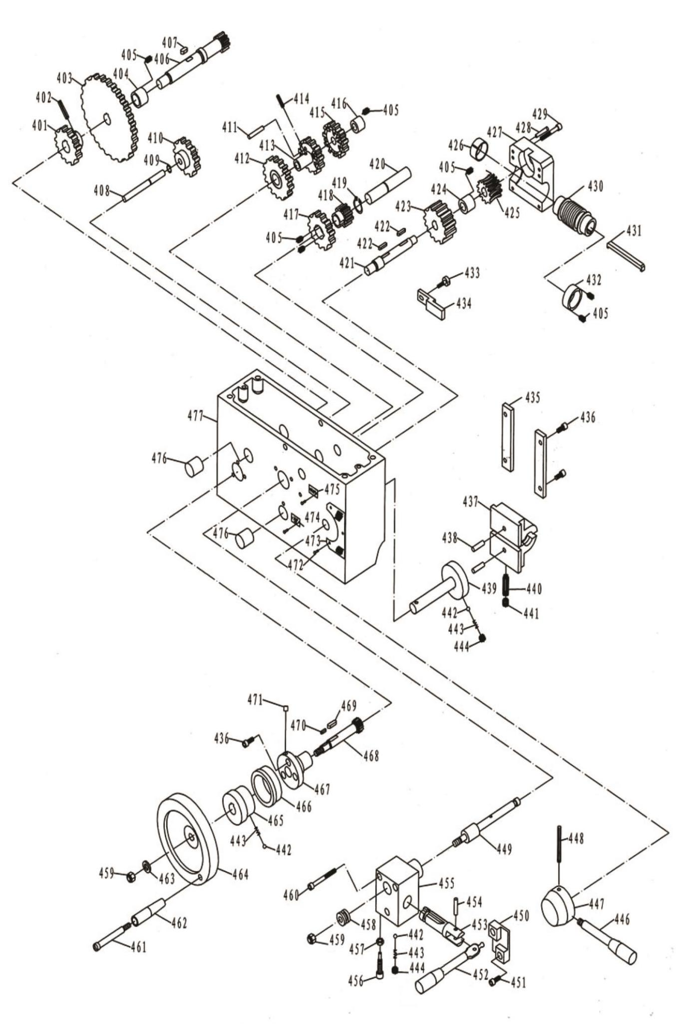

BD-12G Parts List for Breakdown -4

Index Part
No. No. Description Size Qty.

401 BD-12G-4-01 GEAR 1
402 BD-12G-69 PIN DIN 1481 Φ 5×24 1
403 BD-12G-4-03 GEAR 1
404 BD-12G-4-04 WASHER 1
405 BD-12G-70 SOCKET HD SCREW DIN912 M4×8 7
406 BD-12G-4-06 GEAR SHAFT 1
407 BD-12G-71 KEY DIN 6885 4X8 1
408 BD-12G-4-08 SHAFT 1
409 BD-12G-72 SNAP RING DIN 127 Φ 8 1
410 BD-12G-4-10 GEAR 1
411 BD-12G-4-11 SHAFT 3
412 BD-12G-4-12 GEAR 1
413 BD-12G-4-13 GEAR 1
414 BD-12G-73 PIN DIN 1481 Φ 4×16 1
415 BD-12G-4-15 GEAR 1
416 BD-12G-4-16 WASHER 1
417 BD-12G-4-17 GEAR 1
418 BD-12G-4-18 GEAR 1
419 BD-12G-74 SNAP RING DIN 127-Φ 15 1
420 BD-12G-4-20 SHAFT 1
421 BD-12G-4-21 SHAFT 1
422 BD-12G-75 KEY DIN 6885-5×14 2
423 BD-12G-4-23 GEAR 1
424 BD-12G-4-24 WASHER 1
425 BD-12G-4-25 WORM 1
426 BD-12G-4-26 BEARING 2501 1
427 BD-12G-4-27 WORM BASE 1
428 BD-12G-76 PIN DIN 1481-Φ 4×20 2
429 BD-12G-77 SOCKET HD SCREW DIN 912-M4×30 4
430 BD-12G-4-30 WORM 1
431 BD-12G-78 KEY 1
432 BD-12G-4-32 WASHER 1
433 BD-12G-4-33 SET SCREW DIN 912-M4×8 2
434 BD-12G-4-34 PLATE 1
435 BD-12G-4-35 PLATE 2
436 BD-12G-79 SOCKET HD SCREW DIN 912-M5×12 7
437 BD-12G-4-37 HALF NUT 1
438 BD-12G-80 PIN DIN 1481-Φ 6×18 2
439 BD-12G-4-39 CAM SHAFT 1
440 BD-12G-81 SOCKET HD SCREW DIN 912-M6×20 1
441 BD-12G-82 SOCKET HD SCREW DIN 912-M6×8 1
442 BD-12G-83 BALL Φ 5 3
443 BD-12G-4-43 SPRING 0.7×4×10 3
444 BD-12G-84 SOCKET HD SCREW DIN912-M6×6 2
446 BD-12G-4-46 HANDLE 1
447 BD-12G-4-47 HANDLE BASE 1
448 BD-12G-85 PIN DIN 1481-Φ5×45 1
449 BD-12G-4-49 SHAFT 1

BD-12G Parts List for Breakdown -4

Index Part
No. No. Description Size Qty.

450 BD-12G-4-50 BASE 1
451 BD-12G-86 SOCKET HD SCREW DIN 912-M5×10 6
452 BD-12G-4-52 SHAFT HANDLE 1
453 BD-12G-4-53 SHAFT FORX 1
454 BD-12G-87 PIN DIN 1481-Φ5×20 1
455 BD-12G-4-55 BASE 1
456 BD-12G-88 SOCKET HD SCREW DIN912-M6X20 1
457 BD-12G-89 NUT DIN439-M6 1
458 BD-12G-4-58 SHIFT LEVER 1
459 BD-12G-90 NUT DIN439-M8 2
460 BD-12G-91 SOCKET HD SCREW DIN 912-M5×35 2
461 BD-12G-4-61 SHAFT HANDLE 1
462 BD-12G-4-62 KNOB 1
463 BD-12G-92 WASHER DIN6340-Φ 8 1
464 BD-12G-4-64 HANDWHEEL 1
465 BD-12G-4-65 SHAFT 1
466 BD-12G-4-66 GRADUATED COLLAR 1
467 BD-12G-4-67 BRACKET 1
468 BD-12G-4-68 SHAFT 1
469 BD-12G-93 KEY DIN 6885-5×14 1
470 BD-12G-94 KEY DIN 6885-3×10 1
471 BD-12G-95 OIL BALL Φ 6 1
472 BD-12G-96 RIVET Φ 2×6 3
473 BD-12G-4-73 PLATE 1
474 BD-12G-4-74 PLATE 1
475 BD-12G-4-75 PLATE 1
476 BD-12G-4-76 COLLAR 1
477 BD-12G-4-77 APRON 1

BD-12G Assembly Breakdown -5

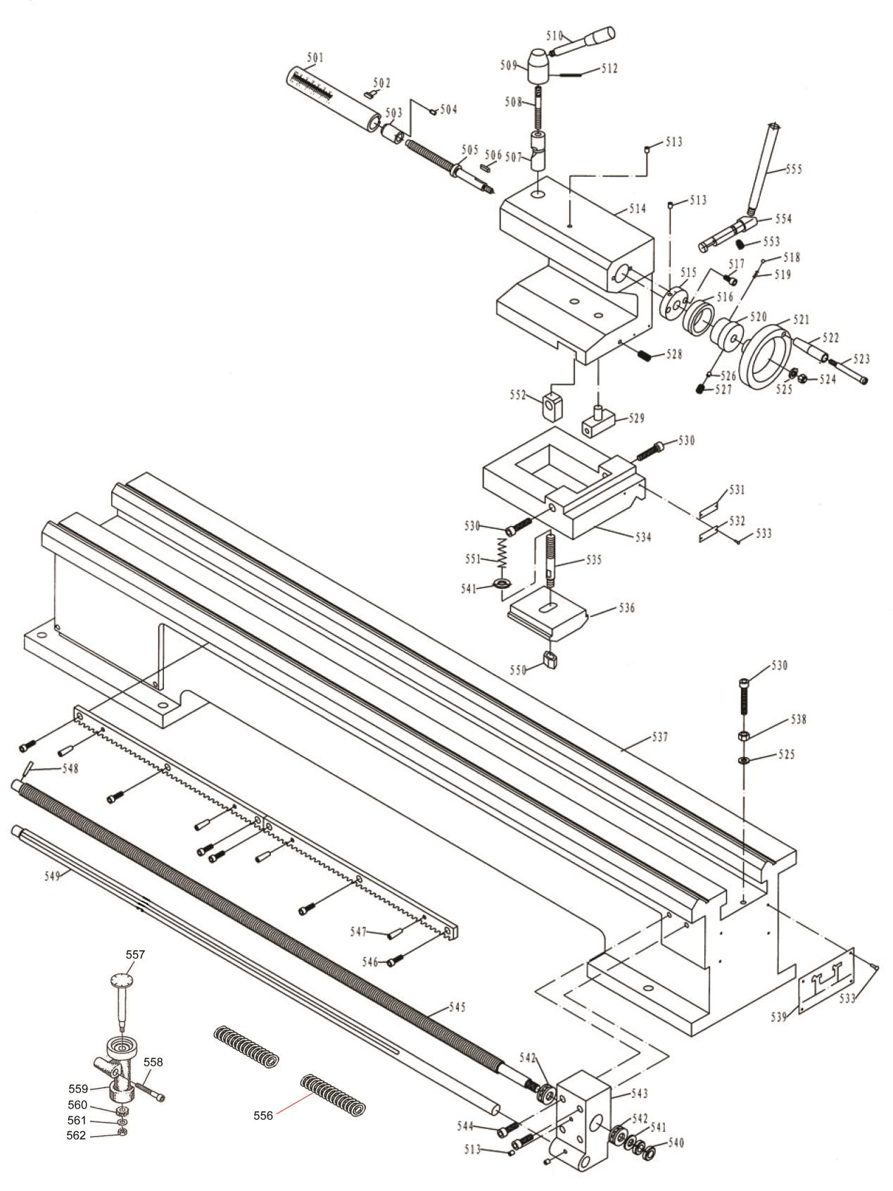

BD-12G Parts List for Breakdown -5

Index Part
No. No. Description Size Qty.

501 BD-12G-5-01 QUILL 1
502 BD-12G-97 KEY 1
503 BD-12G-5-03 NUT 1
504 BD-12G-98 SOCKET HD SCREW DIN912-M6×10 1
505 BD-12G-5-05 SCREW 1
506 BD-12G-99 KEY DIN 6885-4×10 1
507 BD-12G-5-07 PIVOT BLOCK 1
508 BD-12G-5-08 SCREW 1
509 BD-12G-5-09 HANDLE BASE 1
510 BD-12G-5-10 HANDLE 1
512 BD-12G-100 PIN DIN 1481-Φ3×30 1
513 BD-12G-101 OIL BALL Φ6 4
514 BD-12G-5-14 TAILSTOCK BODY 1
515 BD-12G-5-15 FLANGE COVER 1
516 BD-12G-5-16 INDEX RING 1
517 BD-12G-102 SOCKET HD SCREW DIN 912-M6×10 2
518 BD-12G-103 BALL Φ4 1
519 BD-12G-5-19 SPRING Φ4×1×6 1
520 BD-12G-5-20 SLEEVE 1
521 BD-12G-5-21 HANDWHEEL 1
522 BD-12G-5-22 KONB 1
523 BD-12G-5-23 SCREW 1
524 BD-12G-104 NUT DIN439-M8 1
525 BD-12G-105 WASHER DIN6340-Φ8 6
526 BD-12G-5-26 BRAKE BLOCK 1
527 BD-12G-106 SOCKET HD SCREW DIN 912-M6×10 1
528 BD-12G-107 SOCKET HD SCREW DIN 912-M6×16 1
529 BD-12G-5-29 SET SCREW 1
530 BD-12G-108 SOCKET HD SCREW DIN 912-M8×40 3
531 BD-12G-5-31 PLATE 1
532 BD-12G-5-32 PLATE 1
533 BD-12G-109 RIVET Φ 2×6 8
534 BD-12G-5-34 BASE 1
535 BD-12G-5-35 BOLT 1
536 BD-12G-5-36 CLAMPING PLATE 1
537 BD-12G-5-37 BED 1
538 BD-12G-110 NUT DIN439-M8 5
539 BD-12G-5-39 PLATE 1
540 BD-12G-111 NUT DIN1804-M12×1.25 2
541 BD-12G-112 WASHER DIN6340-Φ 12 2
542 TBB-51102 BEARING 51102 2
543 BD-12G-5-43 BRACKET 1
544 BD-12G-113 SOCKET HD SCREW DIN 912-M8×20 2
545 BD-12G-5-45 FEED SHAFT 1
546 BD-12G-114 SOCKET HD SCREW DIN 912-M6×15 6
547 BD-12G-115 PIN DIN 1481-Φ6×22 4
548 BD-12G-116 PIN DIN 1481-Φ4×22 1
549 BD-12G-5-49 SHAFT 1
550 BD-12G-117 NUT DIN439-M12 1
551 BD-12G-5-51 SPRING Φ13×1×62 1
552 BD-12G-5-52 BRAKE BLOCK 1
553 BD-12G-118 SOCKET HD SCREW DIN912-M6×10 1
554 BD-12G-5-54 SHAFT 1
555 BD-12G-5-55 HANDLE 1
556 lead screw protective 65Mn …….…………………………...2
557 shaft 45 ………………………………….1
558 Hexagon socket Screw M6×70 GB7085 1
559 Disorderly buckle plate holder HT200 1
560 Gear ………………………………………………………………………….45……………………………..1
561 WASHER 8 ………………………………………………………………………….GB5287…………………….1
562 HEX NUT M8 ………………………………………………………………………….GB6170 …………………….1

BD-12G Assembly Breakdown -6

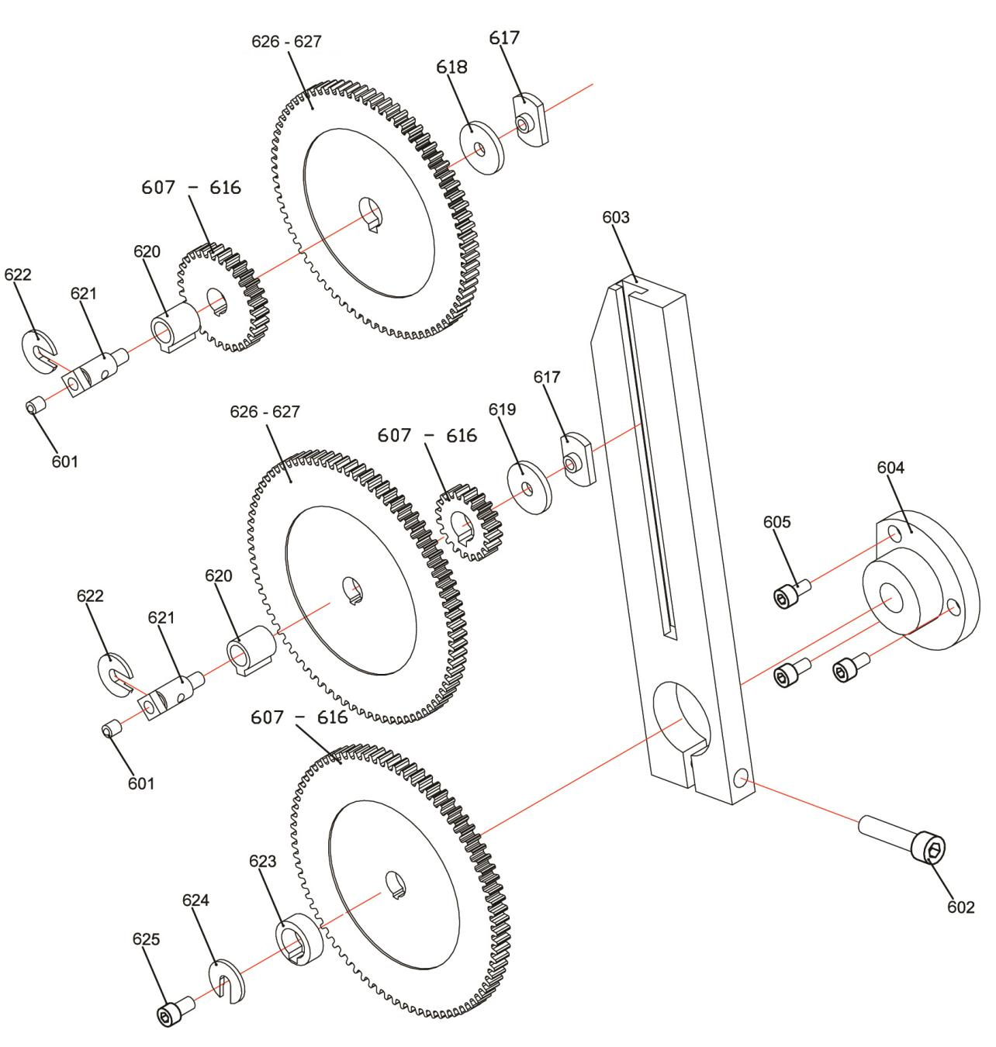

BD-12G Parts List for Breakdown -6

Index Part
No. No. Description Size Qty.

601 BD-12G-119 BALL OILER Φ6 2
602 BD-12G-120 SOCKET HD SCREW M8 × 35 mm 1
603 BD-12G-6-03 RAIL 1
604 BD-12G-6-04 BRACKET 1
605 BD-12G-121 SOCKET HD SCREW M5 × 10 mm 3
607 BD-12G-6-07 GEAR 85 1
608 BD-12G-6-08 GEAR 80 1
609 BD-12G-6-09 GEAR 75 1
610 BD-12G-6-10 GEAR 70 1
611 BD-12G-6-11 GEAR 65 1
612 BD-12G-6-12 GEAR 60 2
613 BD-12G-6-13 GEAR 50 1
614 BD-12G-6-14 GEAR 45 1
615 BD-12G-6-15 GEAR 30 1
616 BD-12G-6-16 GEAR 20 1
617 BD-12G-6-17 T-NUT M5 2
618 BD-12G-6-18 SPACER 1.5 mm 1
619 BD-12G-6-19 SPACER 3 mm 1
620 BD-12G-6-20 KEY SLEEVE 2
621 BD-12G-6-21 THREADED SHAFT 2
622 BD-12G-6-22 C-WASHER 2
623 BD-12G-6-23 COLLAR 1
624 BD-12G-6-24 C-WASHER 1
625 BD-12G-6-25 SOCKET HD SCREW M6 × 10 mm 1
626 BD-12G-6-26 GEAR 90 1
627 BD-12G-6-27 GEAR 40 1

BD-12G Parts List for Breakdown -7

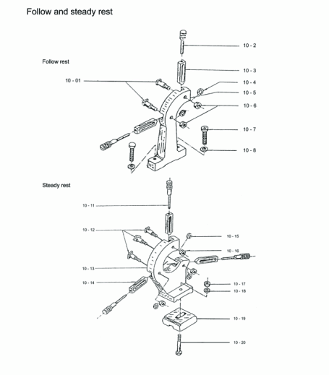
Index Part
No. No. Description Size Qty.

10-01 BD-12G-10-01 Screw 2
10-02 BD-12G-10-02 Tightening screw 2
10-03 BD-12G-10-03 Slide jaw 2
10-04 BD-12G-10-04 Lock washer 10 2
10-05 BD-12G-10-05 Rest frame 1
10-06 BD-12G-10-06 Nut M10 2
10-07 BD-12G-10-07 Screw M8X30 2
10-08 BD-12G-10-08 Washer 8 2
10-09 BD-12G-10-11 Slide jaw 3
10-10 BD-12G-10-12 Screw 1
10-11 BD-12G-10-13 Rest frame 3
10-12 BD-12G-10-14 Slide jaw 3
10-13 BD-12G-10-15 lock washer 10 3
10-14 BD-12G-10-16 NUT M10 3
10-15 BD-12G-10-17 NUT M12 1
10-16 BD-12G-10-18 Washer 12 1
10-17 BD-12G-10-19 clamping claw 1
10-18 BD-12G-10-20 screw M12x70 1

BD-12G Parts List for Breakdown -8

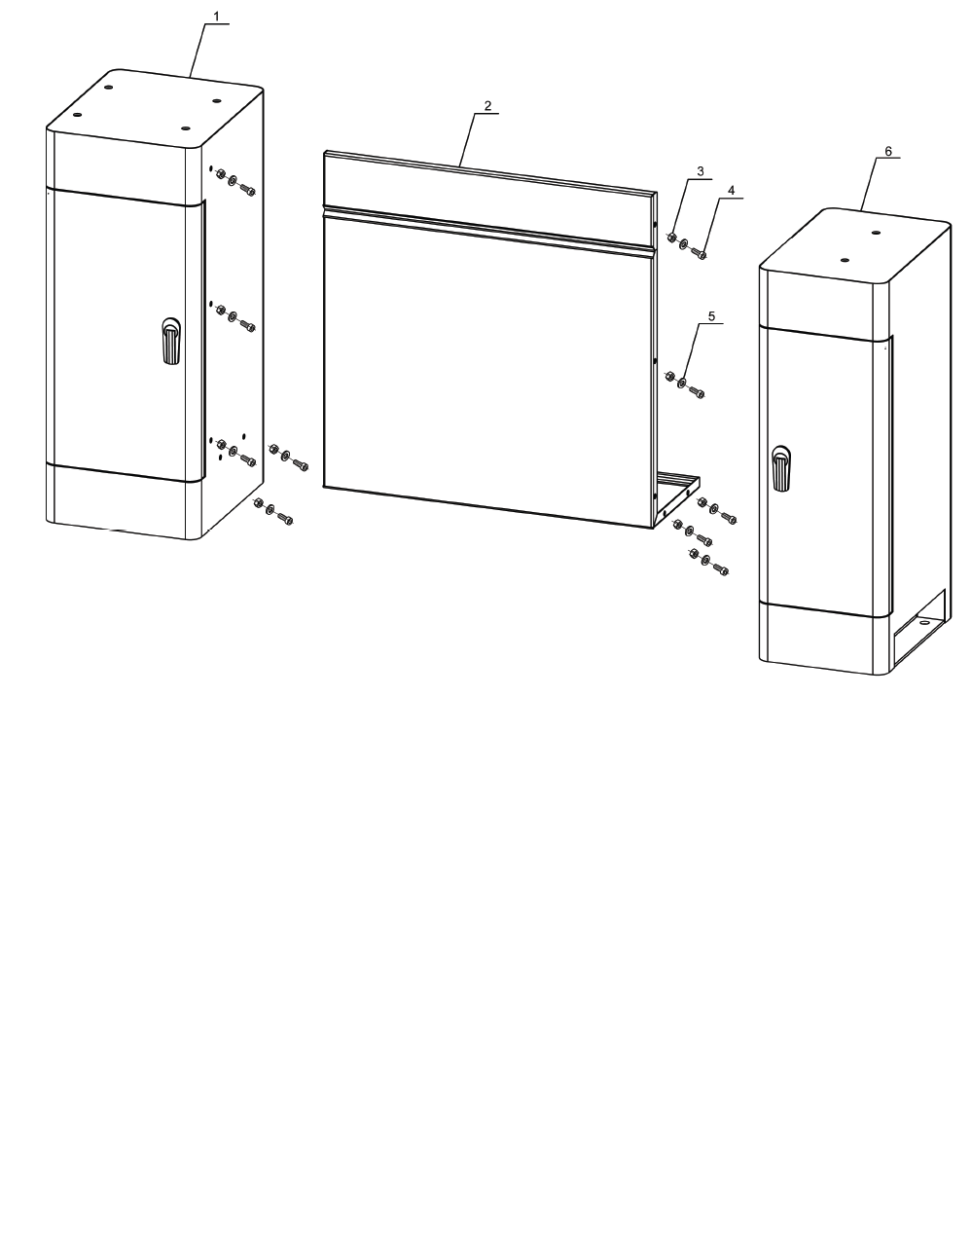
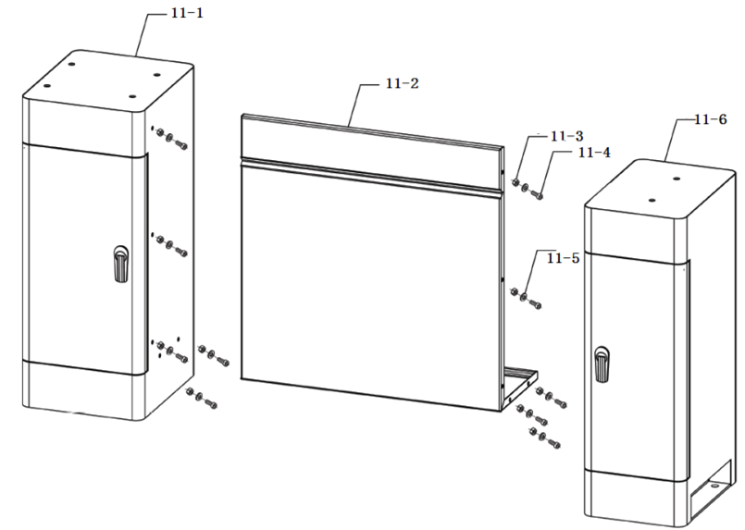
Index Part
No. No. Description Size Qty.

11-1 BD-12G-11-1 Left stand 1
11-2 BD-12G-11-2 Connection plate 1
11-3 BD-12G-11-3 HEX NUT GB617086-M8 10
11-4 BD-12G-11-4 SOCKET HD SCREW GB7085-M8X16 10
11-5 BD-12G-11-5 WASHER GB5287-8 10
11-6 BD-12G-11-6 Right stand 1

BD-12VS Parts List for Breakdown -9

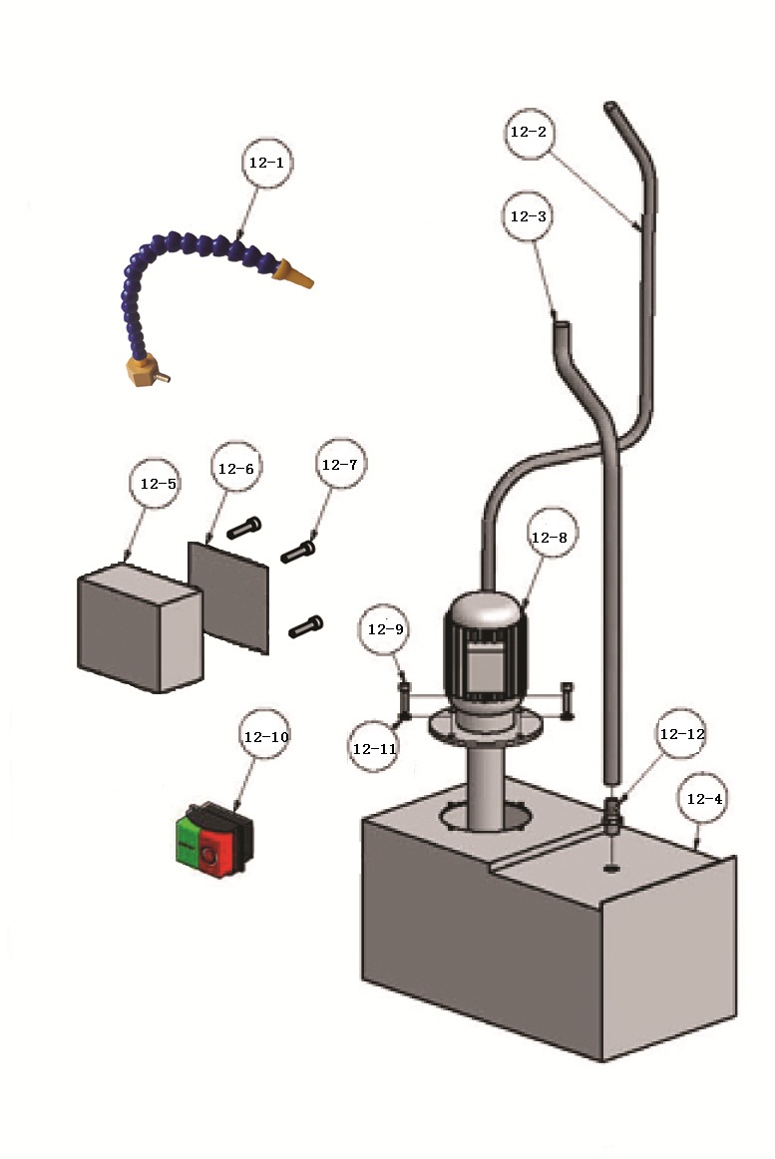
Index Part
No. No. Description Size Qty.

12-1 BD-12VS-12-1 nzzle ……………………………………1
12-2 BD-12VS-12-2 outlet pipe 10 1
12-3 BD-12VS-12-3 return pipe 25 1
12-4 BD-12VS-12-4 water tank 1
12-5 BD-12VS-12-5 electrical box 1
12-6 BD-12VS-12-6 electrical box cover 1
12-7 BD-12VS-12-7 socket HD screw GB7085-M5X30 4
12-8 BD-12VS-12-8 cooling pump 1
12-9 BD-12VS-12-9 socket HD screw GB7085-M5X12 4
12-10 BD-12VS-12-10 switch KJD17B 1
12-11 BD-12VS-12-11 washer GB5287-5 4
12-12 BD-12VS-12-12 hose clip 1

16.0 Wiring Diagrams

BD-12G ……………….1~230V, PE, 50Hz

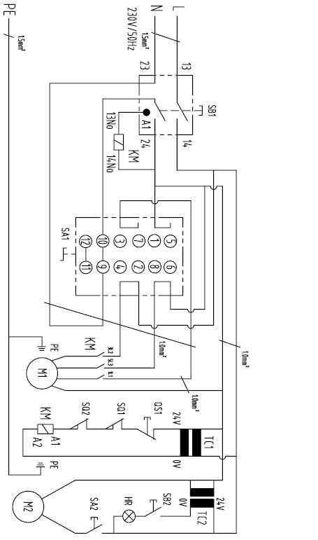

BD-12G Electrical Parts List

ITEM | DESCRIPTION | TYPE | SPECIFICATION | Qty. | Note
SB1 | Magnetic Contactor | KJD17GF | IP-55 AC-1 18A Ue250V  AC-3 15A CE | 1
SA1 | Fwd/0/Rev - Switch | ZH-A | Ue 250V IEN 12A 5E4  CE | 1
KM | Contactor | LC1K0910 | UI 690V IEN 20A  CE | 1
TC1 | Transformer | 230V/24V/20VA | 20VA 230VAC  CE | 1
TC2 | Transformer | 230V-24V/20VA | 20VA 230VAC  CE | 1 | Optional
QS1 | Emergency stop | LAY5 | AE-15 240V IEN 10A  CE | 1
SQ1 | Gear Guard Switch | QKS8 | AC-15 14A 250V IP54  CE | 1
SQ2 | Chuck Guard Switch | LXW5-11Q1 | AC-15 3A IP62 Ue380V  CE | 1
SB2 | Light Switch | KCD1-101 | 6A AC250V CE | 1 | Optional
HR | Work light | 24V | 5W AC12-24V  CE | 1 | Optional
SA2 | Pump Switch | LAY5-BE101 | Ue220V IEN3.3A AC-15 CE | 1 | Optional
M1 | Main Motor | YLJ90L4-12A | 1.1Kw AC230V 6.4A IP54  CE | 1
M2 | Pump | DB-12A | 40W AV230V 0.9A IP54  CE | 1 | Optional

