

|  |  |
| --- | --- |
| **IDTP-16**  **IDTP-22** | **Industrial Drilling Tapping Machine** |
| **GB**  **Operating Instructions** |  |

**JPW (Tool) AG**

Tämperlistrasse 5

CH-8117 Fällanden

Switzerland

Phone +41 (0) 44 806 47 48

Fax +41 (0) 44 806 47 58

[www.jettools.com](http://www.jettools.com)

M-50000985T_50000990T 2017-07

**CE‐Conformity Declaration   
CE‐Konformitätserklärung   
Déclaration de Conformité CE**

Product / Produkt / Produit:

Drill Press

Bohrmaschine

Perceuse

IDTP-16/IDTP-22

**Brand / Marke / Marque:**

**JET**

**Manufacturer / Hersteller / Fabricant:**

JPW (Tool) AG, Tämperlistrasse 5, CH‐8117 Fällanden

Schweiz / Suisse / Switzerland

We hereby declare that this product complies with the regulations

Wir erklären hiermit, dass dieses Produkt der folgenden Richtlinie entspricht

Par la présente, nous déclarons que ce produit correspond aux directives suivantes

2006/42/EC

Machinery Directive

Maschinenrichtlinie

Directive Machines

2014/30/EU

electromagnetic compatibility

elektromagnetische Verträglichkeit

compatibilité électromagnétique

designed in consideration of the standards

und entsprechend folgender zusätzlicher Normen entwickelt wurde

et été développé dans le respect des normes complémentaires suivantes

EN ISO 12100:2010

**EN 60204-1:2006+A1:2009+AC:2010,**

**EN 61000-6-4:2007+A1:2011, EN 61000-6-2:2005,**

**EN 61029-1:2009/A11:2010,**

**EN 55014-1:2006/A2:2011, EN 55014-2:1997/A2:2008,**

EN 61000-3-2:2014, EN 61000-3-11:2000

Responsible for the Documentation / Dokumentations‐Verantwortung / Résponsabilité de Documentation:

Hansjörg Meier

Head Product‐Mgmt. / Leiter Produkt‐Mgmt. / Resp. Gestion des Produits

JPW (Tool) AG



2016‐05‐24 Alain Schmid, General Manager

JPW (Tool) AG, Tämperlistrasse 5, CH‐8117 Fällanden

Schweiz / Suisse / Switzerland

**GB - English**

Operating Instruction

Dear Customer,

Many thanks for the confidence you have shown in us with the purchase of your new JET-machine. This manual has been prepared for the owner and operators of IDTP-16/IDTP-22 Industrial Drilling Tapping Machine to promote safety during installation, operation and maintenance procedures. Please read and understand the information contained in these operating instructions and the accompanying documents. To obtain maximum life and efficiency from your machine, and to use the machine safely, read this manual thoroughly and follow instructions carefully.

Declaration of conformity

On our own responsibility we hereby declare that this product complies with the regulations* listed on page 1. Designed in consideration with the standards **.

JPW Group Warranty

JPW (Tool) AG guarantees that the supplied product(s) is/are free from material defects and manufacturing faults.

This warranty does not cover any defects which are caused, either directly or indirectly, by incorrect use, carelessness, damage due to accidents, repairs or inadequate maintenance or cleaning as well as normal wear and tear.

Further details on warranty (e.g. warranty period) can be found in the General Terms and Conditions (GTC) that are an integral part of the contract.

These GTC may be viewed on the website of your dealer or sent to you upon request.

JPW (Tool) AG reserves the right to make changes to the product and accessories at any time.

**Table of Contents**

**Section Page**

**Table of Contents** 3

**Warnings** 4

**Machinery General Safety Warnings** 4

**Safety Instructions for Drill Presses** 5

**1. General Specifications** 6

**2. Product Features and Terminology** 7

**3. Getting to Know Your Machine** 8

3.1 Control Panel 8

3.2 The Machine Head 8

3.3 The Work Table 8

**4. Transporting the Machine** 9

**5. Machine Installation** 9

5.1 Install the machine 9

5.2 Positioning the Machine 9

5.3 Anchoring the Machine 9

5.4 Minimum Requirement for Housing the Machine 10

5.5 Assembling Loose Parts 10

5.6 Electrical Connection of the Machine 10

**6. Machine Operation** 10

6.1 Control Panel 10

6.2 Depth Indicator 10

6.3 Operation Cycle 10

**7. Machine Adjustment** 11

7.1 Adjusting the table & Rack Height 11

7.2 Adjusting the Headstock Height 12

7.3 Speed adjustment 12

7.4 Radial Head Position Adjustment 12

7.5 Tool Installation and Uninstallation 12

7.6 The Spindle Shield 13

**8. Operating Precautions** 14

**9. Maintenance** 14

Lubrication and Routine Maintenance 14

**10. Troubleshooting** 16

10.1 Electric 16

10.2 General Trouble Shooting 17

**11. Exploded View & Parts List** 17

11.1 IDTP-16 Assembly Breakdown 18

IDTP-16 Parts List for Breakdown 19

11.2 IDTP-22 Assembly Breakdown 21

IDTP-22 Parts List for Breakdown 22

11.3 IDTP-16/22 ACCESSORIES Parts List 25

**12. Wire Diagram** 26 **13. Electrical Parts List** 27

**Warnings**

- Misuse of this machine can cause serious injury.

- For safety, machine must be set up, used and serviced properly.

- Read, understand and follow instructions in the Operating Instructions and Parts Manual which was shipped with your machine.

When setting up machine:

- Always avoid using machine in damp or poorly lighted work areas.

- Always be sure the machine support is securely anchored to the floor or the work bench.

When using machine:

- Always wear safety glasses with side shields

- Never wear loose clothing or jewelry.

- Never overreach—you may slip and fall.

When servicing machine:

- Always disconnect the machine from its electrical supply while servicing.

- Always follow instructions in Operating Instructions and Parts Manual when changing accessory tools or parts.

- Never modify the machine without consulting PROMAC.

**You—the stationary power tool user—hold the key to safety.**

Read and follow these simple rules for best results and full benefits from your machine. Used properly, PROMAC machinery is among the best in design and safety. However, any machine used improperly can be rendered inefficient and unsafe. It is absolutely mandatory that those who use our products be properly trained in how to use them correctly. They should read and understand the Operating Instructions and Parts Manual as well as all labels affixed to the machine. Failure in following all of these warnings can cause serious injuries.

**Machinery General Safety Warnings**

1. Always wear protective eye wear when operating machinery. Eye wear shall be impact resistant, protective safety glasses with side shields which comply with ANSI Z87.1 specifications. Use of eye wear which does not comply with ANSI Z87.1 specifications could result in severe injury from breakage of eye protection.

2. Wear proper apparel. No loose clothing or jewelry which can get caught in moving parts. Rubber soled footwear is recommended for best footing.

3. Do not overreach. Failure to maintain proper working position can cause you to fall into the machine or cause your clothing to get caught, pulling you into the machine.

4. Keep guards in place and in proper working order. Do not operate the machine with guards removed.

5. Avoid dangerous working environments. Do not use stationary machine tools in wet or damp locations. Keep work areas clean and well lit.

6. Avoid accidental starts by being sure the start switch is "OFF" before plugging in the machine.

7. Never leave the machine running while unattended. Machine shall be shut off whenever it is not in operation.

8. Disconnect electrical power before servicing. Whenever changing accessories or general maintenance is done on the machine, electrical power to the machine must be disconnected before work is done.

9. Maintain all machine tools with care. Follow all maintenance instructions for lubricating and the changing of accessories. No attempt shall be made to modify or have makeshift repairs done to the machine. This not only voids the warranty but also renders the machine unsafe.

10. Machinery must be anchored to the floor.

11. Secure work. Use clamps or a vise to hold work, when practical. It is safer than using your hands and it frees both hands to operate the machine.

12. Never brush away chips while the machine is in operation.

13. Keep work area clean. Cluttered areas invite accidents.

14. Remove adjusting keys and wrenches before turning machine on.

15. Use the right tool. Don't force a tool or attachment to do a job for which it was not designed.

16. Use only recommended accessories and follow manufacturer's instructions pertaining to them.

17. Keep hands in sight and clear of all moving parts and cutting surfaces.

18. All visitors should be kept at a safe distance from the work area. Make workshop completely safe by using padlocks, master switches, or by removing starter keys.

19. Know the tool you are using — its application, limitations, and potential hazards.

Familiarize yourself with the following safety notices used in this manual:

This means that if precautions are not heeded, it may result in minor injury and/or possible machine damage.

**CAUTION**

This means that if precautions are not heeded, it may result in serious or even fatal injury.

**WARNING**

**Safety Instructions for Drill Presses**

1. All work shall be secured using either clamps or a vise to the drill press table. It is unsafe to use your hands to hold any workpiece being drilled.

2. Drill press head and table shall be securely locked to the column before operating the drill press. This must always be checked prior to starting the machine.

3. Always use the correct tooling. Tooling shall always be maintained and properly sharpened. All tooling must be run at the proper speeds and feeds as they apply to the job. Use only recommended accessories and follow those manufacturer's instructions pertaining to them. Tooling shall not be forced in to any work piece but fed according to the proper specifications. Failure to follow these instructions will not only ruin the tooling as well as the machine, but can cause serious injury.

4. Never brush away any chips while the machine is in operation. All clean up should be done when the machine is stopped.

5. Keep hands in sight. Do not put hands or fingers around, on, or below any rotating cutting tools. Leather safety gloves should be used when handling any sharp objects or cutting tools. See Figure A.

6. Always wear protective eye wear when operating, servicing or adjusting machinery. Eyewear shall be impact resistant, protective safety glasses with side shields. Figure B.

7. When drilling in material which causes dust, a dust mask shall be worn. See Figure C.

8. Avoid contact with coolant, especially guarding the eyes.

9. Non-slip footwear and safety shoes are recommended. See Figure D.

10. Wear ear protectors (plugs or muffs) during extended periods of operation. See Figure E.



**1. General Specifications**

|  |  |  |
| --- | --- | --- |
|  | IDTP-16 | IDTP-22 |
| Drilling Capacity Mild Steel | 16mm | 32mm |
| Drilling Capacity Mild Steel | M12 | M14 |
| Chuck Size | Keytype B16 1-16mm | Keytype B16 1-16mm |
| Spindle Travel | 98mm | 134mm |
| Distance chuck to Base | 500mm | 1100mm |
| Distance Chuck to Table (max) | 255mm | 760mm |
| Table Size Diameter | 246×278mm | 380mm×416mm |
| Table Travel | 224mm | 760mm |
| Table Tilt | ± 45 ° | n/a |
| Work Table Weight Capacity | 60kg | 60kg |
| Head Travel | 345mm | n/a |
| Spindle Taper | MT-2 | MT-3 |
| Column Diameter/ Material | Ø70mm / Cast Iron | Ø93mm / Steel Tube |
| Number of Spindle Speeds | 5 | 5 |
| Pulleys Material | Cast Iron | Cast Iron |
| Range of Spindle Speeds | 200-2350 RPM | 200-2250 RPM |
| Base Size | 340mm×520mm | 440mm×648mm |
| Base Work Area | 258mm ×275mm | 350mm×357mm |
| Table / Base Material | Cast Iron | Cast Iron |
| Head Stock Material | Cast Iron | Cast Iron |
| Spindle Distance to Column | 203mm | 246mm |
| Net Weight | 91kg | 230kg |
| Machine Overall Dimension | 690mm L×410mm W×1040mm H | 740mm L × 460mm W × 1030mm H |

**2. Product Features and Terminology**

Work Table

Column

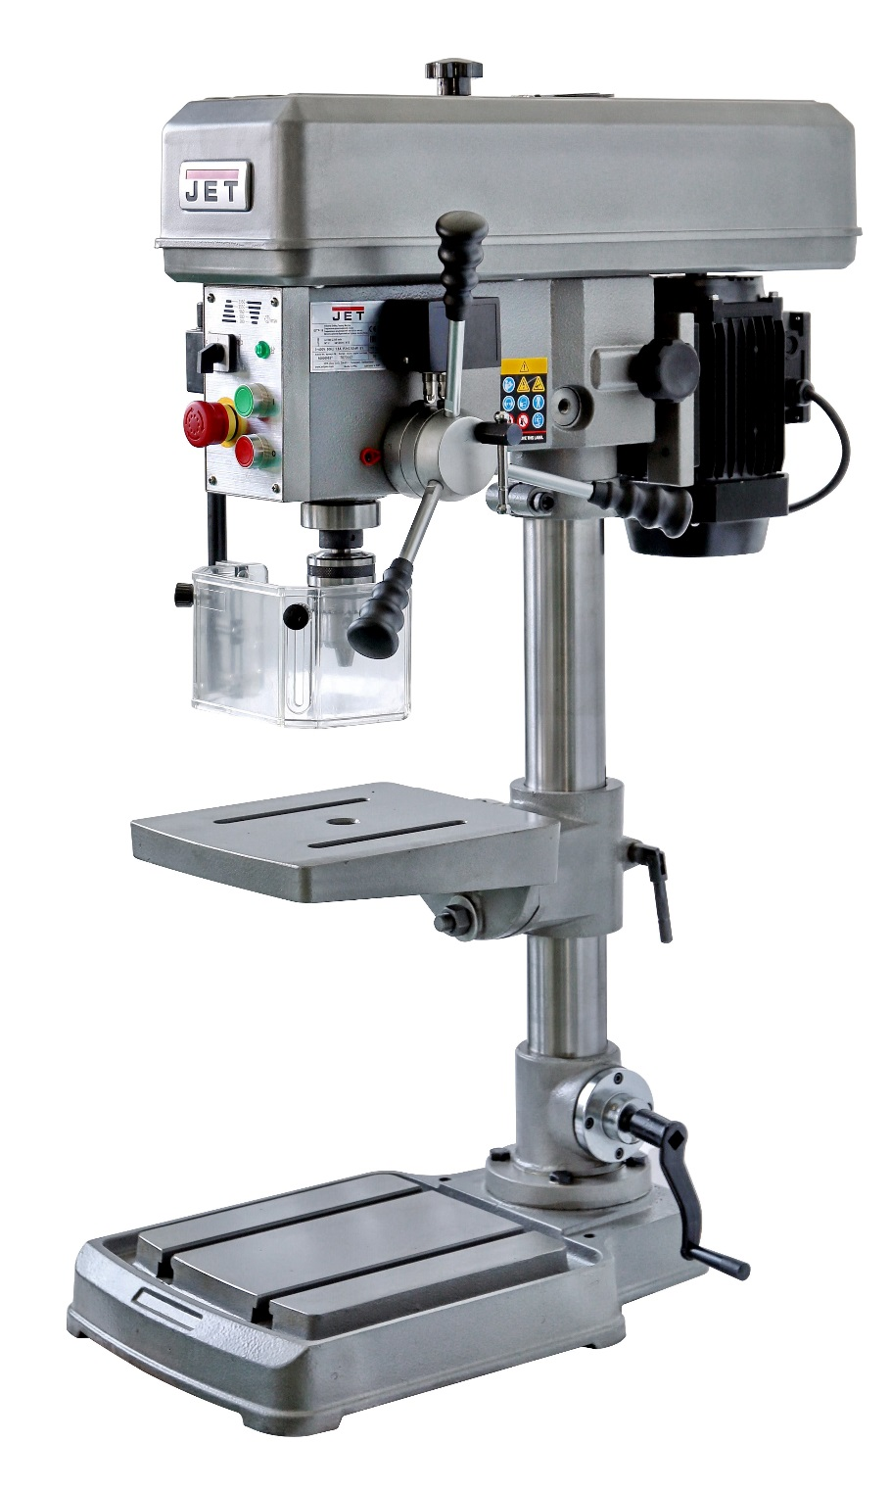

Pulley Cover

Mounting slots

Column Lock Handle

Control Panel

Main Motor

Quill feed levers

Slide Bar Knob

Safety guard

Crank Handle

Base

**3. Getting to know your Machine**

This machine is equipped with drilling and tapping functions. The machine's structure is rigid and is driven by a well-sized V-belt, which in turn generates powerful spindle rotation. Controlled by inverter, it is run with a variable speed range for easy and safe speed adjustment. In terms of material, the entire machine body including the base, table and column are made by high-strength casting iron for higher durability.

This manual contains procedures for both speed control versions. The manual provides separate instructions when differences in operation and maintenance exist.

**3.1. Control Panel**

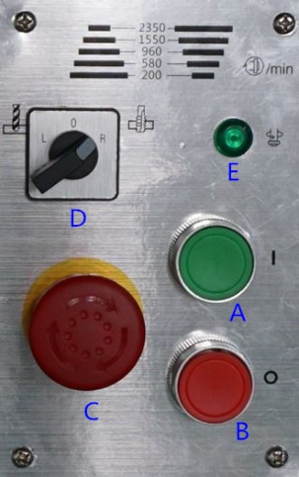

A. Power ON Switch

B. Power OFF Switch

C. Emergency Stop Switch

D. Drilling/Tapping Selector

E. Indicating lamp of Spindle Reversing



After daily use, disconnect machine from power source or press emergency stop switch to shut off the power completely. Do not keep the machine connected over 24 hours, it may cause damage to the machine.

**3.2. The Machine Head**

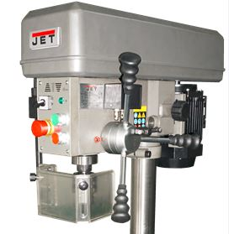

The machine head is fixed to the column. It allows more intensity in work piece machinery.

**3.3. The Work Table**

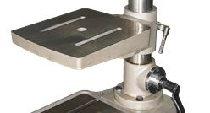

The work table can be positioned at varying heights, and it is T-slotted to allow the use of M12 T-nuts. Please limit the maximum weight of the work piece to 60 kg.

Overloading the table may affect the accuracy of the table.

By the help of lock nut and tilting scale on the table bracket, user can freely rotate both work table. It allows more flexibilities in work piece machinery at different angle.

Note: Only the work table of IDTP-16 has tilting function.

**4. Transporting the Machine**

The machine will be delivered in a closed crate.

For transport use a forklift or hoist. Make sure the machine does not tip or fall off during transport.

Danger of tipping due to high gravity center!

During handling, the machine shall be lifted only in vertical direction.

Please refer to instruction manual in specification and machine weight to arrange handling manner. Be sure to use capable fork - lifter or hoist to lift of machine. The handling and transportation shall be carried out by qualified persons. Fork - lift or hoist can be used in handling and shall be operated by qualified driver.

Before handling, make sure all movable parts are secured in their position and all movable accessories should be removed from machine. The steel rope should average pull the machine head, table and column tightly.

Keep all the processes in a carefully and slightly condition. Bump or crash are strictly prohibited. It will cause precision shift and electronic controller damaged.

**5. Machine Installation**

**5.1. Install the Machine**

Owing the machine is heavy, please use crane to pull it out from the carton box

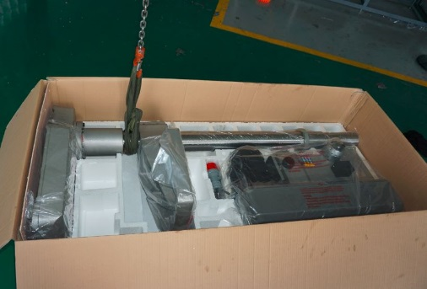

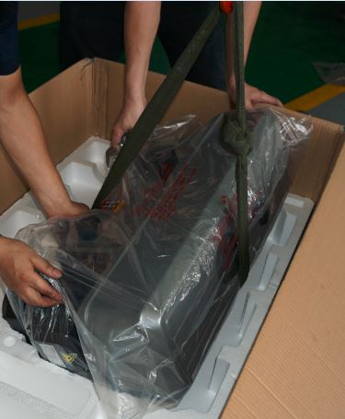

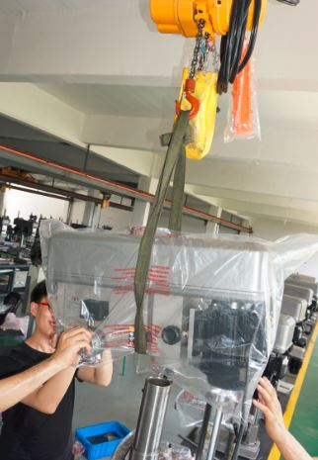

**5.2. Positioning the Machine**

I. The head and the worktable of the machine can be rotated 360°, so choose a location with enough space and solid foundation.

II. Clean all rust protected surfaces with a mild solvent e.g. petroleum.

**5.3. Anchoring the Machine**

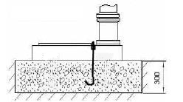

Assure the sufficient load capacity and proper condition of your lifting devices.

I. Position the machine on a firm and level concrete floor.

II. A minimum distance of 800mm towards a rear wall must be kept (for access to the electrical box).

III. Anchor the machine to the ground, as shown in the diagram, using screws and expansion plugs or sunken tie rods that connect through holes in the base.

**5.3. Minimum Requirement for Housing the Machine**

Please comply with the following terms to maximize the life and performance of the machine and its components.

The Main voltage and frequency complying with the requirements for the machine's motor.

Environment temperature from -10°C to +50°C.

Relative humidity not over 90%.

**5.4. Assembling Loose Parts**

Attach Riser handle to the necessary crankshaft, and use Hex-wrench to tighten/loosen the machine head lock nut.

**5.5. Electrical Connection of the Machine**

Make sure whether the voltage 400V matches the requirement for the machine, prior to connection to power supply. If the machine cannot be operated after wires have been connected, please check the following items:

I. Is the Emergency switch released?

II. Is the door of the electrical cabinet is properly closed and switched ON (locked) position?

III. Is the safety guard in the proper position (closed)?

**6. Machine Operation**

**6.1. Control Panel**

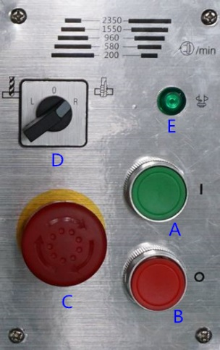

A. Power ON Switch: Starts the motor.

B. Power OFF Switch: Stops the motor. As the power still exists, pressing ON restarts the machine.

C. Emergency Stop Switch: Stops the machine. Turn the switch clockwise to unlock the switch before starting the machine.

D. Drilling/Tapping Selector: Selects the mode of operation

E. Indicating lamp of Spindle Reversing: light on when spindle reversing.

**6.2. Depth Indicator**

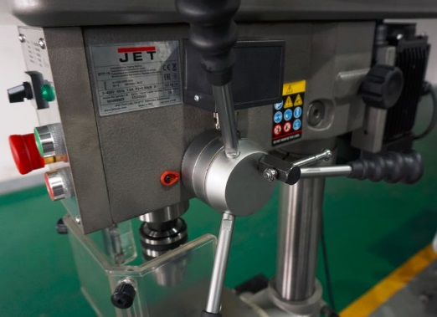

A drilling depth indicator is provided on the side of the drill head. The lock knob is provided at the side, on the top of quill lever.

Before starting the motor:

I. Set the depth to zero by lowering and holding the cutting tools to the surface of the work piece. Use quill lever to lower the spindle.

II. Unlock the depth scale by turning the lock knob.

III. Set the depth stop by rotating the depth stop stud to the desired depth.

IV. Lock the depth scale by turning the lock knob.

**6.3. Operation Cycle**

Safety chuck guard must be in position, electric box must be closed and locked, and unlock emergency stop switch (C) by turning the red cap of the switch clockwise to start machine. In a critical condition, stop machine by hitting emergency stop switch or Power OFF switch (B) to stop machine.

1. Check if the head is secured.

Failure to secure the head can result in damage of the machine and personal injury.

2. Secure the work piece to the table.



3. Use crankshaft to adjust the table to the desired height.



4. Use lock-lever to secure the table.

5. Use the spindle/quill feed lever to bring the drill or tapping tip down to the surface of the work piece and hold.

6. Set the depth indicator/stop to required depth.

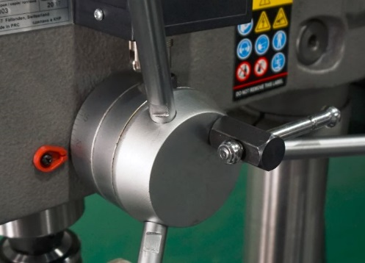

7. Back the drill or tapping tip off the work piece a bit.

8. Select drilling or tapping mode.

9. Press Power ON switch to begin spindle rotation.

**In Drilling Mode**

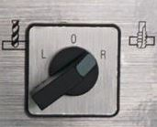

10. Use the depth handle to bring the tip of the drill bit to the surface of the work piece hold.

11. The required depth is set by previous steps 5 and 6.

12. Select proper speed.

13. Begin drilling by using the quill feed lever.

**In Tapping Mode**



In general, speeds for tapping require low speed which is lower than 200 min-1.

14. Use the depth handle to bring the tip of the tapping bit to the surface of the work piece and hold.

15. The required depth is set by previous steps 5 and 6.

16. Select the spindle speed.

17. Begin tapping by using the quill feed levers.

18. At the end of a tapping or drilling operation, press the stop button switch to turn off the machine.

Note: While tapping, pause spindle down feed at the bottom of operation to allow the breaking and reversal of rotation of the spindle.

In general, use low speeds for tapping. Tapping at high speed will tap more quickly,

But there is a danger of damage to work piece and tool. Tapping requires an accurate setting for the depth stop to allow the machine to switch tapping direction and the removal of the tapping bit.

**7. Machine Adjustment**

**7.1. Adjusting the table & Rack Height**

The table can be raised, lowered, and tilted with desired angles to accommodate the work piece.

To raise or lower the table, loosen the lever-locks behind the table bracket, then use the hand crank to move the table to the desired height. Then lock the table in position.

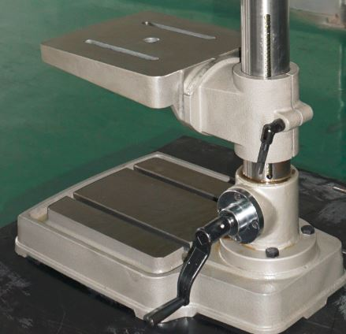

Note: Only the work table of IDTP-16 has tilting function.

To tilt the table, loosen the nut first to adjust the table to desired angle, then lock the table in position.

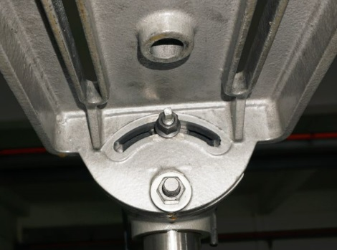

**7.2. Adjusting the Headstock Height**

Note: Only IDTP-16 has headstock height adjusting function.

1. Cut off the power before this operation.
2. Open the pulley cover.
3. If the machinery object is out of loading ability of work table, it can be set on the base. Then adjust the headstock height along the column to make sure the working range of machinery be proper.

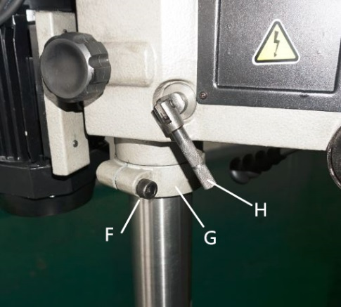

1. Please make sure the handle (H) is tightened.
2. Loose the tightening bolt (F) first, and adjust the retaining ring (G) to preferred height, then go tighten the bolt again.
3. Carefully loose the handle (H) to let the headstock slowly come down to be against the retaining ring, then tightened the handle (H) again.
4. If the headstock need to be at higher position, please carefully lift it up because the severe heaviness after loosing the locking handle (H). And make sure the retaining ring (G) be settled to be aginst the headstock properly.

**7.3. Speed adjustment**

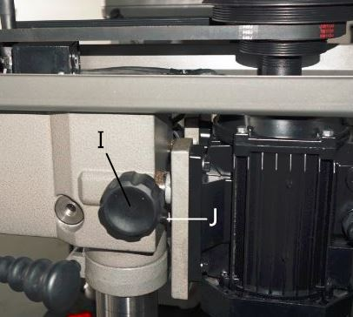

1. Cut off the power before this operation.
2. Open the pulley cover.
3. Loosen “I” and “J” to free the motor.
4. Change the belts location according the speed chart.
5. Manually push/pull out the motor along the motor rods then thread the bolts (J) to be against the motor bracket letting the belt be tensioned.

Note: Belt tension should be loose enough to allow 5-10mm movement when pushing the belt from the side.



1. Put back the pulley cover then thread the fastening bolt.

**7.4. Radial Head Position Adjustment**

Change the radial position of the drill head only if the drill press base is secured to the floor. Swinging the drill head without the base being secured to the floor will cause the drill press to become unstable and tip over resulting in injury and/or damage to the machine.

**7.5. Tool installation and Uninstallation**

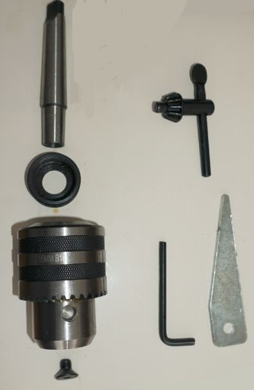

1. Clean the drill chuck, arbor and spindle taper thoroughly before installation. Any insufficient cleaning on mating surfaces may cause drill loosen as operating and unsafe conditions.
2. Place a thin wood plank on the worktable to protect the surface of the worktable and chuck drill. Draw back the chuck nose into chuck body and slightly hit the arbor onto the chuck by rubber hammer.





1. Place a thin wood plank on the worktable to protect the surface of the worktable and chuck drill. Draw back the chuck nose into chuck body and slightly hit the arbor onto the chuck by rubber hammer.



1. Slide the assembled drill chuck and arbor into spindle taper, and slightly hit them by rubber hammer to fit in.



1. Sequentially tighten”K” and ”L”



1. Lower the spindle about 100 mm.
2. Place the drift key into the aperture of the quill and tap the end of the drift key with a hammer until the bit or chuck arbor falls down.

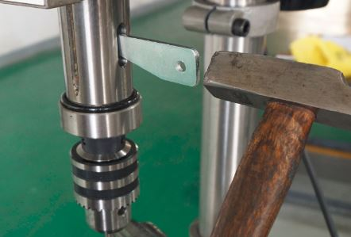

**7.6. The Spindle Shield**

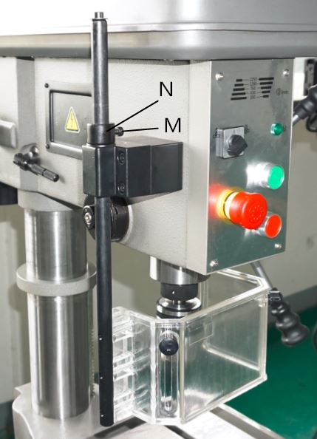

This clear plastic shield should be use whenever conducting a drilling or tapping operation. Clean the safety guard periodically to provide a clear view of the work piece. Adjustments can be done as follows.

1. Adjust the internal cover shield to have better range protection.
2. If both internal and external shields cannot provide enough protection, loosen locking bolt (M) to shift setting ring (N) in proper position.

Note: make sure the bolt (M) aligning to the groove (aimed by the arrow), otherwise the power-off switch would not be triggered when the shields being opened.

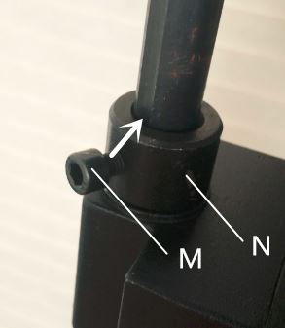

**8. Operating Precautions**

The following operating and safety precautions must be observed in order to avoid harm to the operator or damage to the drill press.

1. Make sure the power voltage is for the machine. Before connecting the plug to socket, it is necessary to check the power spec. to avoid any damage occurring.

2. If the machine is not used for a long time, the plug should be disconnected.

3. Never put the power cable near the fire or water environment, to break or press the power cable is not allowed.

4. The head assembly must be locked to the column so the thrust produced by drilling will not force the head assembly up the column.

5. The work table must be locked to the column so it will not be forced down the column.

6. Before drilling, release the quill lock nut to permit free travel of the quill.

7. Be sure the belt is tightened to the proper tension.

8. DO NOT start to drill the work piece until making certain the work piece is held down securely.

9. Make sure the power being off when changing the belt for shifting speed.

10. Point of operation protection is required for maximum safety. This remains the responsibility of the user/purchaser since conditions differ between jobs.

11. Make sure the drill is secured in the spindle or chuck before attempting to use the drill press.

12. Make sure the spindle taper is clean and free of burrs, scoring, and galling to assure maximum gripping.

13. Lock the quill in position when using any side-loaded tool.

**9. Maintenance**

**Lubrication and Routine Maintenance**

Apply oils to the driving parts of the machine prior to operation and supply coolant during operation to ensure stability of cutters and the object being processed. Please refer to the lubrication as below for more details about use oil. To extend your machine life, please make a maintenance schedule daily, weekly, monthly or semi-annual and annual. Neglecting the machine maintenance will result in premature wear and poor performance.

1. **Lubrication**

1. Lubricate - Column, Quill. Use machine tool oil with light film of oil.

2. Grease - Rack on the column so that the worktable can move up/down smoothly. Use SAE 20 oil. To clean rack with kerosene before applying oil.

1. **Daily Maintenance**

Make a general cleaning by removing dust and shavings from the machine.

Check that the shields and emergency stops are in good working order.

After daily use, disconnect machine from power source or press emergency stop switch to shut off the power completely. Do not keep the machine connected over 24 hours, it may cause damage to the machine.

1. **Weekly Maintenance**

Clean the machine

1. **Monthly Maintenance**

Lubricate machine column, spindle and rack devices.

Check that all screws on the motor, the pump and the guard are tight and secure on the right position.

1. **Annual Maintenance**

Replace the driving belt by using:

440J for IDTP-16,

530J for IDTP-22.

1. **Oils for Lubricating Coolant**

Considering the vast range of products in the market, the user can choose the one most suited to their own requirements, using as reference the type SHELL LUTEM OIL ECO.

THE MINIMUM PERCENTAGE OF OIL DILUTED IN WATER IS 8~10%.

1. **Oil Disposal**

Oil products must be disposed in a proper manner following local regulations.

1. **Special Maintenance**

Special maintenance operations must be carried out by skilled personnel. However, we advise contacting dealer and/or importer the term special maintenance also covers the resetting of protection and safety equipment and devices.

**10. Trouble shooting**

1. **Electric**

**Prior to operating all electronic parts, the following aspects should be taken into consideration first**

Note: Only eligible and qualified personnel can make electronic adjustments

1. Disconnect machine from power supply.
2. Electronic parts are extremely sensitive, do not use hands or metal tools to remove or install such parts.
3. As remaining voltage still exists in the capacitor even after the electric current has been cut off, wait until the light disappears from the lighted display completely before proceeding with any work to prevent any accidents or hazards from occurring.
4. Pay close attention to the electronic circuit board so that they are free from any defects.
5. Never connect the alternating current directly to the output connector (U/V/W) of the speed adjuster. The electronic self-diagnosis program can notify you of situations like motor overloading and too low or too high voltage, etc. When the program detects an error, the machine will stop immediately and such error will be displayed on the inverter's digital display. Follow the solutions to correct any errors. Close the electrical cabinet and connect machine to power supply.
6. **General Trouble Shooting**

|  |  |  |
| --- | --- | --- |
| **Trouble** | **Probable Cause** | **Remedy** |
| Spindle does not turn. | Motor overload protector tripped. | Let the motor cool down, and the overheat switch would be reset by itself, then push the start button. |
| Caused by chuck guard adjustment | Please refer section 7.6 |
| Defective switch. | Replace switch. |
| Broken drive belt. | Replace drive belt. |
| Spindle noisy. | Damaged spindle bearings. | Replace bearings. |
| Worn spline. | Replace spline. |
| Drill stalls. | Worn drive belt. | Check condition of belt. Replace if glazed or slipping on pulleys. |
| Excessive feed rate for size of drill and material being drilled. No cutting fluid or improper cutting fluid. | Reduce feed pressure or use cutting fluid. Use correct cutting fluid. |
| Poorly drilled holes. | Drill dull. | Sharpen drill. |
| Lack of rigidity in hold-down method. | Check that all T-slot hold-downs are tight and that table-lock and drill head bolts are tight. |
| Speed too fast for material and drill size. | Check spindle speed recommendations. Reduce speed if necessary. |
| Feed too fast for material and drill size. | Reduce feed rate. |
| No or improper cutting fluid or coolant being used. | Use cutting fluid, or change to proper fluid or coolant for material being drilled. |
| Improperly ground drill bit. | Check for proper angles and reliefs. Regrind to proper geometry. |
| Motor overheating. | Electrical circuit fault. | Check current draw in circuit. Make sure current draw is the same as rating on motor plate. |
| Oversize drill. | Reduce drill size. |
| Excessive feed. | Reduce feed rate. |
| No cutting fluid, or wrong fluid. | Use correct cutting fluid for the material and drill. |
| Table cannot be raised. | Lack of lubrication. | Lubricate. |

**11. Exploded View & Parts List**

1. **IDTP-16 Assembly Breakdown**

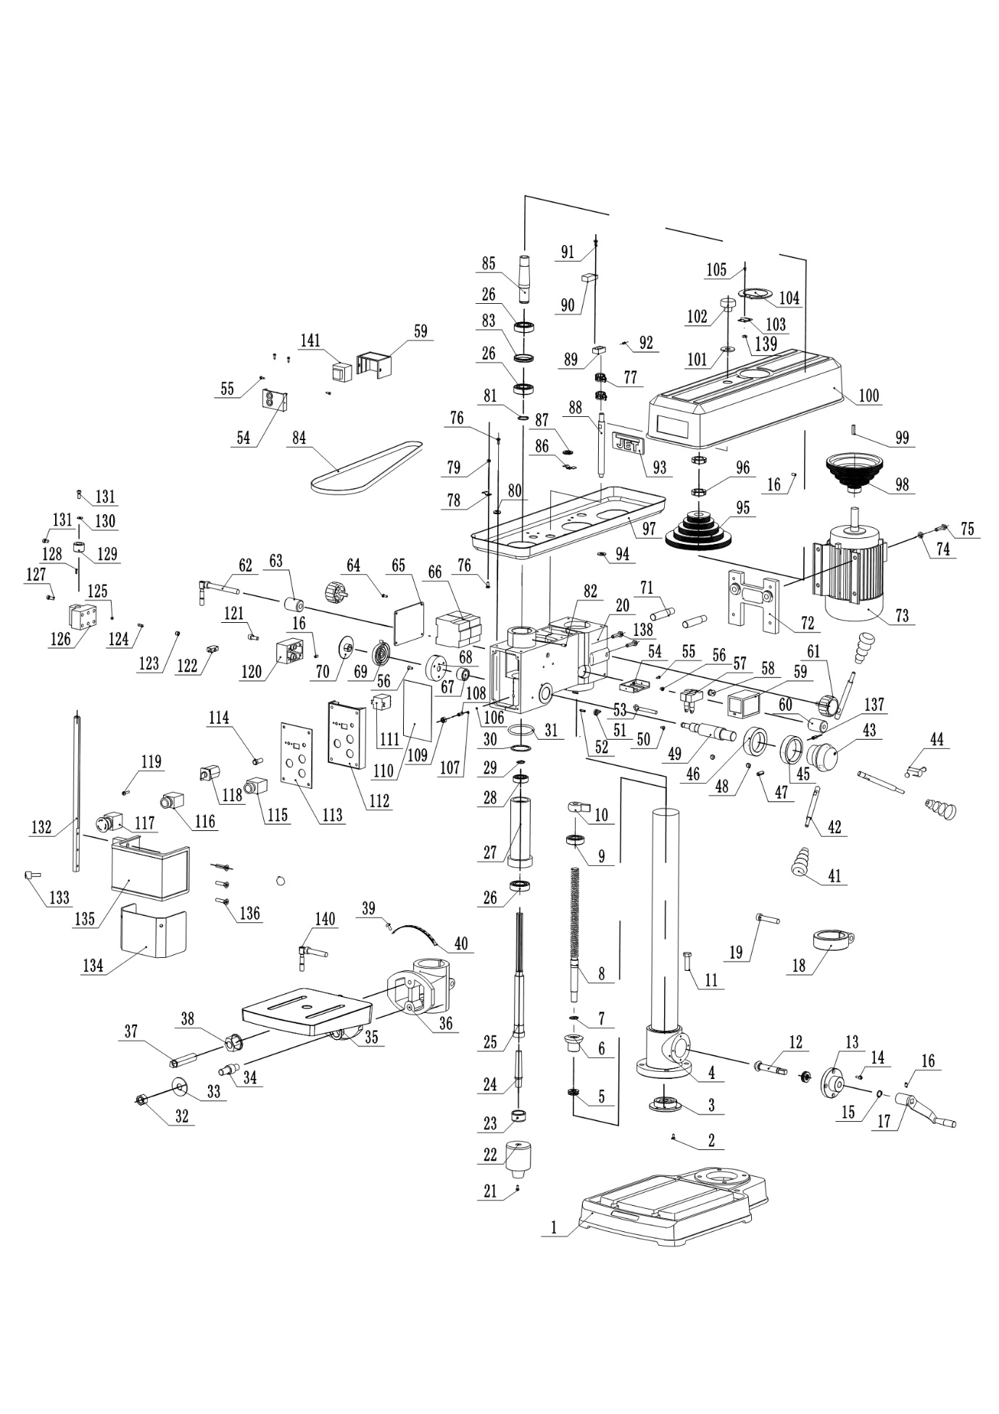

**IDTP-16 Parts List for Breakdown (1/3)**

Index Part   
No. No. Description Size Qty.

1 IDTP16-001 Base 1

2 IDTP16-002 Cross Pan Head Screw M4×10 4

3 IDTP16-003 Cover 1

4 IDTP16-004 Column 1

5 BB-51102 Thrust Bearing 51102 2

6 IDTP16-006 Cone Gear 1

7 IDTP16-007 C-Clip 20 1

8 IDTP16-008 Lead Screw 1

9 BB-6204 Bearing 6204 1

10 IDTP16-010 Nut 1

11 TS-1492041 Hex Cap Screw M12×40 4

12 IDTP16-012 Cone Gear Shaft 1

13 IDTP16-013 Cover 1

14 TS-1502031 Hex Socket Cap Screw M5×12 4

15 IDTP16-015 C-Clip 15 1

16 IDTP16-016 Set screw M5×12 3

17 IDTP16-017 Crank Arm Handle Assembly 1

18 IDTP16-018 Retaining Ring 1

19 IDTP16-019 Hex Socket Cap Screw M12×60 1

20 IDTP16-020 Headstock 1

21 IDTP16-021 Screw M8×12 1

22 IDTP16-022 Keytype Chuck B16 1

23 IDTP16-023 Nut 1

24 IDTP16-024 Arbor MT2/B16 1

25 IDTP16-025 Spindle 1

26 BB-6205 Bearing 6205 3

27 IDTP16-027 Quill 1

28 BB-6203 Bearing 6203 1

29 IDTP16-029 C-Clip 17 1

30 IDTP16-030 C-Clip 40 1

31 IDTP16-031 Rubber Washer φ50×4 1

32 IDTP16-032 Nut M16 2

33 IDTP16-033 Flat Washer 16 2

34 IDTP16-034 Double End Bolt 1

35 IDTP16-035 Table 1

36 IDTP16-036 Table Support 1

37 IDTP16-037 Bolt M12×40 1

38 IDTP16-038 Nut M12 2

39 IDTP16-039 Rivet 2.5×5 2

40 IDTP16-040 Tilt Scale 1

41 IDTP16-041 Grip 3

42 IDTP16-042 Handle 3

43 IDTP16-043 Hub 1

44 IDTP16-044 Lock Handle Assembly 1

45 IDTP16-045 Ring 1

46 IDTP16-046 Scale Ring 1

47 IDTP16-047 Pin 8×25 1

48 IDTP16-048 Pin 2

49 IDTP16-049 Pinion Shaft 1

50 IDTP16-050 Cross Pan Head Screw M4×8 1

**IDTP-16 Parts List for Breakdown (2/3)**

Index Part   
No. No. Description Size Qty.

51 IDTP16-051 Indicator 1

52 IDTP16-052 Pin 4×16 2

53 IDTP16-053 Bolt 1

54 IDTP16-054 Micro Switch Box 2

55 IDTP16-055 Tapping Screw M3.5×9.5 6

56 IDTP16-056 Cross Pan Head Screw M5×12 3

57 IDTP16-057 Micro Switch LXW5-11Q1 2

58 IDTP16-058 Strain Relief 1

59 IDTP16-059 Micro Switch Box Cover 2

60 IDTP16-060 Pivot Block 1

61 IDTP16-061 Locking Button 2

62 IDTP16-062 Lock Handle 1

63 IDTP16-063 Lock Block 1

64 IDTP16-064 Cross Pan Head Screw M4×12 4

65 IDTP16-065 Cover 1

66 IDTP16-066 Contactor 1211B7E-AC24V 2

67 IDTP16-067 Spacer 1

68 IDTP16-068 Collar 1

69 IDTP16-069 Coil Spring 1

70 IDTP16-070 Spring Cover 1

71 IDTP16-071 Motor Rod 2

72 IDTP16-072 Motor Base 1

73 IDTP16-073 Motor 1

74 IDTP16-074 Flat Washer 8 4

75 TS-1490051 Hex Cap Screw M8×30 4

76 IDTP16-076 Cross Pan Head Screw M5×12 11

77 IDTP16-077 Fastener 2

78 IDTP16-078 Plate 2

79 IDTP16-079 Nut M5 4

80 IDTP16-080 Strain Relief 1

81 IDTP16-081 C-Clip 25 1

82 IDTP16-082 Set screw M6×12 1

83 IDTP16-083 Spacer 1

84 IDTP16-084 Poly V-Belt 440J 1

85 IDTP16-085 Driving Sleeve 1

86 IDTP16-086 Plate 2

87 IDTP16-087 Rubber Sleeve 2

88 IDTP16-088 Shaft 1

89 IDTP16-089 Proximity Switch Seat 1

90 IDTP16-090 Proximity Switch 1

91 IDTP16-091 Cross Pan Head Screw M4×16 2

92 IDTP16-092 Set screw M6×8 1

93 JET-92 Logo JET-92 1

94 IDTP16-094 Foam Pads 6

95 IDTP16-095 Spindle Pulley 1

96 IDTP16-096 Nut M24×1.5 2

97 IDTP16-097 Pulley Cove 1

98 IDTP16-098 Motor Pulley 1

99 IDTP16-099 Flat Key 6×6×40 1

100 IDTP16-100 Pulley Cove 1

101 IDTP16-101 Flat Washer 12 1

**IDTP-16 Parts List for Breakdown (3/3)**

102 IDTP16-102 Locking Button 1

103 IDTP16-103 Hinge 1

104 IDTP16-104 Plate 1

105 IDTP16-105 Cross Pan Head Screw M4×8 4

106 IDTP16-106 Steel Ball 6 1

107 IDTP16-107 Spring 0.5×4.5×5.94 1

108 IDTP16-108 Set Screw M8×12 1

109 IDTP16-109 Nut M8 1

110 IDTP16-110 Insulating Paper 1

111 IDTP16-111 Relay JQX-13F2Z-L 1

112 IDTP16-112 Panel Bracket 1

113 IDTP16-113 Panel 1

114 IDTP16-114 Indicator light ZSD-AC24V 1

115 IDTP16-115 Stop Switch LAY7-11BN42E 1

116 IDTP16-116 Start Switch LAY7-11BN32E 1

117 IDTP16-117 Emergency Stop Switch HY57B 1

118 IDTP16-118 Select Switch ZH-A 1

119 IDTP16-119 Cross Pan Head Screw M5×40 1

120 IDTP16-120 Block 1

121 TS-1504041 Hex Socket Cap Screw M8×20 2

122 IDTP16-122 Micro Switch AV-165-1C25C 1

123 IDTP16-123 Set Screw M10×8 2

124 IDTP16-124 Spring 1×6×15.75 2

125 IDTP16-125 Steel Ball 8 2

126 IDTP16-126 Chuck Guard Micro Switch Assy 1

127 TS-1503081 Hex Socket Cap Screw M6×35 4

128 IDTP16-128 Pin 3×35 1

129 IDTP16-129 Spacer 2

130 IDTP16-130 Flat Washer 6 1

131 TS-1503031 Hex Socket Cap Screw M6×12 1

132 IDTP16-132 Chuck Guard Rod 1

133 IDTP16-133 Shifter Bolt 1

134 IDTP16-134 Chuck Guard 1

135 IDTP16-135 Chuck Guard 1

136 IDTP16-136 Screw M6×40 1

137 IDTP16-137 Set screw M5×6 1

138 TS-1491051 Hex Cap Screw M10×35 2

139 IDTP16-139 Nut M4 4

140 IDTP16-140 Column Lock Handle 1

141 IDTP16-141 Transformer 1

1. **IDTP-22 Assembly Breakdown**

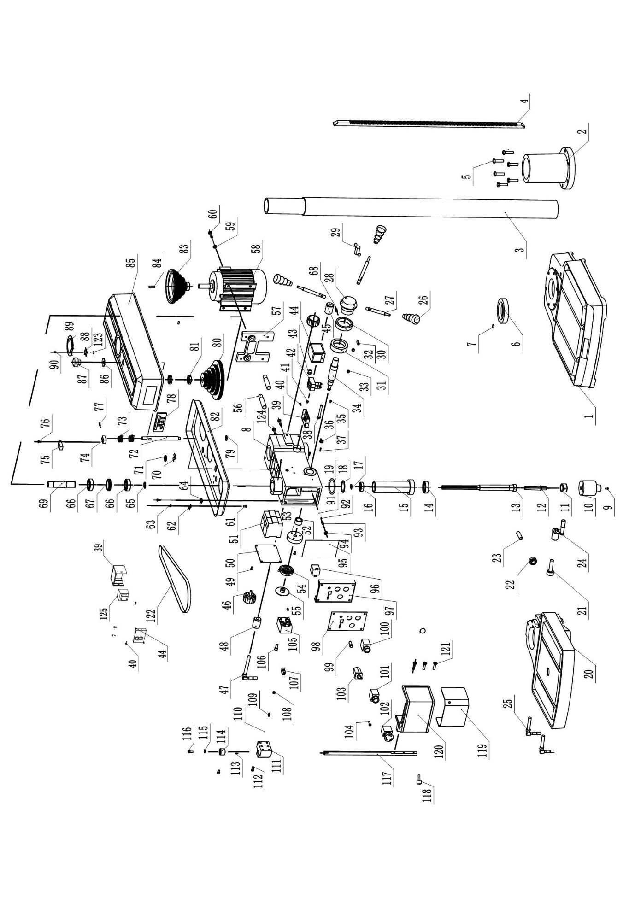

**IDTP-22 Parts List for Breakdown (1/3)**

Index Part   
No. No. Description Size Qty.

1 IDTP22-001 Base 1

2 IDTP22-002 Column support 1

3 IDTP22-003 Column 1

4 IDTP22-004 Rack 1

5 TS-1492041 Hex Cap Screw M12×40 6

6 IDTP22-006 Rack Collar 1

7 IDTP22-007 Socket Set Screw M6×12 1

8 IDTP22-008 Head 1

9 IDTP16-021 Screw M8×12 1

10 IDTP16-022 Keytype Chuck B16 1

11 IDTP16-023 Nut 1

12 IDTP22-012 Arbor MT3/B16 1

13 IDTP22-013 Spindle 1

14 BB-6206 Bearing 6206 3

15 IDTP22-015 Quill 1

16 BB-6204 Bearing 6204 1

17 IDTP22-017 C-Clip 20 1

18 IDTP22-018 C-Clip 47 1

19 IDTP22-019 Rubber Washer Ø60×4 1

20 IDTP22-020 Table 2

21 IDTP22-021 Worm Shaft 2

22 IDTP22-022 Helical Gear 1

23 IDTP22-023 Gear Pin 1

24 IDTP22-024 Crank Arm Handle Assembly 1

25 IDTP22-025 Column Lock Handle 2

26 IDTP22-026 Grip 3

27 IDTP22-027 Handle 3

28 IDTP22-028 Hub 1

29 IDTP22-029 Lock Handle Assembly 1

30 IDTP22-030 Ring 1

31 IDTP22-031 Scale Ring 1

32 IDTP22-032 Pin 8×30 1

33 IDTP22-033 Pin 2

34 IDTP22-034 Pinion Shaft 1

35 IDTP22-035 Cross Pan Head Screw M4×8 1

36 IDTP22-036 Indicator 1

37 IDTP22-037 Pin 4×16 2

38 IDTP22-038 Bolt 1

39 IDTP22-039 Micro Switch Box 2

40 IDTP22-040 Tapping Screw M3.5×9.5 6

41 IDTP22-041 Cross Pan Head Screw M5×12 3

42 IDTP22-042 Micro Switch LXW5-11Q1 2

43 IDTP22-043 Strain Relief 1

44 IDTP22-044 Micro Switch Box Cover 2

45 IDTP22-045 Pivot Block 1

46 IDTP22-046 Locking Button 2

47 IDTP22-047 Lock Handle 1

48 IDTP22-048 Lock Block 1

49 IDTP22-049 Cross Pan Head Screw M4×12 4

50 IDTP22-050 Cover 1

51 IDTP22-051 Contactor 2

**IDTP-22 Parts List for Breakdown (2/3)**

Index Part   
No. No. Description Size Qty.

52 IDTP22-052 Spacer 1

53 IDTP22-053 Collar 1

54 IDTP22-054 Coil Spring 1

55 IDTP22-055 Spring Cover 1

56 IDTP22-056 Motor Rod 2

57 IDTP22-057 Motor Base 1

58 IDTP22-058 Motor 1

59 IDTP22-059 Flat Washer 8 4

60 TS-1490051 Hex Cap Screw M8×30 4

61 IDTP22-061 Cross Pan Head Screw M5×12 11

62 IDTP22-062 Plate 2

63 IDTP22-063 Nut M5 4

64 IDTP22-064 Strain Relief 1

65 IDTP22-065 C-Clip 30 1

66 BB-6202 Set screw 6206 2

67 IDTP22-067 Spacer 1

68 IDTP22-068 Socket Set Screw M5×6 1

69 IDTP22-069 Driving Sleeve 1

70 IDTP22-070 Plate 2

71 IDTP22-071 Rubber Sleeve 2

72 IDTP22-072 Shaft 1

73 IDTP22-073 Fastener 2

74 IDTP22-074 Proximity Switch Seat 1

75 IDTP22-075 Proximity Switch LJC1-3/24 1

76 IDTP22-076 Cross Pan Head Screw M4×16 1

77 IDTP22-077 Socket Set Screw M6×8 4

78 JET-92 JET Logo JET-92 1

79 IDTP22-079 Foam Pads 6

80 IDTP22-080 Spindle Pulley 1

81 IDTP22-081 Nut M30×1.0 2

82 IDTP22-082 Pulley Cove 1

83 IDTP22-083 Motor Pulley 1

84 IDTP22-084 Flat Key 8×7×45 1

85 IDTP22-085 Pulley Cove 1

86 IDTP22-086 Flat Washer 12 1

87 IDTP22-087 Locking Button 1

88 IDTP22-088 Hinge 1

89 IDTP22-089 Plate 1

90 IDTP22-090 Cross Pan Head Screw M4×8 4

91 IDTP22-091 Steel Ball 6 1

92 IDTP22-092 Spring 0.5×4.5×6 1

93 IDTP22-093 Socket Set Screw M8×16 1

94 IDTP22-094 Nut M8 1

95 IDTP22-095 Insulating Paper 1

96 IDTP22-096 Relay JQX-13F2Z-L 1

97 IDTP22-097 Panel Bracket 1

98 IDTP22-098 Panel 1

99 IDTP22-099 Indicator light ZSD-AC24V 1

100 IDTP22-100 Stop Switch LAY7-11BN42E 1

101 IDTP22-101 Start Switch LAY7-11BN32E 1

102 IDTP22-102 Emergency Stop Switch HY57B 1

103 IDTP22-103 Select Switch ZH-A 1

104 IDTP22-104 Cross Pan Head Screw M5×40 1

105 IDTP22-105 Block 1

106 TS-1504041 Hex Socket Cap Screw M8×20 2

107 IDTP22-107 Micro Switch AV-165-1C25C 1

108 IDTP22-108 Socket Set Screw M10×8 2

109 IDTP22-109 Spring 1×6×16 2

110 IDTP22-110 Steel Ball 8 2

111 IDTP22-111 Chuck Guard Micro Switch Assy 1

112 TS-1503081 Hex Socket Cap Screw M6×35 4

113 IDTP22-113 Pin 3×10 1

114 IDTP22-114 Spacer 2

115 IDTP22-115 Flat Washer 6 1

116 TS-1503031 Hex Socket Cap Screw M6×12 1

117 IDTP22-117 Chuck Guard Rod 1

118 IDTP22-118 Shifter Bolt 1

119 IDTP22-119 Chuck Guard 1

120 IDTP22-120 Chuck Guard 1

121 IDTP22-121 Screw M6×40 1

122 IDTP22-122 Poly V-Belt 530J 1

123 IDTP22-123 Nut M4 4

124 TS-1491051 Hex Cap Screw M10×35 2

125 IDTP22-125 Transformer 1

1. **IDTP-16/22 ACCESSORIES Parts List**

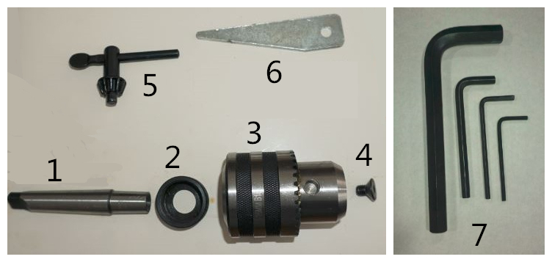

Index Part   
No. No. Description Size Qty.

1 IDTP16-024 Arbor (for IDTP-16) MT2/B16 1

IDTP22-012 Arbor (for IDTP-22) MT3/B16 1

2 IDTP16-023 Nut 1

3 IDTP16-022 Keytype Chuck B16 1

4 IDTP16-021 Screw M8×12 1

5 IDTP-ACCS-01 Chuck Key 1

6 IDTP-ACCS-02 Slant Wedge 1

7 IDTP-ACCS-03 L Hex Wrench 3 mm 1

IDTP-ACCS-04 L Hex Wrench 4 mm 1

IDTP-ACCS-05 L Hex Wrench 5 mm 1

IDTP-ACCS-06 L Hex Wrench 10 mm 1

**12. Wiring Diagrams**

**IDTP-16/22 ………………. ~3L/PE, 400V, 50Hz**

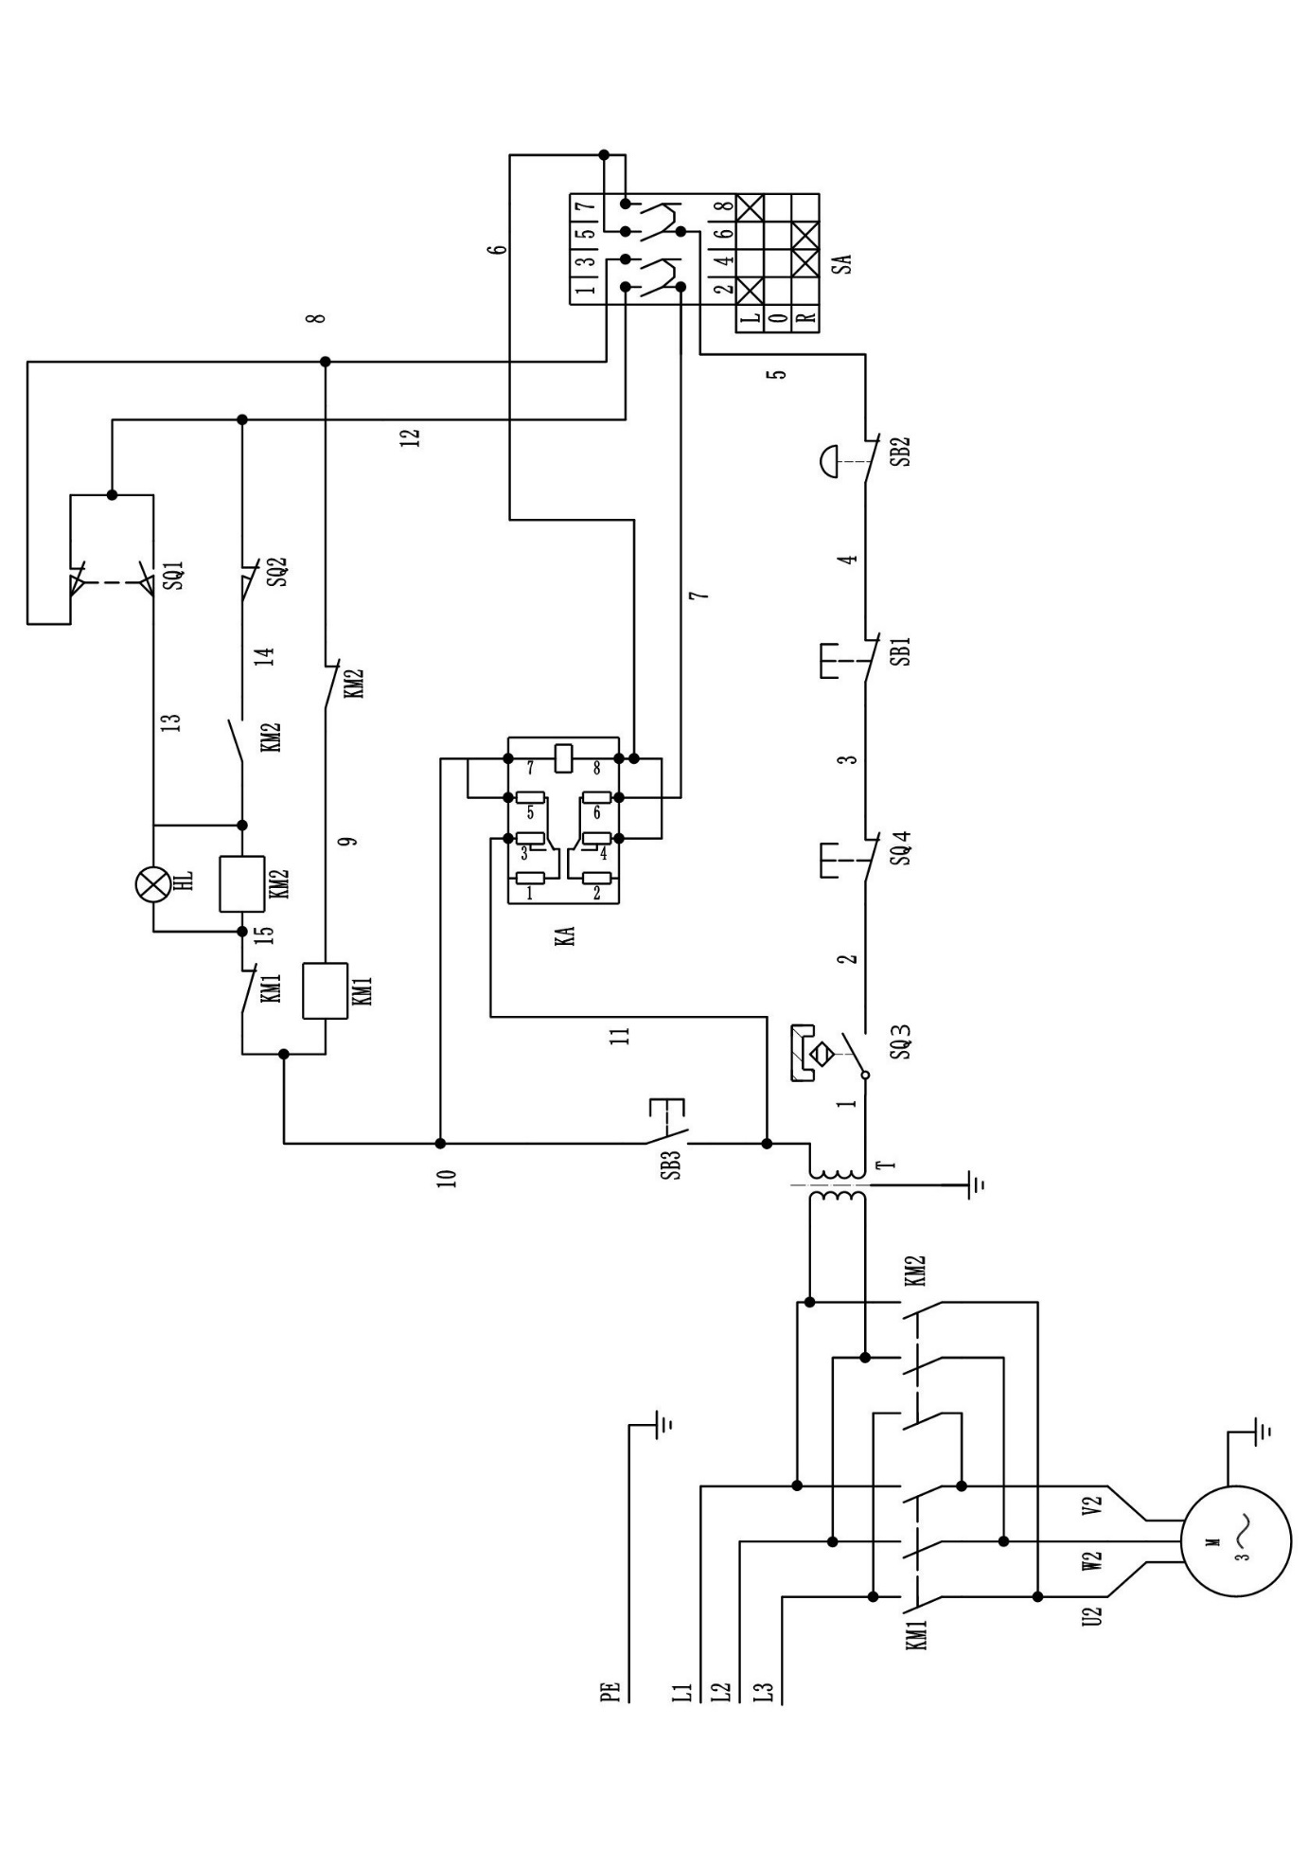

**13. Electrical Parts List**

|  |  |  |  |
| --- | --- | --- | --- |
| **ITEM** | **DESCRIPTION** | **TYPE** | **SPECIFICATION** |
| SB2 | Emergency stop switch | HY57B KEDU CE | 250V 12A |
| SB1/SB3 | Push button switch | LAY7 DELIXI CE | Ui:660V Ith:10A |
| SA | Convertible switch | ZH-A KEDU CE | 400V 10A |
| SQ3 | Proximity switch | LTC1-3/24 CHIIB | 24V 1.2W 50mA |
| HL | Indicator light | Ø10mm | 24V |
| SQ1/SQ2 | Micro switch | LXW5-11Q1 DELIXI 3C | AC-15 Ue=380V Le:2.5A |
| SQ4 | Chuck shield Micro switch | AV-165-1C25C TEZUO CE | 250V 16A |
| KA | Intermediate relay | JQX-13F 2Z DELIXI CE | 240VAC 10A |
| LM1/KM2 | Contactor | CDC9i-12 DELIXI CE | Ui:690V Ith:20A |
| T | Transformer |  | In:400V Out:24V |
|  | Plug | P551 plug KEDU CE | 415V 16A |
| M | Motor | IDTP-16-6P | 500W , 400V , 50Hz , 3PH , 6P , 1.8A , 910RPM |
| IDTP-22-6P | 750W , 400V , 50Hz , 3PH , 6P , 2.6A , 910RPM |
|  |  |  |  |
|  |  |  |  |
|  |  |  |  |
|  |  |  |  |
|  |  |  |  |
|  |  |  |  |