X6336 UNIVERSAL RADIAL   
 MILLING MACHINE

EXPLOSION DIAGRAM

CONTENTS

Ⅰ. 01 Column and Base & Cooling part

Ⅱ. 02 Knee part

Ⅲ. 03 Table part

Ⅳ. 04 Feeding box part

Ⅴ. 05 Ram part

Ⅵ. 06 Horizontal milling transmission part

Ⅶ. 07 Vertical milling head part

Ⅷ. 08 Accessories part

Ⅸ. 10 Table lubrication part

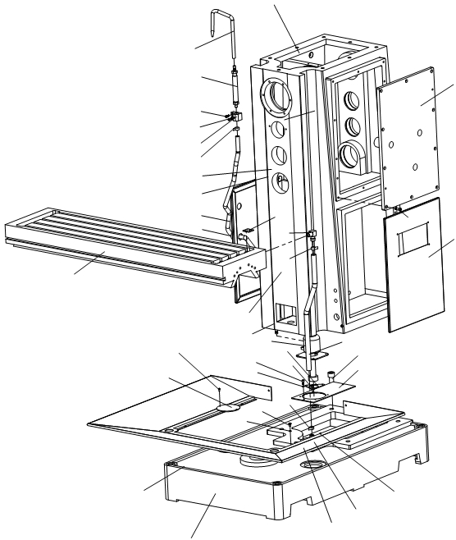

01 Column & base parts

02

25

24

26

10

10

23

05

22

02

17

29

18

14

13

06   
 10

09 08

15

19

21

05

16 17

28

07

05

27

20

12

11

07

08

02 06

04

03

01

01 Column & base parts

No. Name Qty

01001 Base 1

01002 M10×1 Oil plug 3

01003 Tray 1

01004 Pipe joint 1

01005 Φ16-Φ19 Hoop 4

01006 M4×10 Cross recessed countersunk flat head 4

01007 M6×12 Cross recessed countersunk flat head 4

01008 6 Elastic washer 10

01009 Cover board 1

01010 M6×16 Hexagon socket head cap screw 2

01011 Cooling pump block 1

01012 M20×65 Hexagon socket head cap screw 5

01013 Pipe joint 1

01014 Door 1

01015 Column 1

01016 90W Cooling pump 1

01017 Φ20×1500 PVC pipe 1

01018 Worktable 1

01019 Cover board 1

01020 Door 1

01021 Pipe joint 1

01022 M6×25 Cross recessed pan head screw 1

01023 Fixing base 1

01024 Connecting pipe 1

01025 SR301 Cooling pipe 1

01026 Cover board 1

01027 M8×25 Hexagon socket head cap screw 1

01028 Cover 1

01029 Pipe joint 1

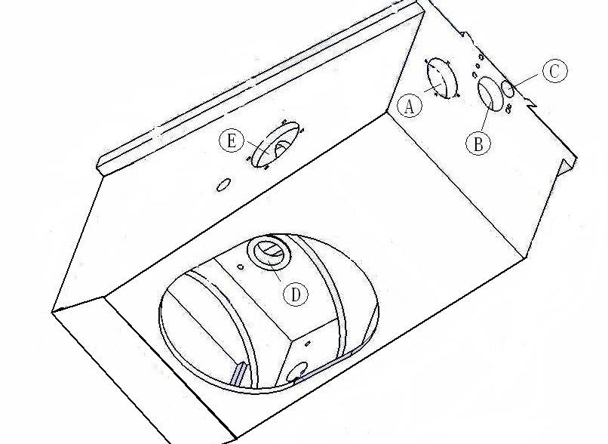

02 Knee part

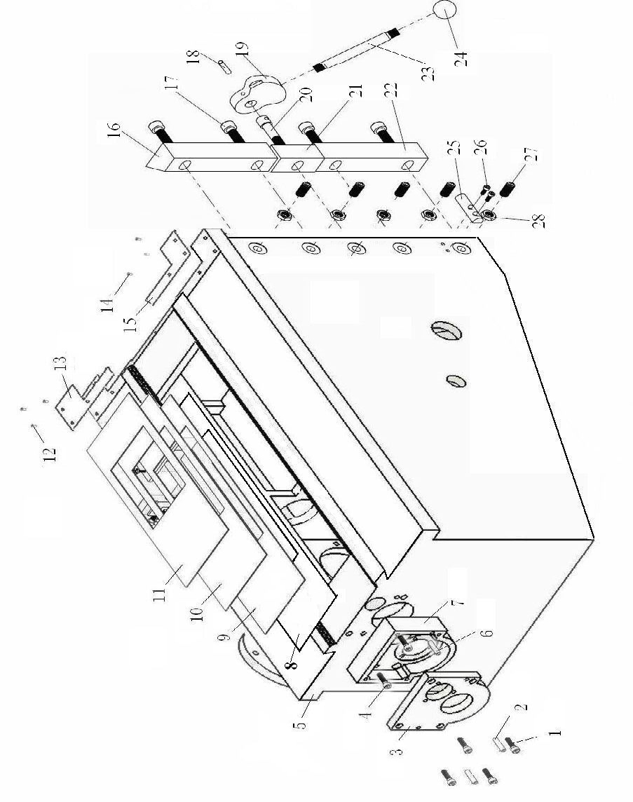

02 Knee part

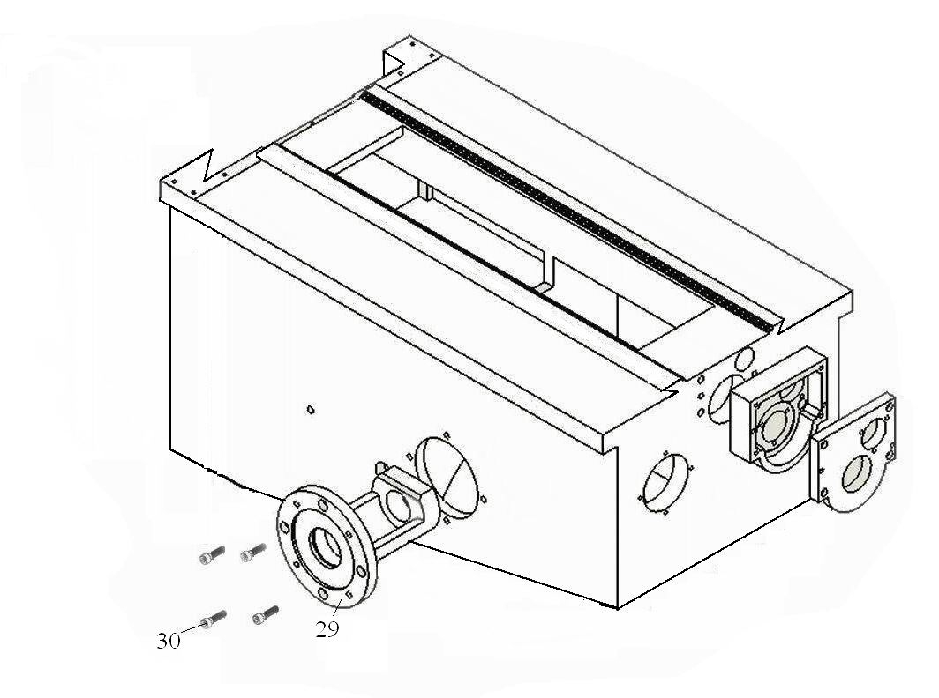

02 Knee part

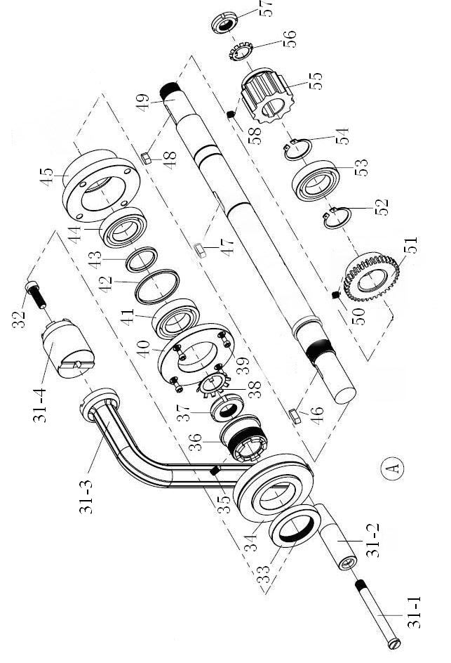

02 Knee part

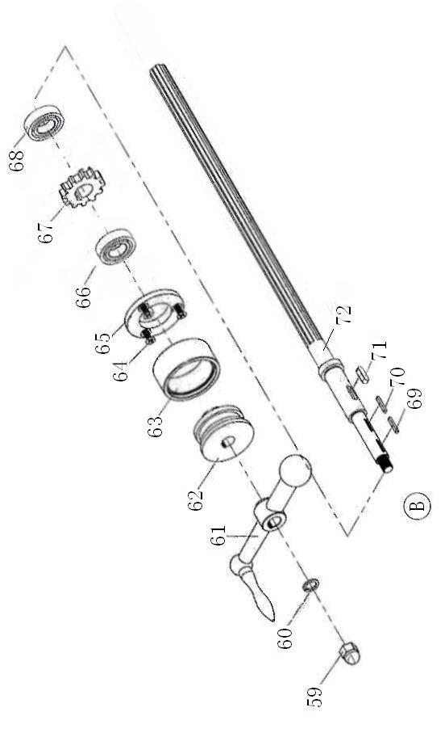

02 Knee part

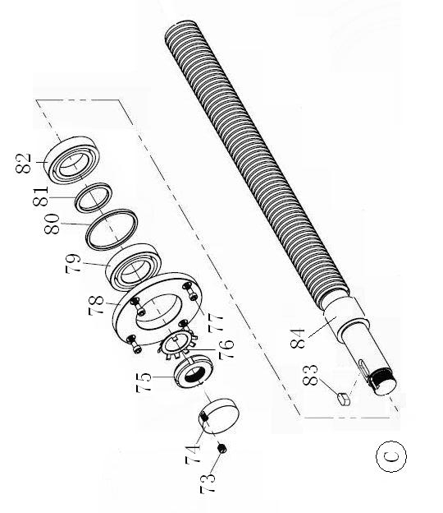

02 Knee part

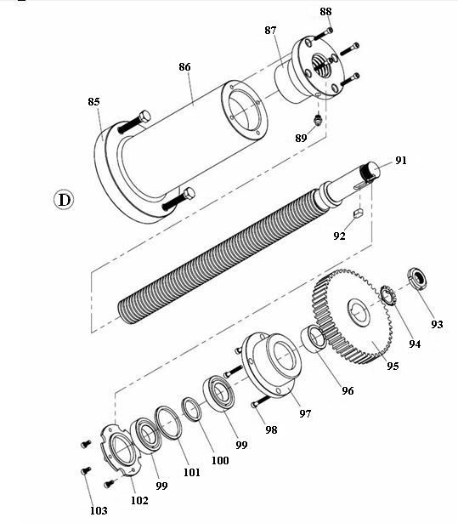

02 Knee part

02 Knee parts List

No. Name Model Qty

1 HEX. SOCKET HEAD BOLT M8×25 4

2 TAPER PIN A6×25 2

3 COVER PLATE 1

4 HEX. SOCKET HEAD BOLT M8×25 4

5 KNEE 1

6 TAPER PIN A6×25 2

7 BRACE 1

8 WAY SLIDE LARGE 1

9 WAY SLIDE LARGE 1

10 WAY SLIDE LARGE 1

11 WAY SLIDE LARGE 1

12 CROSS RECESSED PAN HEAD SCREW M5×12 3

13 WIPER 1

14 CROSS RECESSED PAN HEAD SCREW M5×12 3

15 WIPER 1

16 KNEE GIB LONG 1

17 HEX. SOCKET HEAD BOLT M12×35 2

18 TAPER PIN 5×50 1

19 LOCK SLEEVE 1

20 HEX. SOCKET HEAD BOLT M12×45 1

21 KNEE GIB SHORT 1

22 KNEE GIB LONG 1

23 LOCK HANDLE 1

24 BALL KNOB 1

25 WAY STOP 1

26 HEX. SOCKET HEAD BOLT M5×12 2

27 SET SCREW M12×25 1

28 HEX NUT M12 1

29 LIFTING BOX 1

30 HEX. SOCKET HEAD BOLT M8×25 4

31-1 HANDLE 1

31-2 HANDLE BUSHING 1

31-3 CRANK 1

31-4 COLLAR 1

32 HEX. SOCKET HEAD BOLT M10×30 1

02 Knee parts List

No. Name Model Qty

33 HANDLE NUT 1

34 GRADUADTED DIAL 1

35 SET SCREW M6×15 1

36 CLUTCH 1

37 SPANNER NUT M35×1.5 1

38 LOCK WASHER 35 1

39 SET SCREW M6×15 4

40 RETAINER 1

41 BEARING 7007AC 1

42 SPECIAL WASHER 1

43 SPECIAL WASHER 1

44 BEARING 7007AC 1

45 BRACKET 1

46 KEY 8×7×25 1

47 KEY 8×7×30 1

48 KEY 8×7×35 1

49 SHAFT 1

50 SET SCREW M8×15

51 GEAR 1

52 SHAFT RETAINING RING 35 1

53 BEARING 6008-2Z 1

54 SHAFT RETAINING RING 35 1

55 GEAR 1

56 LOCK WASHER 27 1

57 SPANNER NUT M27×1.5 1

58 SET SCREW M8×15 1

59 NUT M12 1

60 PLAIN CUSHION 12 1

61 HANDWHEEL 16×160 1

62 JUNCTION 1

63 INDEXING NING 1

64 SET SCREW M6×16 3

65 RETAINER 1

66 BEARING 6004-2Z 1

67 GEAR 1

02 Knee parts List

No. Name Model Qty

68 BEARING 6004-2Z 1

69 KEY 3×20 1

70 KEY 3×20 1

71 KEY 6×16 1

72 SPLINE SHAFT 1

73 SET SCREW M6×10 1

74 PLUG 1

75 SPANNER NUT M20×1.5 1

76 LOCK WASHER 20 1

76-1 GEAR 1

77 SET SCREW M6×16 4

78 RETAINER 1

79 BEARING 7004AC 1

80 SPECIAL WASHER 1

81 SPECIAL WASHER 1

82 BEARING 7004AC 1

83 FLAT KEY 6×16 1

84 CROSS LEAD SCREW 1

85 HEX BOLT M10×50 2

86 KNEE COLUMN 1

87 THREADED RETAINER 1

88 CAP SCREW M6×20 4

89 GREASE FITTING M8×1 1

91 KNEE LEAD SCREW 1

92 KEY 8×7×22 1

93 SPANNER NUT M27×1.5 1

94 LOCK WASHER 27 1

95 GEAR 1

96 BUSHING 1

97 BRACKET 1

98 CAP SCREW M6×20 4

99 ANG CONTACT BEARING 7006C/AC 2

100 SPECIAL WASHER 1

101 SPECIAL WASHER 1

102 RETAINER 1

02 Knee parts List

No. Name Model Qty

103 CAP SCREW M5×16 4

03 Table part

No. Name Qty

03001 M20×1.5 Slotted roundness nut 1

03002 20 tab washer 1

03003 m=2 z=15 Gear 1

03004 6×16 Flat key 1

03005 M6×16 Hexagon socket head cap screw 10

03006 25 Retaining ring 2

03007 6005-2Z 25×47×12Deep groove ball bearing 1

03008 A8×40 Screw taper pin 2

03009 M8×25 Hexagon socket head cap screw 2

03010 Nut 1

03011 Nut 1

03012 Spacer 1

03013 M10×50 Hexagon socket head cap screw 4

03014 M6×25 Hexagon socket head cap screw 4

03015 Block 2

03016 8×20 Flat key 1

03016-1 m=2 z=36 Gear 1

03017 Spacer 1

03018 7005AC-Z 25×47×12 angular contact ball bearing 2

03019 Spacer 1

03020 Spacer 1

03021 support frame 1

03022 M6×40 Hexagon socket head cap screw 3

03023 support frame 1

03024 M6×30 Hexagon socket head cap screw 3

03025 20 tab washer 1

03026 M20×1.5 Slotted roundness nut 1

03027 Lead screw rod 1

03 Table part

No. Name Qty

03028 Table 1

03029 Bracket 2

03030 indicator drop 1

03031 M10×10 Setscrew with hex.socket flat end 1

03032 1.6×8×25 Compressed spring 1

03033 8 steel ball 1

03034 hand grip 1

03035 A6×50 Screw taper pin 1

03036 bushing block 1

03037 Shaft 1

03038 A5×30 Screw taper pin 1

03039 double hane 1

03039-1 Shifting fork 1

03040 12 Retaining ring 1

03041 20 Retaining ring 1

03042 m=2 z=36 Gear 1

03043 6×16 Flat key 1

03044 6004-2Z 20×42×12Deep groove ball bearing 1

03045 Spacer 1

03046 61905-2Z 25×42×9 Deep groove ball bearing 1

03047 m=2 z=20 Gear 1

03048 8×28 Flat key 1

03049 M6×12 Setscrew with hex.socket flat end 1

03050 6002 15×32×9 Deep groove ball bearing 1

03051 m=2 z=20,38 Gear 1

03052 m=2 z=24 Gear 1

03053 25 Retaining ring 1

03054 20 Retaining ring 1

03055 Spline housing 1

03 Table part

No. Name Qty

03056 Lead screw 1

03057 Cap 1

03058 6004-2Z 20×42×12Deep groove ball bearing 1

03059 m=2 z=38 Gear 1

03060 6×16 Flat key 1

03061 6004-2Z 20×42×12Deep groove ball bearing 1

03062 shaft 1

03063 Wedge 1

03064 Wedge 1

03065 positioning screw 2

03066 Double End Studs Bolts 2

03067 Hexagonal nut| 6

03068 Saddle 1

03069 Wiper 2

03070 M5×12 Cross-recessed head screw 8

03071 Dog binder plate 1

03072 Dog binder plate 2

03073 12 Plain washe 9

03074 M12×30 Hexagon socket head cap screw 9

03075 Handle lever 1

03076 Grip 1

03077 M10×35 Hexagon socket head cap screw 4

03077-1 Spacer 1

03077-2 A8×30 Screw taper pin 2

03078 Nut 1

03079 Wedge 1

03080 Adjusting screw 1

03081 Nut 1

03082 M8×25 Hexagon socket head cap screw 2

03 Table part

No. Name Qty

03083 A8×60 Cylindrical pin 1

03084 Dog binder plate 1

03085 M12×58×25 Positional adjustment 2

03086 A10×26 Taper bolt 2

03087 Clamp piece 2

03088 3×20 Flat key 1

03089 3×20 Flat key 1

03090 shaft 1

03091 6×16 Flat key 1

03092 M12 Nut 1

03093 12 Spring Washer 1

03094 16×160 Handwheel 1

03095 Spacer 1

03096 spacer bush 1

03097 Dial scale 1

03098 M6×20 Phill screw 3

03099 Bearing cap 1

03100 6004-2Z 20×42×12Deep groove ball bearing 2

03101 42 Retaining ring 1

03102 spacer bush 1

03103 m=2 z=15 spiral gear 1

03104 6 Plain washer 1

03105 6 Spring Washer 1

03106 M6×25 Hexagon socket head cap screw 1

03107 M8×30 Hexagon socket head cap screw 4

03108 Dog binder plate 1

03109 A6×30 Screw taper pin 2

03110 m=2 z=20 Bevel gear shaft 1

03111 6×16 Flat key 1

03 Table part

No. Name Qty

03112 61904-2Z 20×37×9 Deep groove ball bearing 1

03113 spacer bush 1

03114 M8×16 Setscrew with hex.socket taper end 1

03115 61904-2Z 20×37×9 Deep groove ball bearing 1

03116 m=2 z=36 Gear 1

03117 20 Retaining ring 1

03118 30 Retaining ring 1

03119 61806-2Z 30×42×7 Deep groove ball bearing 1

03120 spacer bush 1

03121 M6×12 Setscrew with hex.socket taper end 2

03122 61806-2Z 30×42×7 Deep groove ball bearing 1

03123 m=2 z=20 Bevel gear shaft 1

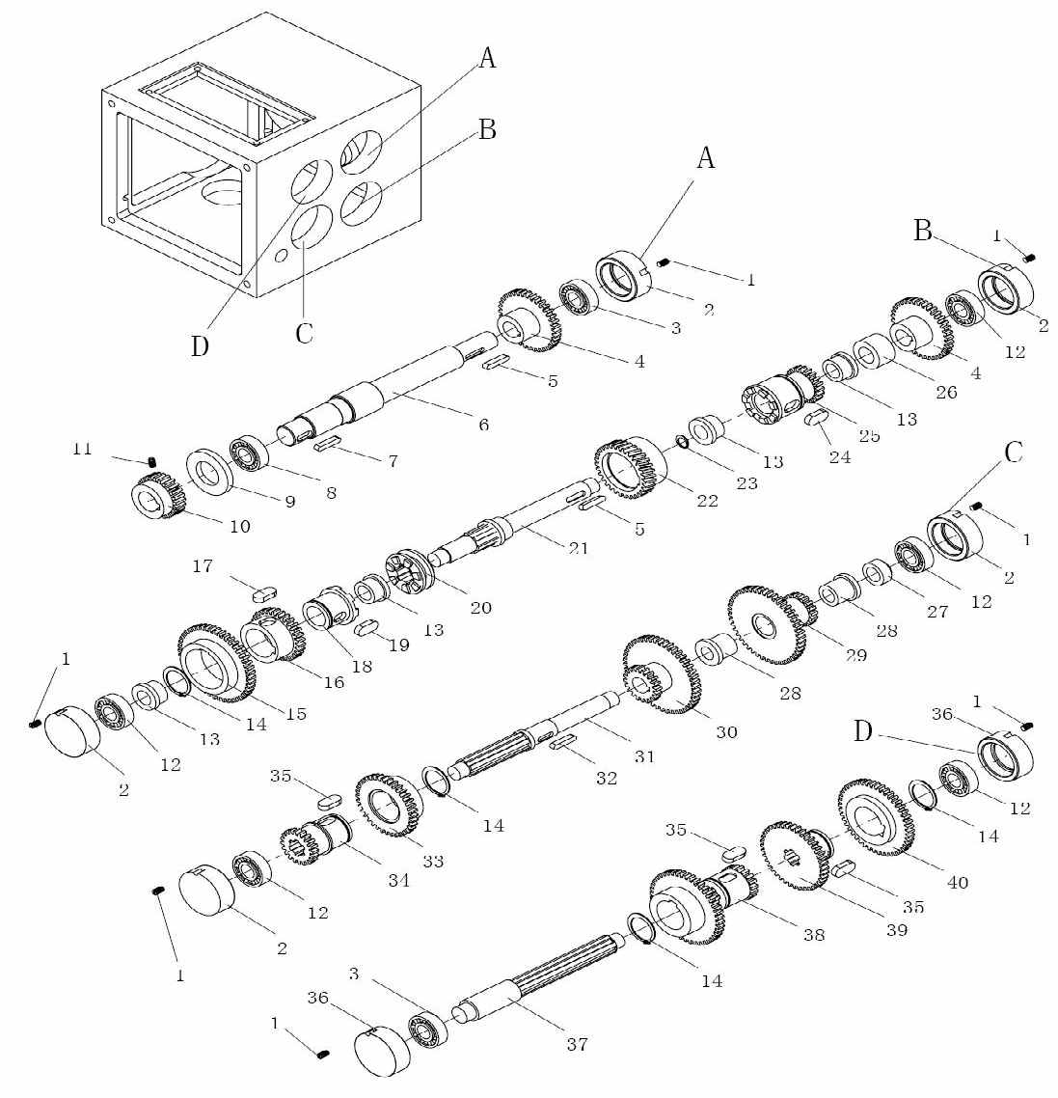

04 Feeding box part

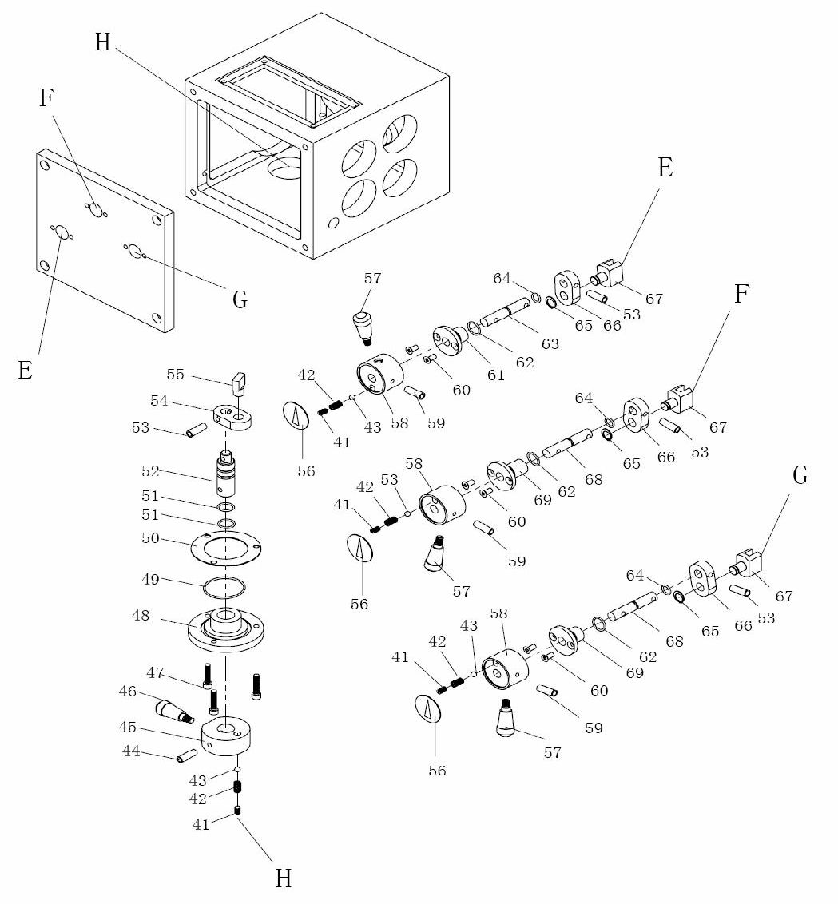

04 Feeding box part

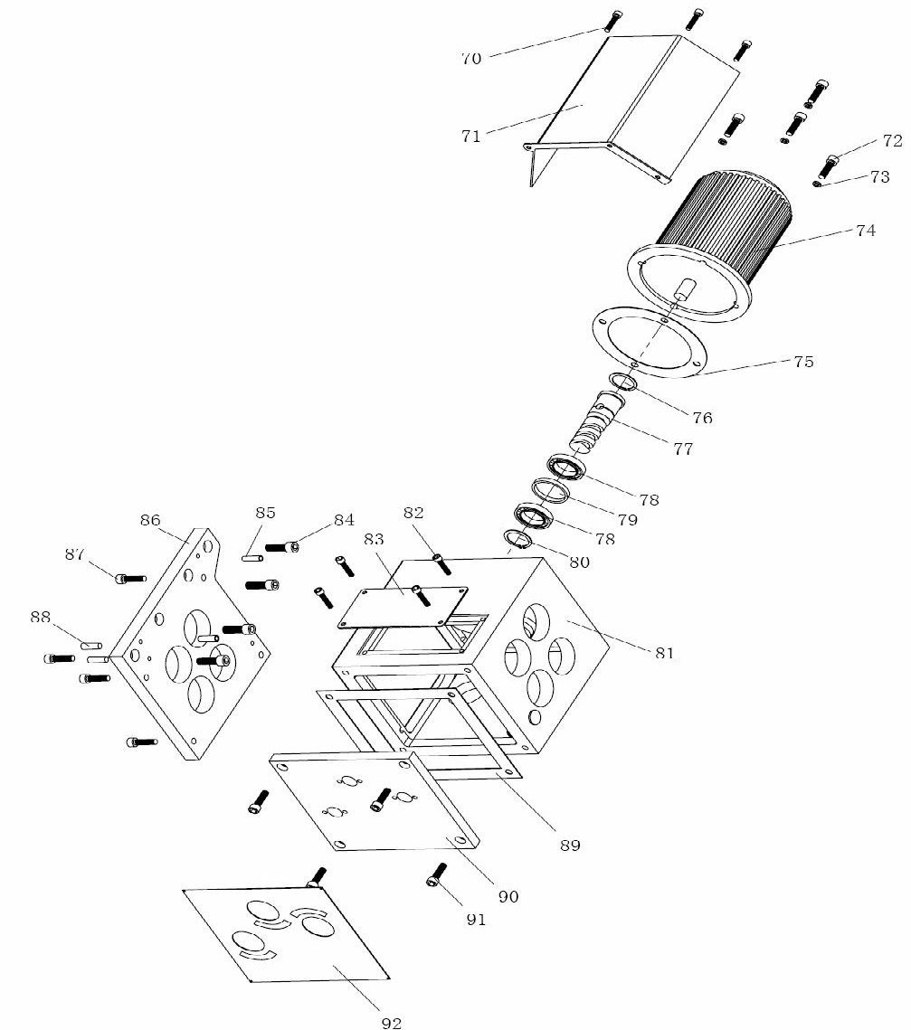

04 Feeding box part

04 Feeding box parts List

No. Name Model Qty

1 SET SCREW M6 × 10

2 PLUG

3 BALL BEARING 6004

4 GEAR

5 KEY 6×6×25

6 SHAFT

7 KEY 8×7×20

8 BALL BEARING 6006

9 WASHER

10 GEAR

11 SET SCREW M6 × 10

12 BALL BEARING 6203

13 BUSHING

14 EXT RETAINER RING 36

15 GEAR

16 GEAR

17 KEY 12 × 6 × 18

18 CLUTCH

19 KEY 10 × 6 × 16

20 CLUTCH

21 SHAFT

22 BEVEL GEAR

23 EXT RETAINER RING 45

24 KEY 12 × 6 × 20

25 GEAR

26 BUSHING

27 BUSHING

28 BUSHING

29 GEAR

30 GEAR

31 SHAFT

32 KEY 6×6×20

33 GEAR

34 GEAR

35 KEY 10 × 6 × 20

04 Feeding box parts List

No. Name Model Qty

36 PIUG

37 SHAFT

38 GEAR

39 GEAR

40 GEAR

41 SET SCREW M8 × 8

42 COMPRESSION SPRING 1×5×15

43 STEEL BALL 6

44 TAPER PIN 6×50

45 HANDLE BASE

46 HANDLE

47 CAP SCREW M6 × 12

48 RETAINER

49 O-RING 2.65 × 43.7

50 PACKING WASHER

51 O-RING 2.65 × 15

52 SHAFT

53 TAPER PIN 4×30

54 JUNCTION PLATE

55 SHIFTING FORK

56 INDICATOR PLATE

57 HANDLE

58 HANDLE BASE

59 TAPER PIN 5×40

60 PLPH HD SCR M6 × 10

61 RETAINER

62 O-RING 1.8 × 17

63 SHAFT

64 O-RING 1.8 × 8.75

65 EXT RETAINER RING 12

66 JUNCTION PLATE

67 SHIFTING FORK

68 SHAFT

69 RETAINER

70 PLPH HD SCR M6 × 12

04 Feeding box parts List

No. Name Model Qty

71 COVER OF MOTOR

72 CAP SCREW M8 × 25

73 LOCK WASHER 8

74 FEEDING MOTOR 1.5kW

75 PACKING WASHER

76 INT RETAINER RING 47

77 WORM

78 BALL BEARING 61906-2RS

79 WASHER

80 EXT RETAINER RING 30

81 BOX

82 CAP SCREW M5 × 12

83 COVER

84 CAP SCREW M10 × 25

85 TAPER PIN 6×30

86 BOX COVER

87 CAP SCREW M8 × 25

88 TAPER PIN 8×35

89 PACKING WASHER

05 Ram part

N0. Name Qty

0501 Ram 1

0502 Cover board 1

0503 M5×10 Cross recessed pan head screw 4

0504 Shaft 1

0505 M16 Hexagon nut 4

0506 Spring washer 4

0507 M16×90 “T “threaded bolt 4

0508 Fixed seat 1

0509 Gyre seat 1

0510 M16×65 Hex socket head bolt 7

0511 M12×40 Hex socket head bolt 2

0512 A10×20 Straight pin 2

0513 Ruler 1

0514 Indicator drop 1

0515 GB/T894.1 24 Shaft retaining ring 1

0516 Bush 1

0517 m=2 z=17 Gear shaft 1

0518 A6×30 Unhardened taper pins 1

0518-1 A8×50 Unhardened taper pins with externalthread 1

0518-2 M8 Hexagon nut 1

0519 Wedged pad iron 1

0520 Adjusting screw 1

0521 M10×1 Oil plug 1

0522 M16×1.5 Oil plug 1

0523 200mm Caddice 1

0524 Cover 1

0525 Junction plate 1

05 Ram part

N0. Name Qty

0526 M16×65 “T “threaded bolt 7

0527 M20 Hexagon nut 2

0528 Bush 1

0529 Hanger 1

0530 JB/T7941.2 A10 Oil scale 1

0531 200mm Double End Studs Bolts 1

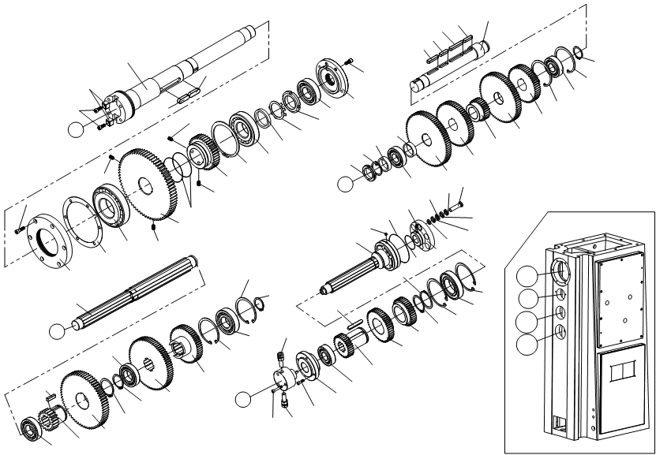

001   
088

089 002

A

008

002

008   
 012

011   
010

009

017

016   
015

014

013   
 038

037   
 036   
035

C

032 034   
033

032   
031

041   
040

029 039

087

030   
 028   
029

028   
 043   
042

003

005   
004

018

008   
082

007   
006 008

081   
044

028   
 030   
 033

086

083 086

082 086

086   
085

084   
082

055   
 053

054   
053

A   
B

B

021

019

025

026   
024

023

022   
020

029 046   
028

027

D   
 045 046

052   
051

050

049   
048

047

023 C

D

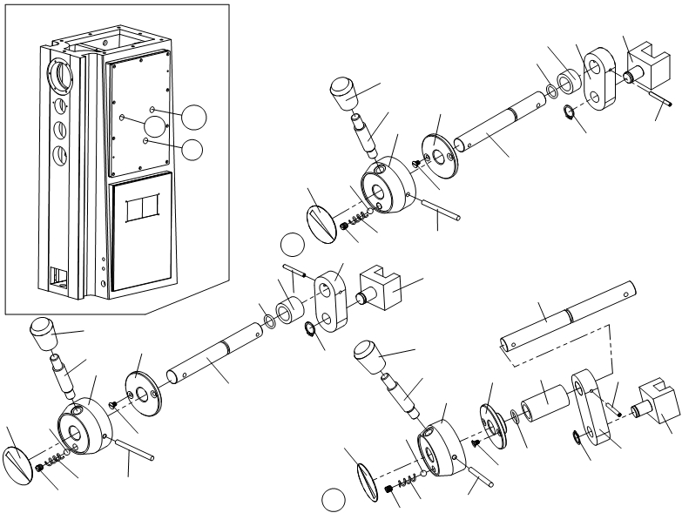

062

061   
 060

G   
E

F

064

056 059

E 057

074   
073

070   
072

069

071

067 068   
072

062

061 064 070

060 069

066

063

058 065

075   
 080

062   
 061 076

056 059

G

079

063   
 056

058 065   
057

F

064   
060

059   
 063

065 057 058

070

078

072 077

069

06 Main transmission part

No. Name Qty

06001 Main shaft 1

06002 16×50 Flat key 2

06003 M8×30 Hexagon socket head cap screw 6

06004 End cover 1

06005 Gasket 1

06006 32217/P5 85×150×38.5 Bearing 1

06007 m=3.5 z=71 Gear 1

06008 M10×16 Setscrew with slotted flat end 4

06009 m=3 z=39 Gear 1

06010 120 Elastic collar 1

06011 30311/P5 55×120×29 Bearing 1

06012 68×55.2×10 Pad 1

06013 52 Check washer 1

06014 M52×1.5 Round nut 1

06015 6309 45×100×25 Bearing 1

06016 End cover 1

06017 M8×20 Hexagon socket head cap screw 6

06018 Shaft 1

06019 6307 35×80×21 Bearing 1

06020 m=3.5 z=19 Gear 1

06021 10×36 Flat key 1

06022 m=3 z=66 Gear 1

06023 58 Elastic collar 2

06024 45 Elastic collar 1

06025 T6209 45×85×19 Bearing 1

06026 m=2.5 z=73 Gear 1

06027 m=2.5 z=51 Gear 1

06028 90 Elastic collar 4

06029 40×90×23 Bearing 3

06 Main transmission part

No. Name Qty

06030 40 Elastic collar 2

06031 10×50 Flat key 1

06032 10×40 Flat key 2

06033 10×63 Flat key 2

06034 Shaft 1

06035 M40×1.5 Round nut 1

06036 40 Check washer 1

06037 50×40.2×14 Pad 1

06038 50×42.2×14 Pad 1

06039 m=2.5 z=77 Gear 1

06040 m=2.5 z=62 Gear 1

06041 m=2.5 z=29 Gear 1

06042 m=2.5 z=70 Gear 1

06043 m=2.5 z=51 Gear 1

06044 Shaft 1

06045 M6×35 Hexagon socket head cap screw 3

06046 Pipe joint 2

06047 M6×20 Hexagon socket head cap screw 4

06048 Connecting seat 1

06049 30×72×19 Bearing 1

06050 m=2.5 z=31 Gear 1

06051 m=2.5 z=46 Gear 1

06052 m=2.5 z=38 Gear 1

06053 100 Elastic collar 2

06054 6211-2RS 55×100×21 Bearing 1

06055 60 Elastic collar 1

06056 Indicator 3

06057 M10×10 Setscrew with slotted flat end 3

06058 1.6×8×25 Pressure spring 3

06 Main transmission part

No. Name Qty

06059 8 Steel ball 3

06060 Hand seat 3

06061 Hand lever 3

06062 M12×60 Taper knob 3

06063 M5×10 Slotted countersunk flat head screw 6

06064 Sleeve 3

06065 6×70 Taper bolt 3

06066 Shaft 1

06067 30×20.5×16 Distance sleeve 3

06068 Connector 1

06069 16 Elastic collar 3

06070 4×40 Taper bolt 3

06071 Shifting fork 1

06072 15×2.65 O-ring 3

06073 30×20.5×24 Distance sleeve 1

06074 Connector 1

06075 Shifting fork 1

06076 30×20.5×58 Distance sleeve 1

06077 Connector 1

06078 Shifting fork 1

06079 Shaft 1

06080 Shaft 1

06081 M6X8 Screw 6

06082 φ1.2 Iron wire 2

06083 M8X14 Screw 1

06084 Collar 1

06085 18×12×3 Washer 6

06086 Elastic ring 24

06087 Shaft 6

06 Main transmission part

No. Name Qty

06088 Key 2

06089 M12×35 Hexagon socket head cap screw 2

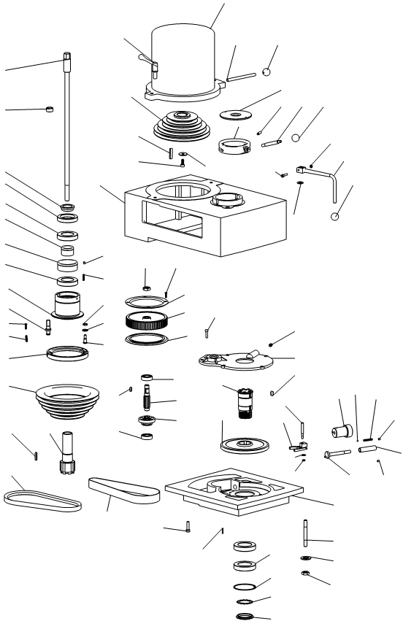

85

1

2

3

4

5

6

7

8

11

17

16

15

18

19

21 20

22

45

49

49-1   
 49-3   
42

10

28

9

12

13

14

61

63

23

69

27

26

25

24

59

60

62

67

36 29-A

31-1   
 32 30   
31

49-2   
 35

34-1

51

55

50

56

57

64

58 65

64-2   
64-1

71

72

73

74

29

33

34-A-1   
 29-A

82 83 84

81

80

78 79   
66

76

77

75

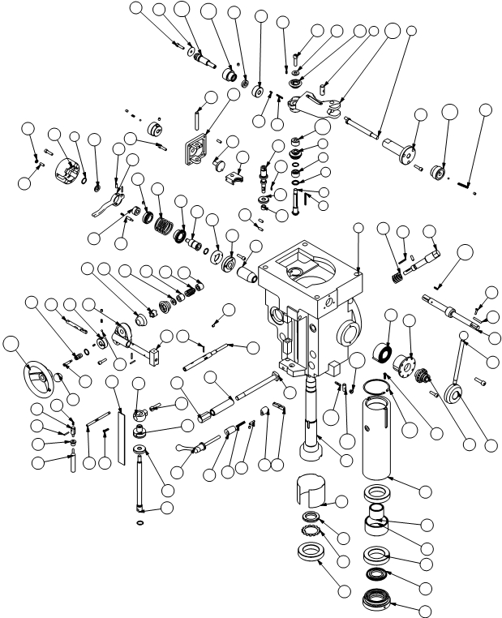

5H B

20

51

49 4 48 20

53

47

51 45

46 54

31 32 30 29

38 74 34 33

19 107 108 18

58 57

56

55

52

44

43 42 50

41

28 27

37

17

16

40

12

14 13 11 8

15 104

21 7

3

16 2

22 5

6

23

1

106 9

10 109 72

87 15 88

110

84

79 86

80

105

77

26

78

76

59 27

36

39 93 92 97

36 75 14

91

25 96

73

90

89

24

102

96

95

100

101

99 71 98 60

70 73

61

62

63

65

85

83

103 94

81 82

65

66

67

64

68

69

07 Head Parts List (5H-A)

No. Name Qty

5A-01+02 Drawbar Each 1

5A-03+20 Spindle clutch nut Each 1

5A-04+11 Turnbuckle Each 1

5A-05+08 GB/T276 6009 Deep groove ball bearing Each 1

5A-06+07 Spacer Each 1

A -09 Compressed spring 1

A -10 M4 Setscrew with hex.socket taper end 1

A -12 5/16 Hexagonal nut| 1

A -13 5/166 Spring Washer 1

5A-14 Fastening Screw 1

A -15 Compressed spring 2

A -16 M3×6 Cross-recessed head screw 4

5A-17 Brake pipe wind-up 1

5A-18 Brake pipe ring 1

5A-19 Spindle belt pulley 1

5A-21 6×6×38 Flat key 1

5A-22 V-belt 1

A-23 Timing Belt 1

A-24+25+26 tooth form Belt pulley 1

A-27 M3×6 Flat head screw 4

A -28 5/8”×18 Hexagonal nut| 1

A -29 5/16” Black plastic ball 2

A-30 Reverse clutch rod 1

5A-31 Spring washer 1

A-32 dowel pin 2

A -33 M6 Hexagonal nut| 1

5A-34-A -1 locking lever 1

A -35 M6×25 Hexagon socket head cap screw 1

07 Head Parts List (5H-A)

No. Name Qty

5A-36 Motor handle 1

5A-42 Belt Housing 1

5A-45 Positional adjustment 2

5A-49 Motor Belt pulley 1

A-49-1 7×7×40 Flat key 1

A-49-2 8 Plain washe 1

A-49-3 M8×25 Hexagon socket head cap screw 1

A-50 Cover 1

A-51 M5×12 Hexagon socket head cap screw 5

A-55 1/8PTA well bean 1

A-56 8×8×16 Flat key 1

5A-57+74 Overload Clutch 1

5A-58+62 Overload Clutch gear 1

A-60 spline shaft 1

A-63 GB/T276 6203 Deep groove ball bearing 2

A-64 Stop pin 1

A-64-1 M6×20 Hexagon socket head cap screw 1

A-64-2 6 Plain washe 1

A-65 Bracket 1

5A-66 Gearbox cover 1

A-67 A3×16 Screw taper pin 2

A-69 M8×20 Hexagon socket head cap screw 6

5A-71 GB/T276 6010 Deep groove ball bearing 2

A-72 80 circlip for hole 1

A-73 50 tab washer 1

A-75 7/16” Hexagonal nut| 4

5A-76 threaded rod 4

A-77 7/16” Plain washe 4

07 Head Parts List (5H-A)

No. Name Qty

5A-78 camwheel shaft 1

A-79 M6 positioning screw 1

5A-80 sleeve 1

A-81 M6 positioning screw 1

5A-82 governor handle 1

5A-83 5 steel ball 1

5A-84 φ3×φ5×50 Compressed spring 1

5A-85 5HP Motor 1

07 Head Parts List (5H-B)

No. Part No Name Qty

1 5B-192 Headstock 1

2 B-034 Spacer 1

3 B-034 Spacer 1

4

5 B-031+035

20X16X1 Spacer   
Cluster gear shaft

Feed reverse bevel pinion

5

Each 1

6 3×3×45 Flat key 1

7 B-028 triple gear 1

8 B-016 Feed pin joint 1

9 5B-018 Worm gear cradle throw-out 1

10 5B-019 Shift sleeve 1

11 B-015 Washer 1

12 3×3×8 Cluster gear key 1

13 20X10X2 Spacer 1

14 M8×30 Hexagon socket head cap screw 3

15 3×3×26 Cluster gear key 2

16 3×3×9 Cluster gear key 3

17 B-008 Feed drive worm gear 1

18 B-007 Worm cradle spacer 1

19 15X7X1 Spacer 1

20

21 B-036+038

M8×30 Hexagon socket head cap screw   
 Feed driving gear

Cluster gear input shaft

1

Each 1

22 B-040 Feed drive gear 1

23 SCE66 Needle bearing 1

24 B-057 Feed worm shaft 1

25 B-055 Reverse clutch rod 1

26 φ3×20 Roll pin 5

07 Head Part List (5H-B)

No. Part No Name Qty

27 B-042 Bushing 1

28 B-043 Worm 1

29 B-044 Feed worm shaft bushing 1

30 B-047   
31 B-048+049

Feed worm shaft thrust washer   
 Bushing

Feed reverse bevel gear

1

Each 1

32 B-047 Feed teverse clutch 1

33 B-106 Feed trip bracet 1

34 B-113 Handwheel clutch 1

35 φ4.7 Steel ball 3

36 5×1×10 Snap spring 4

37 M6×6 Flat head screw 8

38 B-110 Feed reverse knob stud 1

39 B-111 Reverse knob 4

40 B-090 Quil pinin shaft Bushing 1

41 B-092 Overload clutch worm gear 1

42 B-093 Overload clutch Ring 1

43 B-081 Overload clutch sleeve 1

44 B-080 Overload clutch 1

45 B-078 Overload clutch locknut 1

46 B-075 Clutch Ring 1

47 B-096 Overload clutchTrip lever 1

48 B-097 Overload clutch washer 1

49 B-099 Clutch arm cover 1

50 M6×15 Cap screw 5

51 M6×3.2 Chem blacket locknut 1

52 40×10×45 Safety Clutch spring 1

53 B-074 Clutch Ring pin 1

07 Head Part List (5H-B)

No. Part No Name Qty

54 B-089 Overload clutch leverspring plunger 1

55 B-063 Feed gear shift crank 1

56 B-064 Cluster gear shift crank 1

57 B-066-A Cluster gear cover 1

58 B-060 Feed shaft rod 1

59 B-118 Cam rod sleeve assy 1

60 B-127NT Spindle 1

61 B-128 Quill skirt 1

62 B-129 Locknut 1

63 M40×1 Lockwasher 1

64 GB/T276 6210 Deep groove ball bearing 3

65 B-142 Quill 1

66 B-136 Bearing spacer-large 1

67 B-137 Bearing spacer-small 1

68 B-138 Spindle dirt shield 1

69 B-133NT Nose-piece 1

70 B-153 Quill lock sleeve tapped 1

71 B-148 Quill lock sleeve 1

72

73 B-149+152

6×1×30 Plain washer|   
 Lock handle

Quill lock bolt

2

1

74 B-103 Cam rod 1

75 27 Block plastic ball 2

76 B-124 Feed trip plunger 1

77 B-121 Trip plunger 1

78 B-123 Trip plunger bushing 1

79 Clock spring 1

80 B-177 Spring cover 1

07 Head Part List (5H-B)

No. Part No Name Qty

81 B-176 Pinion shaft hub sleeve 1

82 B-175 Rack feed handle hub 1

83 B-190 Pinion shaft hub handle 1

84 B-168 Spring pin 1

85 B-166 Quill Pinion shaft 1

86 5×5×30 key 1

87 B-186 Worm gear 1

88 B-189 ADJ Worm shaft 1

89 B-164 Quill stop Micro-screw 1

90 B-161 Quill Micro-stop nut 1

91 B-162 Micrometer nut 1

92 B-163 Quill stop knob 1

93 B-159 Micrometer scale 1

94 M5×20 pan head mimusscrew 2

95 B-155 T-bolt assy 4

96 B-156 Lower clamping bolt spacer 4

97 B-157 Locknut 4

98 B-145 Feed trip lever 1

99 B-146 Trip lever pin 1

100 B-183 Reverse trip ball lever 1

101 B-184 Feed reverse trip plunger 1

102 B-185 Reverse trip ball lever screw 1

103 φ62 Retaining ring for hole 1

104 B-027 Cluster gear shaft upper bearing 1

105 B-125+126 Handlewheel 1

106 5B-017 Worm gear cradle 1

107 5B-003 Feed bevel pinion 1

07 Head Part List (5H-B)

No. Part No Name Qty

108 B-005 Worm cradle bushing 1

109 B-023-A Shift crank 2

110 3×3×15 key 1

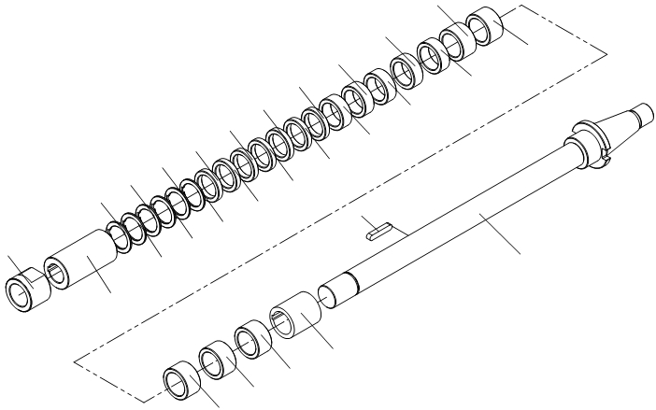

004

008   
008

008

010

009

006   
007

007   
007

007   
007

008   
008

008

004   
004

004

005   
005

005   
005

006

002

003

004   
005

001

08 Accessories part

No. Name Qty

08001 Φ27. 32 Cutter arbor each 1

08002 Key 1

08003 Distance sleeve 1

08004 Distance sleeve 5

08005 Distance sleeve 5

08006 Distance sleeve 2

08007 Adjusting washer 5

08008 Adjusting washer 6

08009 Sleeve 1

08010 M27.M30locknut each1

10 Table lubrication part

N0. Name Qty

10001 M8×1 lubrication pump(XL5P) 1

10002 M6×25 Hexagon socket head cap screw 4

10003 M8×1 Oil distributor(20348J-12) 1

10004 Gage (B1061C) 17

10005 M8×1 Collar nut 12

10005-1 φ4.1Dual taper cutting sleeve 12

10006 M8×1 Oil distributor(20348J-5) 2

10007 M8×1/ M8×1 Angle coupling 5

10008 plastic tubing Total 8

10009 pipe clamp(A2435C-1) 10

10010 M6×15 Cruciform Slot Screw 10

10011 pipe clamp(A2435C-3) 3

10012 Oil pipe with protecting sheath Total 12