

Parts list insert (For Russia area)14-inch Woodworking Band Saw

Model: JWBS-14OS

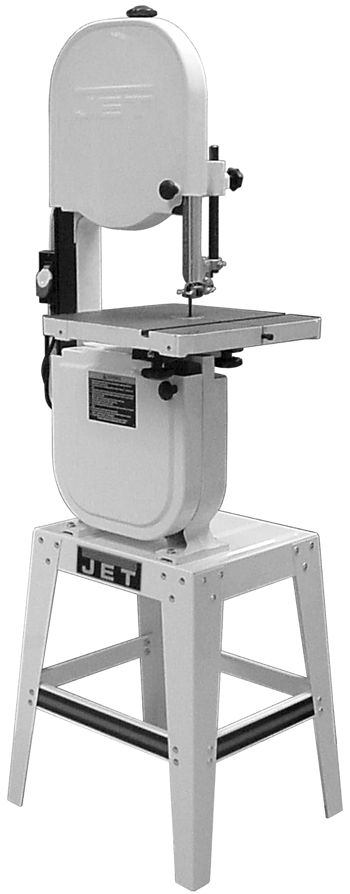

This parts list insert is made for Russia customers. Except for the difference noted for electric device in this insert, all other contents in the owner’s manual applies to this machine.

10/2016

# 

# Specifications

Model Number JWBS-14OS

Stock Number 708113A-RU

Cutting Capacity (height/in.) 6

Cutting Capacity (width/in.) 13-1/2

Minimum Blade Width (in.) 1/8

Maximum Blade Width (in.) 3/4

Blade Length (in.) 93-1/2

Blade Speed (SFPM) 2800

Table Size (in.) 14x 14

Table Slot Size (DxW/in.) 3/8 x 3/4

Table Height From Floor (in.) 44

Table Tilt (deg.) 45 right, 10 left

Dust Port Diameter (in.) 4

Overall Dimensions (HxWxD/in.) 68 x24x 26-1/2

Motor TEFC, 0.75kW, 1Ph, 230V 50Hz

Net Weight 80kg

Shipping Weight 85 kg

## 

# Replacement Parts

Replacement parts are listed on the following pages. To order parts or reach our service department. Having the Model Number and Serial Number of your machine available when you call will allow us to serve you quickly and accurately.

Body Assembly (JWBS-14OS-RU Band Saw)

Index No. Part No. Description Size Qty

1 JWBS14OS-101 Base 1

2 990180 Hex Cap Screw M16x55 1

3 TS-155010 Flat Washer M16 2

4 TS-154010 Hex Nut M16 1

5 100031 Pin 4

6 JWBS14OS-106 Lower Wheel Shaft 1

7 BB-6204VV Ball Bearing 6204LLU 2

8 KD050525 Key 5x5x25 2

9 TS-1550061 Flat Washer M8 1

10 TS-2248162 Button Head Socket Screw M8x16 1

11 M11241101EAS02 Motor..........................................................0.75kW, 230V, 50Hz 1

JWBS14OS-SC Starting Capacitor (not shown) 300MFD, 125VAC 1

JWBS14OS-RC Running Capacitor (not shown) 30µF, 250VAC 1

JWBS14OS-CC Capacitor Cover (not shown) 2

JWBS14OS-CSS Centrifugal Switch Set (not shown) 1

JWBS14OS-MFC Motor Fan Cover (not shown) 1

12 130027 Motor Pulley 50Hz 1

13 TS-1523031 Set Screw M6x10 1

14 170239B Switch KJD12 1

15 990811 Tapping Screw M3.5x12 2

16 TS-1550021 Flat Washer M4 2

17 150261 Switch Plate 1

18 TS-1533052 Pan Head Screw M5x16 2

19 WE050000 Star Washer M5 2

20 523028U-1.................... Switch Box 1

21 150056 Switch Backing Plate 1

23 990821 Pan Head Screw M5x6 2

24 998621 Strain Relief 2

25 JWBS14OS-125-RU Power Cord (with VDE plug ) VDE 1.0 mm2x3C 1

26 JWBS14OS-126-RU Motor Cord VDE 1.0 mm2x3C 1

27 998621 Strain Relief 1

28 JWBS14OS-128 Upper Frame Arm 1

29 990651 Lock Knob M10x30 1

100016ACP-1 Sliding Bracket Assembly (includes #30-39,125) 1

30 100016A-1 Sliding Bracket*(serial no. 07112632 and higher)* 1

31 NW080000 Wing Nut M8 1

32 990652 Lock Knob M8x45 1

33 990653 Blade Adjusting Screw 1

34 100021 Steel Pin 2

A100019 Upper Wheel Shaft Hinge Assy (includes #35 thru 37) 1

35 150086 Upper Wheel Shaft 1

36 992314 Spring Pin φ4x24 1

37 100019 Upper Wheel Shaft Hinge 1

38 100015A Coil Spring 1

39 150090 Square Nut M10 1

40 JWBS14OS-140 Upper Wheel 1

41 100025A Wheel Protector 2

42 TS-1540083 Hex Nut M12 1

43 992522 Retaining Ring R35 2

44 BB-6202ZZ Ball Bearing 6202ZZ 2

45 JWBS14OS-145 Lower Wheel 1

46 TS-1550061 Flat Washer M8 1

47 JWBS14OS-147 Hex Head Bolt (Left Thread) M8x20 1

48 JWBS14OS-148 Lower Wheel Guard 1

49 150024 Catch Knob M8 2

50 WI080000 Gear Washer M8 2

Index No. Part No. Description Size Qty

51 PWBS14-136 Stud Latch 2

55 TS-1533042 Pan Head Screw M5x12 2

56 150079 Catch 2

57 150054 Locating Bolt 2

58 990804 Tapping Screw M4x8 12

59 150029W Outer Wheel Cover 1

60 Saw Blade 6TPI 93-1/2”x3/8” 1

61 150028W Inner Wheel Cover 1

62 JWBS14OS-162 Washer Head Screw M5x8 2

63 150901 Upper Hinge 1

64 150066 Stud 2

65 110070 Blade Guard 1

66 150097 Washer 2

67 990811 Tapping Screw M3.5x12 2

68 JWBS14OS-168 Poly V-Belt 185J05 1

69 150902 Lower Hinge 1

70 TS-1533032 Phillips Pan Head Machine Screw M5x10 4

71 TS-1490061 Hex Cap Screw* M8x35 4

72 TS-1550061 Flat Washer* M8 4

73 TS-2361081 Lock Washer* M8 4

74 JWBS14OS-174 Serrated Hex Flange Nut* M8 4

75 523024 Wire Clip* 1

76 TS-1533042 Pan Head Screw* M5x12 3

79 JWBS14OS-179 Upper Support Bracket Post 1

80 150013A Thumb Screw M6x16 1

81 150015A Upper Spacing Sleeve 2

82 BB-6200ZZ Ball Bearing 6200ZZ 2

83 JWBS14OS-183 Retaining Ring S10 2

84 JWBS14OS-184 Guide Post 1

85 JWBS14OS-185 Support Bracket 1

86 708719 Guide Block 4

87 150013A Thumb Screw M6x16 1

88 150101 Lower Wheel Blade Guard 1

89 150014A Thumb Screw M6x12 5

90 100002A Upper Wheel Blade Guard 1

91 TS-1550041 Flat Washer* M6 2

92 TS-1482011 Hex Cap Screw * M6x8 2

93 JWBS14OS-193 Lower Support Bracket Post 1

95 TS-1482041 Hex Cap Screw* M6x20 2

96 TS-1550041 Flat Washer* M6 2

97 JWBS14OS-197 Table 14”x14” 1

98 199037 Table Insert 1

99 992311 Spring Pin φ3x8 1

100 100038 Table Pin 1

101 100042 Trunnion 2

102 100051 Scale 1

103 100041 Trunnion Clamp Shoe 2

104 TS-1482021 Hex Cap Screw M6x12 6

105 110045 Trunnion Support Bracket 1

106 TS-1490051 Hex Cap Screw* M8x30 2

108 110049 Pointer 1

109 990821 Pan Head Screw M5x6 1

110 990554 Lock Knob M10 2

111 TS-1491081 Hex Cap Screw M10x50 2

112 TS-1490151 Hex Cap Screw* M8x80 1

Index No. Part No. Description Size Qty

113 TS-1540061 Hex Nut* M8 1

115 TS-1504051 Socket Head Cap Screw* M8x25 2

117 TS-1550061 Flat Washer* M8 2

118 994181 Steel Ball 1

119 150099 Spring 1

120 TS-1525011 Socket Set Screw M10x10 1

121 JWBS14OS-1121 Spring Nut M4 2

122 JWBS14OS-1122 Cord Clamp* 1

124 TS-1482041 Hex Cap Screw * M6x20 1

125 150058 Indicator 1

127 WE050000 Gear Washer M5 1

128 TS-1481011 Hex Cap Screw M5x8 1

129 JWBS14OS-1129 Brush 1

130 150262 O Ring 1

131 994661 Overload 7A 1

132 WA15140102T00E20...Connecting line 14AWGx1C 1

JWBS14OS-SBHK Saw Body Hardware Kit 1

* included in Saw Body Hardware Kit, Part No. JWBS14OS-SBHK

**Body Assembly (JWBS-14OS Band Saw)**



Open Stand Assembly (JWBS-14OS Band Saw)

Index No. Part No. Description Size Qty

1 JWBS14OS-201 Stand Top 1

2 150603W Stand Leg 4

3 612050W Support Plate (long) 2

4 612051W Support Plate (short) 2

5 JWBS14OS-205 JET Logo Label 1

6 991516 Carriage Bolt** M8x16 40

7 JWBS14OS-174 Serrated Hex Flange Nut** M8 40

8 JWBS14OS-208 Rubber Foot 4

JWBS14OS-SAHK Stand AssemblyHardware Kit 1

** included in Stand Assembly Hardware Kit Part No. JWBS14OS-SAHK

Breakdown for JWBS-14OS v3

# Electrical Connections

